Roman Danel, Tomáš Vojtek & Jan Ministr

VŠTE v Českých Budějovicích

Okružní 517/10, 370 01 České Budějovice, Czech Republic

E-mail: rdanel@mail.vstecb.cz

VŠB – Technical University of Ostrava

17. listopadu 15/2172, 708 00 Ostrava, Czech Republic

E-mail: tomas.vojtek@vsb.cz

VŠB – Technical University of Ostrava

Sokolská 33, 702 00 Ostrava, Czech Republic

E-mail: jan.ministr@vse.cz

How To Teach Programing Languages?
- Introduction
In this paper we present our experience with the teaching of informatics and automation at faculties not primarily involved in computer science (for example, Faculty of Mining and Geology, VŠB-TU Ostrava). The aim of the education is to prepare graduates who are not just "pure" programmers and have wider knowledge to be applicable mainly to manufacturing companies. Graduates, in addition to computer science and automation, also get a basic overview of management, marketing, project management, business economics, and process management. From our experience, we know that companies in industry ask for this type of graduates. In this paper, we analyze the requirements of practice for IT graduates, the view of graduates on the lesson, the discussion on how to teach programming and which programming language should be used.
- Approach to teaching IT/ICT on IT study programs at faculty not primarily involved in computer science
At VŠB TU-Ostrava, two curriculum concepts in bachelor and master study were discussed in the past in the preparation of study plans and accreditations.
The first concept is based on the notion that the bachelor's degree is to provide students with a basic overview of existing technologies, approaches and directions, while the specific tools should be deeply presented only in the subsequent stage. This concept stems from systemic thinking, based on the process from abstract, general and global perspectives to details and specific knowledge [1].
The second concept is based on the assumption that the bachelor's degree study should lead to a mastery of specific tools and practices, i.e. “the job”. Follow-up studies should then deal with more complex and abstract approaches, the integration of knowledge and penetration into deeper knowledge, and should be aimed at more abstract concepts [1].
Article authors incline towards the second concept. The first approach has an obvious drawback – if students do not continue in the follow-up study, they actually lack any deeper knowledge and skills, and cannot therefore be very useful in practice. At the VSB, the opinion of proceeding from the general to the specific led at Faculty of Mining and Geology in “Information System Management” study field to including the course “System Integration” in the first year of the bachelor's study. The vast majority of schools in the Czech Republic introduce the course “System Integration” in the second year of follow-up studies as a subject that requires considerable knowledge of IT technologies and teaches students how to integrate these technologies into a single cooperating whole. It is interesting that the system integration usually does exist as a separate subject at foreign universities, but it is part of a series of courses in the following study levels [4]. Within the innovation of study programs at the HGF (2013-2015), the course “System integration” was shifted to the third year [1].
- Programming teaching from a university perspective
By analyzing ads on Jobs.cz, we see a great demand for programmers. There are also available positions suitable for graduates with very interesting financial appreciation and benefits. We still encounter students who want to be IT professionals, but they do not want to be a programmer and learn programming as a necessary evil. Programming seems to students as a difficult discipline, which, moreover, is associated with the use of mathematics. The reason is partly a way of teaching programming, which can be a deterrent to many students. Solving algorithms is predominant, and from the basic constructs of the language to advanced things such as pointer arithmetic or object programming concepts are explained on the C (C++) programming language. Students solve the tasks that serve to explain the procedures, but they have not a practical significance. Students do not know why they should learn these procedures. An example is learning a bubble sorting algorithm. What is the situation in practice when will I need this? Without a vision of practical usability, however, learning is demotivating. Therefore, we believe that the best way to learn programming is to solve real-world applications. Essential is the working program including its visual layer - only after mastering the ability to create a working application it makes sense to go into deeper and more demanding chapters. At this point, students already know how to proceed with the application, and understand why these things are being learned.
- Which programming languages should the university teach?
Another question in teaching programming is which programming language to teach. The problem is that developments in programming tools and techniques are too fast; new versions come every two or three years [7]. Techrepublic.com publishes regular rankings of the most used languages. Recently has been published a forecast which languages does not encourage to learn because of the declining interest in programming in these languages by developers and companies [8].
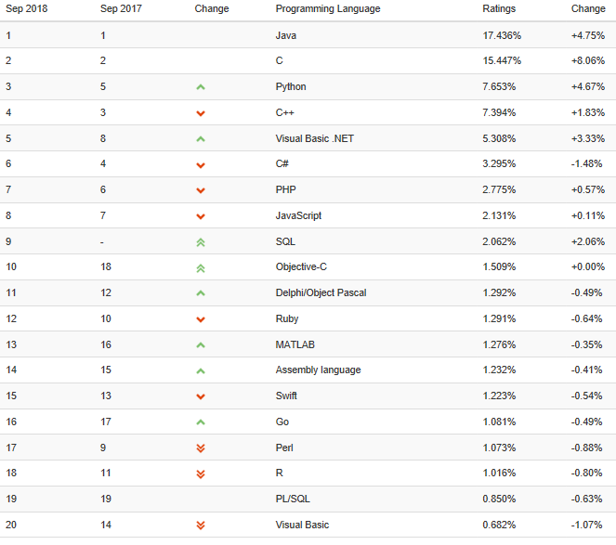
- The TIOBE index – ranking of programming languages in September 2018 [https://www.tiobe.com/tiobe-index/]
An interesting look at the use of programming languages in the world is provided regularly by the TIOBE index [10]. The TIOBE Programming Community index is an indicator of the popularity of programming languages. The ratings are based on the number of skilled engineers worldwide, courses, third party vendors etc.
As the TIOBE index in Figure 1 shows, Java is a winner in the world. It would seem that this language is a suitable candidate for teaching. We think it is not so - the mastering of Java for the beginner is not easy. If we also look at the long-term rating of Java, we see a steady decline over the years (Figure 2). From the analysis of the use of programming languages, their likes and prognoses, Python is now a good candidate for teaching programming languages. Its use is constantly growing and is also suitable for beginners.
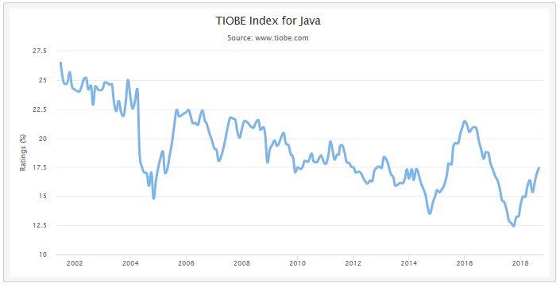
- The long term TIOBE index for Java [https://www.tiobe.com/tiobe-index/java/]
This opinion is also supported by an analysis of job offers in IT / ICT on Jobs.cz. At the time of article writing, advertisements looking for Java, C ++, C # or programming and analysis positions for the SAP ERP system (e.g. ABAP language) predominate. The common denominator of these offers is, however, the requirement for minimum practice (5-year requirement prevails) or experience with team leadership. While the second group of frequently-appearing requirements for language skills, such as Python or PHP, features a "suitable for graduates" note [3].
- Programming teaching from a graduate point of view
Programming as such should be learned from basic principles and procedures to the specific programming languages involved. Very often, programming procedures are identical, they only have different syntax, and then different build and run steps (compilation or not compiling at all).
Does it make sense to teach beginners of pointer arithmetic and objects? Or is it better to start with programming visual applications and work with data so the result can be seen right away, and then move on to more complicated things?
The authors of the article believe that at the beginning it would be good for the students they had a clear idea of where they can apply what they create, and see what their specific program does. Creating calculators again and again is not an original way of learning. It would be more appropriate, for example, to create one's own e-shop, to create a discussion forum, attendance records or other similarly applicable and usable technology.
We think that many basic principles and functions can be clearly demonstrated, for example, in PHP and other similar languages, where it is possible to simply and quickly visualize the work with cycles, conditions, work with strings, fields, and so on. The programmed code can then be run in one of the online tools within a second. While learning C++ and so on, it is very difficult for many students who do not have proper programming practice to see the transition from point A, which is the code, to point B, a visible result of the application's activity [9]. "Hello world" should be the result of every first created code, so that students have the opportunity to "touch" with what they have created.
The survey between the graduates found that they were most satisfied from subjects such as system integration, subjects explaining the creation and principles of databases, security of information systems, basic HTML structures, cascading styles, insights into the problems of information systems as such and editorial systems, e-commerce and the like. All these subjects and many others provide the student with a general overview that can be further developed and acquire practical knowledge and skills. On the other hand, the graduates negatively evaluate the contribution of relatively specialized subjects such as algorithmization, technical calculations, C and C++. Not because they did not attend, but because of teacher access. Students were unable to see practical applicability. They did not see any tangible result, only exercises from the outline, when they transcribe something that they have no idea where, when and for what purpose it can actually be used. So there was no link between study and practice.
It would be appropriate if the students were able to see a particular real application. For example, a given script/program written in a particular programming language controlling the nuclear power plant cooling controls circuits. To this end, a section of code would be available and an analysis would be performed on this code, which would have a different added value than the matrix rotation that only a very small percentage of future programmers will use.
- Absence of practice linking with subject teaching
Here we would like to take focus on the teaching model in Finland and similar advanced countries in which the student already knows that if he/she successfully graduates, he/she will be accepted by a particular firm in which he/she has been in practice for many years and has a clear idea of the amount future wages. Such a student then has the motivation to work, to complete the school, but also to develop further. After graduating from a university in the Czech Republic, students often end up in completely different positions or in other fields, or they do not know where their professional career will take after passing the final exams. They are basically thrown into the sea and threatened with an imaginary drowning in the labor market.
- Teaching subjects according to the curriculum without previous teacher practice experience in the given field
It happens that a certain subject is taught by somebody who has a professional knowledge but has no practice experience with the subject. This situation is not ideal from several points of view:
- Students are much more interested in the subject/issue if the subject is teach by the teacher who knows what they are talking about and is thus able to provide direct feedback from the real environment.
- If the lecturer knows the topics only from the study materials, he offers only a one-dimensional view of the subject, but the practice is very often different from what we can find in professional publications and knowledge is partly distorted. An example might be the question "and is this thing used in practice?" And to which the teacher cannot answer.
- Teachers have to use given curriculum and tasks that students have to learn in exercises with a clearly defined structure, and then evaluate them according to well-defined conditions. Without a link to the practice, the teacher will not teach the subject creatively and in a way to attract students to the subject. Everything is given by the curriculum, and there is no room for linking the themes with the practice, and it is only a mechanical pass through of individual "tasks" and their gradual solving.
- Teachers will prepare for each of the themes and learn what to teach their students themselves. Because of the lack of knowledge from a real environment, some information may misinterpret. Students know very well when the teacher does not really know the subject and tries to avoid answers, even if he is elementary knowledge about the topic. This degrades not only the teacher but also the faculty, the university, and ultimately the educational system as a whole.
- What the student should know from a practice point of view
The paths to achieving the goal are always more and it is often not possible to say that this path is the best or that there is no other solution. In general, however, it does not matter how we will achieve our goals if the application meets the requirements of the customer and if it is competitive compared to what the market offers simultaneously.
Where the punch labels were enough in the past, we now use technologies which programmers at that time could not even imagine. Today's focus is on accessibility, simplicity, user interface, user experience, accessibility from anywhere and on any device. Therefore, standards for user interface creation and user experience are already in place, but also standards for programming itself, such as a framework that meets certain naming conventions, security requirements, Cross Site Request Forgery, SQL Injection etc. Today's applications, if we do not talk about the lowest level of direct connection of production data collection and control based on the data obtained, mostly consist of several elementary layers. Here we will describe especially the widely distributed web technologies today, but this architecture can be applied to any programming language or technology:
- Presentation layer (GUI) - here, as a rule, a template is used as a building kit, as example is the Bootstrap where all the necessary elements and layouts are already designed and need to be put together in the desired form. But still we cannot do all without a small hits on such a template. The GUI consists of two main components, static and dynamic. Static creates compound columns, buttons, grids, etc. Dynamic part takes care of user experience, it can be used to dynamically behave some elements, data masks, element moves etc. The internal environment of Bootstrap uses both internal JavaScript and another external JavaScript framework as for example jQuery.
- Apps process requests and entire internal logic. In this particular case, for example PHP and the framework like Nette, Laravel, CodeIgniter etc. The application then consists of three layers: Model - View – Controller.
- Database layer is the memory of the entire application. There are many types and ways of making it.
Nowadays, it is not enough for a person to be able to use graphics, or just to program or understand the databases; today, all knowledge is interlinked. Each of us is more and more either a programmer or a designer, and at some point we try to understand both areas. By being able to turn on Photoshop or Illustrator, we do not become designers, so it is important to have experts who have a global overview but are the best in one or more specific areas. It is necessary to have a general overview, but at the same time it is equally important to have the opportunity to develop professionally in the area that we most enjoy and can become one of our livelihoods. It often happens that a person with such an overview can later become an IT company manager who will be able to design a suitable solution based on his experience [5]. An inspirational model comes from some Asian countries consisting of advancement in positions in jobs. An employee must first go through lower positions to achieve the highest possible position. This is the only way to obtain all the necessary knowledge of the functioning of the company.
- What IT companies are looking for the most?
From information provided by IT company owners, we know that finding the right employee is not a simple matter at all. This is especially because of the personality characteristics of programmers as such - often introverts and little assertive/communicative individuals. Programmer usually does not search for work, but the job is looking for programmers. A suitable employee may be a top programmer, the question remains whether we can benefit from it and the cooperation with him will be effective if we cannot communicate? Each programmer also has the specific character of his code and must be somehow compatible with other programmers in the team. A common problem is that if a programmer is employed on a particular project, this programmer during the project gets offer from a large multinational company or from a start-up project and the project may get into trouble. It is then very difficult to find the follower [2].
There are two types of programmers, one type is referred to as "wow, it works" and the other is a professional who has automated activities such as measure time of programming, sending errors as SMS to his cell phone, or linking a local and external synchronized repository. However, a professional is expensive and it is quite possible that he will be acquired by another company in the future. Regarding project and code sustainability leaving programmer will be a problem. The professional will create a complex code so that it will be difficult to read and continue for the average programmer, the type of "wow, it works" will suffer from the same problem.
For example, the solution could be a smaller, well-motivated team of professionals understanding the same technology, ideally, members could have their own "small" projects that they keep and spend in their spare time. Motivation can be financial participation in project revenue beyond the normal valuation.
- Recommendations for teaching of programming
Based on the analysis of the current state of education at VŠB TU Ostrava and the subsequent survey of the opinions of graduates and business owners, we have formulated the following recommendations:
- One semester (12 lectures and exercises in real terms) is not enough to prepare "programmer".
- Teach the programming course in way that the students from the beginning create a meaningful application (e-shop, evidence system, warehouse ...) and do not learn the programming with fictitious tasks (calculator, bubble-sort, calculating integral ...).
- Overall, consider whether it would be better to have less subjects and instead of this a multiple blocks via more than one semester with a higher credit rating (e.g. students could solve the project in collaboration with the company: the analysis of the assignment - requirements analysis - solution design - application creation - testing and debugging, etc.). An example of such an approach is the teaching of programming and IT/ICT subjects at the DMU University in Leicester.
- The problem is the current way of financing schools, which does not allow the flexible use of professionals form practice in teaching. An academic worker who has been working for a number of years at a university is supposed to be an expert in his field. It may be true in IT, but only in a particular specialization. Such a person has no chance to follow up with the rapid development of technology in a wide range of areas - therefore he cannot teach ten subjects professionally. The rapidly evolving technology should be taught by professionals. However, for this purpose it is necessary to have funds at school.
- For teaching programming, we recommend one of the scripting languages such as PHP or Python, where one can see the result immediately and writing the first program does not require complicated installations. When using C++, for example, it is a very long way to the point where a student is able to write a visual GUI application - it is not realistic for beginners to master this over one semester.
- Conclusion
In this paper, we attempted to consolidate views on teaching programming from a university, graduates, and from companies’ perspective. The development of IT/ICT is very fast, and pedagogical practices that are successfully used in other fields are not ideal here. It is necessary to link the teaching to practice, not to teach IT just theoretically, but to involve experienced professionals in teaching. We understand that the changes will not be done immediately, but if we have at least achieved the fact that IT study programme curriculum makers are starting to discuss this issue more, it will be a step forward. Given the growing demand for IT professionals from companies, universities will have to react more flexibly to technological change if we want to be competitive.

Literature
- DANEL, R.: Adapting IT/ICT education to current requirements from practice. IDIMT - 2016 Information Technology and Society Interaction and Interdependence - 24nd Interdisciplinary Information Management Talks. Poděbrady, Czech Republic. Linz: Trauner Verlag Universitat, 2016, pp. 63-68.
- DOUCEK, P.; NEDOMOVÁ, L.; MARYŠKA, M.: Is it attractive to be the ICT professional in the Czech economy? IDIMT - 2015 Information Technology and Society Interaction and Interdepence - 23nd Interdisciplinary Information Management Talks. Poděbrady, Czech Republic. Linz: Trauner Verlag Universitat, 2015, pp. 73-87.
- Job offers - Jobs.cz. [Online]. [Accessed 2005-09-15] Available from: https://www.jobs.cz
- JUREČKOVÁ, D.: Analýza výuky systémové integrace na VŠ v ČR, Rakousku a Německu [In Czech: Analysis of teaching of system integration at universities in CR, Austria and Germany]. Bachelor thesis. Supervisor: R. Danel, VŠB-Technical University of Ostrava, 2015.
- MINISTR, J.; PITNER, T.: Academic-industrial cooperation in ICT in a transition economy – two cases from the Czech Republic. Information Technology for Development, 21(3), Routledge. 2015, pp. 480-491.
- MINISTR, J.; PITNER, T.: The academic-industrial Collaboration as an innovation instrument. IDIMT - 2016 Information Technology, Society and Economy strategic cross-influences – 24th Interdisciplinary Information Management Talks. Poděbrady, Czech Republic. Linz: Trauner Verlag Universitat, 2016, pp. 53-61.
- PETKOV, A.: Here are the best programming languages to learn in 2018. [Online]. [Accessed 2005-09-21]. Available from: https://medium.freecodecamp.org/best-programming-languages-to-learn-in-2018-ultimate-guide-bfc93e615b35.
- RAYOME, A.: The 5 worst programming languages to learn in 2018. [Online]. January, 2018. [Accessed 2005-09-21]. Available from: https://www.techrepublic.com/article/the-5-worst-programming-languages-to-learn-in-2018/.
- ŘEPKA, M.; DANEL, R.; NEUSTUPA, Z.: Use of the Bioloid robotic kit in the teaching of automation and programming. SGEM 2012 - 12th International Multidisciplinary Scientific Geo-Conference, Albena, Bulgaria, volume III, 2012, pp. 1229-1236.
- TIOBE Programming Community index. [Online]. [Accessed 2005-09-21]. Available from: https://www.tiobe.com.

Summary
In this article, the authors analyze the status of teaching IT courses and programming at faculties not primarily involved in computer science. It describes teaching from the University's point of view and recommendations for changes, programming teaching from graduate point of view and the view of IT company owners. Based on an analysis of the demand for programmers and the above-mentioned opinions, the authors recommend not using complex programming languages such as c ++ and fictitious matrix multiplication in beginners learning, but focus on easy-to-use scripting languages like PHP or Python. Programming should be taught on real applications. The authors recommend that, as a result of the rapid development of IT technologies, these technologies should by teach by the professionals from practice. This, however, requires a change in funding and adaptation at the level of accreditation of study programs.
Key words: Teaching programming languages; recommendation for teaching; practice linking to teaching; TIOBE index.

