Athanasios Podaras¹

¹Technical University of Liberec, Faculty of Economics,

Department of Informatics

Voroněžská 13, 460 01 Liberec 1, Czech Republic

E-mail: athanasios.podaras@tul.cz

a data warehouse model for industrial safety management
- Introduction
The failure of safety critical systems is an issue which is thoroughly discussed and analysed by both practitioners as well as academic researchers. Business continuity Management is a topic which is strongly related to the safety science. More precisely, the part of an integrated business continuity management entitled Business Impact Analysis defined as “a process that identifies and evaluates the potential effects (financial, life/safety, regulatory, legal/contractual, reputation and so forth) of natural and man-made events on business operations” [4].
Business Continuity Management [16] aims to the rapid restoration of all the critical systems and business functions in the enterprises, the public organizations and the industry. Business Impact Analysis [13], which is a crucial part of the BCM, deals with the efficient settlement of recovery priorities based on the criticality of each business function. In its turn, the criticality prioritization is highly dependent on the defined by industry experts and business continuity managers recovery time [5]. These experts have proposed a 4-level criticality ranking system in accordance to the defined resumption timeframes.
Neither a standard mathematical method for classifying an individual business function as critical/non-critical, nor sophisticated software tools which could support such a process have been proposed so far. In order to fill this gap, a standard mathematical method for classifying individual business functions, entitled business continuity testing points (or simply business continuity points) [8] has been recently developed. Its principle is the focus on estimating the recovery complexity of an individual business function. This estimation can help classify a business function as critical or non-critical with the help of specific mathematical calculations.
The goal of the present article is the proposal of a star schema data warehouse solution which is aimed to support the computation of the recovery time effort for interrupted business functions and its supported information systems. Additionally it is discussed its possibility to improve industrial safety via reliability engineering and system availability measurement.
- Related work and problem statement
“A Safety Critical System is such a system which has the potential and may cause accidents either directly or indirectly. Failure of such systems can result in loss of life, property damage, environmental harm and financial loss. Safety is dependent on proper operations of such systems” [11]. It is thus, important to classify such systems as highly critical with regard to their recovery priority, if we consider that such systems should operate virtually without interruptions. As a consequence, the incorporation of mathematical tools for criticality ranking of industrial business functions which are dependent on such systems becomes a clear necessity. An interesting mathematical approach by [14] refer to proactive recovery time estimation and criticality ranking of a group of BF which is extremely useful but does not thoroughly examine all the possible technical and environmental elements of an individual BF. In addition to the above mentioned facts, the business continuity points is based on simple mathematical calculations which makes it more comprehensible by business stakeholders.
Moreover, software tools which have been designed and developed for the BCM domain [10], though proactive, they serve as tools which rather react to operational failures, focus exclusively on the technical aspects of business functions, and do not take into account the environmental aspects (i.e. experience of the end user) of an individual business function. Additionally, mathematical models which are proposed in conjunction with software based solutions [9] serve as reactive (not proactive) BCM and disaster recovery planning (DRP) solutions for the resumption of critical operations after their failure.
Finally, “data collection is an important activity throughout the BCM development process” [2] and “the resilient organization, through an enhanced sensing capability, integrates business intelligence in order to improve situational awareness” [12]. The current work describes how business intelligence tools and data warehouses can efficiently support data collection towards the precise classification and recovery time estimation of a given business function.
- The business continuity points (BCPTs)
The approach has been developed by the author and his research team [8] and focuses on the proactive estimation of the recovery time effort for an individual business function and its corresponding criticality ranking [7]. The approach has been thoroughly analyzed and validated. The algorithmic process for calculating the Recovery Time is below depicted (see Fig.1). For the better interpretation of the derived results we briefly mention that for the estimation of the recovery time effort we have to consider the following recovery complexity parameters:
Unadjusted Business Function Recovery Points (UBFRP): In order to compute the specific value human and application level actors have to be considered along with their corresponding impact (weight) on the recovery process.
Adjusted Business Function Recovery Points (ABFRP): For the computation of the specific value the following recovery complexity paparemets are considered:
- Technical Recovery Factors (TRF)
- Environmental Recovery Factors (ERF)
- Unexpected Recovery Factors (URF), and
UBFRP
The RTE value is provided by the Formula 1:
(1)

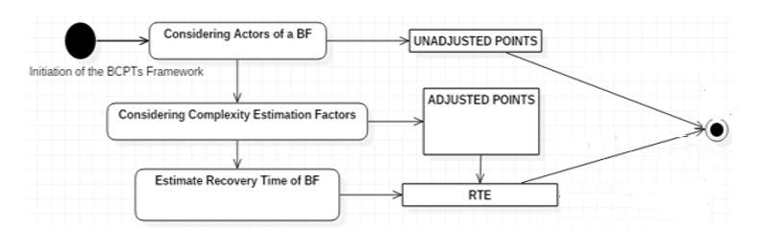
- The summarized model of BCPTs (Source:Author)
- Tools and methods
  - Star schema data warehouse
“A data warehouse is a particular database targeted toward decision support. It takes data from various operational databases and other data sources and transforms it into new structures that fit better for the task of performing business analysis. Data warehouses are based on a multidimensional model, where data are represented as hypercubes, with dimensions corresponding to the various business perspectives and cube cells containing the measures to be analyzed” [15].
In data warehouses data is organized as multidimensional facts, where each fact “represents a business event that has been recorded in a transactional database, is identified by a node for each dimension, and described by one or several measures. Each dimension is given by a leveled hierarchy of nodes, whereby each node is described by a set of non-dimensional attributes and all nodes of the same level have the same attributes with different attribute values“[6].
For the design of a multidimensional data warehouse model two basic types of multidimansional schemas are proposed, namely a) the star schema (Mendoza et al., 2015) (see Figure 2) and, b) the snowflake schema [1].
  - Computing system availability
In reliability engineering, the system availability is calculated according to the formula (2) [3]:
(2)
MTBF = Mean Time between Failure, MTTR= Mean Time to Repair, and A= Availability of a system for a given time period. MTBF is also calculated as the ratio 1/λ, where λ is the failure rate (number of failures N per X number of hours. The current contribution discusses the possibility of validating RTE value by including it to the Formula 2.
- Results and Discussion
The proposed data warehouse solution is currently analyzed and illustrated (Figure 3):

Facts Table: BF_Recovery_Data. This table includes the calculated values of the recovery complexity parameters as well as the primary keys used for its connection with the dimensions tables. The facts table informs us of the Total Unadjusted Actor Weights (TUAW), Unadjusted Unadjusted Business Function Weights and the UBFRP values after considering the input parameters in BF_Data table.
Dimension Tables: BF_Data: The specific table includes information about the business function for which the criticality classification is implemented. Moreover, the table is used as an input entity regarding the number of simple, average and complex actors (both human and application level types) which participate in the execution of the business function, as well as the number of the involved simple, average and complex business processes.
Business_Entity: The specific table is utilized for defining the type of business entity, which might be a department, a division or even an SME.
RTE_Interval: The table informs us of the recovery time effort (RTE) value based on the classification proposed by Gibson. Furthermore, information regarding the corresponding impact value levels is included (IVL types).
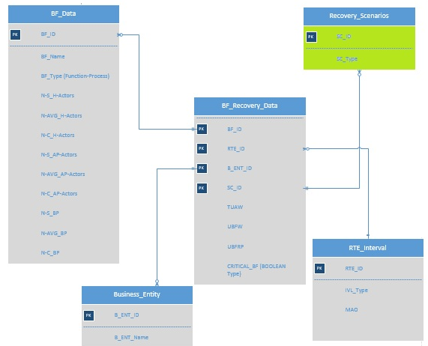
- The data warehouse star schema regarding the RTE estimation and classification of a Business Function (Source: Author)

Recovery Scenarios: The table includes the list of possible recovery scenarios. During the speedy classification of a business function the scenario type can be determined by the system, after the input of the data regarding the involved Actors and Business Processes has been terminated. Speedy classification is based on predicting IVL based on UBFRP [7].
A practical way to validate the derived by the BCPTs model RTE value, is to replace the MTTR value by RTE in Formula 2.The following schema is proposed as an integrated solution for the timely restoration of safety critical systems and functions (see Figure 3).
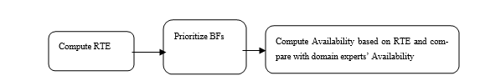
- A proposed solution for implementing effective safety management for critical systems and functions (Source: Author)
- Conclusions – Implications for further research
In order to further increase the value of the BCPTs method and consider it as a standard approach for integrated safety management solution the following contributions are currently presented: a) a new data ware house model which can support the BCPTs approach and compute the RTE values of functions that are safety critical, and b) utilization of the system availability formula in order to control the validity of the computed RTE. Future tasks include the construction of a more detailed data model base on snowflake schema and normalized entities, a physical form of the proposed data model and a practical implementation of the RTE value to the availability formula in a practical case study from the business or industrial sector.

Literature
- DATTA, A.; THOMAS, H. (1999). The cube data model: a conceptual model and algebra for on-line analytical processing in data warehouses. Decision. Support Systems. Vol 27, No(3), pp. 298–301.
- ENGEMANN, K.J. ; HENDERSON, D.M. Business Continuity and Risk Management: Essentials for an Organizational Resilience. 2012. Rothstein Associates Inc., Connecticut, USA.
- GARCIA, I.E.M., SANCHEZ, A.S. & BARBATI, S. Reliability and Preventive Maintenance. 2016. In W. Ostachowicz et al. (Eds.), MARE-WINT. New Materials and Reliability in Offshore Wind Turbine Technology (pp. 235-272). Switzerland: Springer International Publishing AG.
- GARTNER: IT Glossary: Business Impact Analysis. 2017. [Online] Retrieved September 2017-09-12]. Available from: https://www.gartner.com/it-glossary/bia-business-impact-analysis.
- GIBSON, D. Managing Risks in Information Systems. 2011. Jones & Bartlett Learning.
- NEUBOCK, T.; NEUMAYR, B.; SCHREFL, M.; SCHUTZ, C. Ontology-Driven Business Intelligence for Comparative Data Analysis. 2014. In E. Zimanyi (Ed.): eBISS 2013. Lecture Notes in Business Information Processing, 172 , (pp. 77-120). Switzerland: Springer International Publishing.
- PODARAS, A. Measuring the Accuracy Levels Regarding the Dual Business Function Criticality Classifier. 2018. IEEE Access. Vol. 6, No 1, pp. 41598-41606. ISSN: 2169-3536.
- PODARAS A., ANTLOVA, K., and MOTEJLEK, J. Information Management Tools for Implementing an Effective Enterprise Business Continuity Strategy, 2016. E&M Ekonomie a Management,Vol. 19, No 1, pp. 165-182.
- SAHEBJAMNIA, N., TORABI, S. A.; MANSOURI, A. Integrated Business Continuity and Disaster Recovery Planning: Towards Organizational Resilience, European Journal of Operational Research, 2014, Vol. 242, No. 1, pp. 261-273. ISSN: 0377-2217.
- ŠIMONOVA, S., O.; ŠPRYNC, Proactive IT/IS Monitoring, E&M Ekonomika A Management, vol. 2011, No 3, pp. 57-65.
- SRINIVAS ACHARYULU, P.V. ; SEETHARAMAIAH, P. (2015). A Framework for Safety Automation of Safety-Critical Systems Operations. Safety Science, 2015, 77, pp. 133-142. ISSN: 0925-7535.
- STARR, R., Enterprise Resilience: Managing Risk in the Networked Economy, http://www.boozallen.com/content/dam/boozallen/media/file/Enterprise_Resilience_Report.pdf, 2003.
- TAMMINEEDI, R. L. Business Continuity Management: A
Standards-Based Approach. 2010. Information Security Journal: A Global Perspective, Vol. 19, No 1, pp. 36-50. ISSN: 1939-3555.
- TORABI, S.A., Rezaei, H., & Sahebjamnia,N. (2014). A New Framework for Business Impact Analysis in Business Continuity Management (with a case study). Safety Science, 68(2014), pp. 309 - 323. ISSN: 0925-7535.
- VAISMAN, A. & ZIMANYI, E. Data Warehouse Systems: Design and Implementation. Data Centric Systems and Applications. 2014. Heidelberg: Springer.
- WATTERS, J. Disaster Recovery, Crisis Response, and Business Continuity. A Management Desk Reference. 2014. Berkeley, CA: Apress.

Summary
Business continuity Management is a topic which is strongly related to the safety science. The article introduces a data model for enterprise business continuity management as a software solution for supporting timely restoration of safety critical systems. The illustrated data model is constructed with the business intelligence data warehouse star schema and depicts a non-arbitrary solution for computing proactively the recovery time effort of an individual business function which differs from the currently applied vague and arbitrary criticality prioritization, even when the business continuity management process is supported by modern software solutions and mathematical tools. Data collection is an important activity throughout the BCM development process and resilient organizations, through an enhanced sensing capability, integrate business intelligence in order to improve situational awareness. The entities as well as the corresponding attributes of the data model stem from the already proposed by the author business continuity points approach to the classification of business functions based on their recovery complexity, which, in its turn, stems from the use case points method of software complexity estimation. The computed resumption timeframes for an individual business function which are supported by safety critical systems can be used as an input for computing the availability of safety critical systems. A summarized illustration of this proposal is also included.
Key words: Business Continuity; Safety Critical Systems; Data warehouse; Availability Formula

