Jakub Novotný

Department of Systems Analysis, Faculty of Informatics and Statistics

University of Economics, Prague

W. Churchill Sq. 1938/4
130 67 Prague 3 – Žižkov, Czech Republic

E-mail: novotnyj@vse.cz

Sport Wearables - From the First Hearth Rate Monitor to Online Services
- Introduction
Although the use of information and communication technology (ICT) in sport does not belong to the critical area or mainstream of ICT industry, it is an area that is interesting in terms of its development and especially in terms of the future outlook. The development of sport and fitness market sector of personal ICT can be significant for future development of broader segment of ICT. Relevant ICT companies are well aware of market potential of amateur athletes and also wellness fans and so a wide variety of products and solutions directed to sport area can be found. It includes various kinds of hardware accessories, sport and fitness software applications, online services and completely designed equipment developed and offered in the market.
In this overview paper we will focus on the main development milestones in this segment of personal ICT market (i.e. ICT solutions for mass amateur sport) and we will try to derive more general trend for the given segment of ICT from it.
- Dawn of Wearables
Historically longest period in the sport market have sport watches with the function of hearth rate monitor (heart rate indicates present state of human body and its ability to adapt to stress provoked by physical activity) and they are also probably the most widely used specialized sport device historically and also nowadays. It is usually a sport watch displaying and recording the actual heart rate of their users mostly via wirelessly connected chest belt or via optical sensor directly on the device. This concept comes from the Finnish company Polar. According to information presented by POLAR the idea originated in 1975 during a cross-country skiing tour of future company founder and national coach of the Finnish cross-country ski team. Then in 1977 at the University of Oulu a finger pulse sensor was developed and its market variant was introduced in 1978 by Polar. A prototype of wireless heart rate monitor was introduced at the same time, initially designed for the needs of the Finnish cross-country ski team. The wireless heart rate monitoring method was developed for Polar at the University of Oulu (department of electronics). As mentioned before it was originally aimed at Finnish cross-country team to help raise the quality and efficiency of their training. This measurement method was also useful for researchers. With this invention starred gradual expansion of methods of training by heart rate and necessary equipment has begun to penetrate the market and reached also the segment of amateur and recreational sports. From point of view of market was a major breakthrough year 1982, when company Polar began to sell device Sport Tester PE2000 – “The world's first wireless wearable heart rate monitor [3].” Following models also allow the evaluation of the training load and its effect through connection to a personal computer (IBM PC).
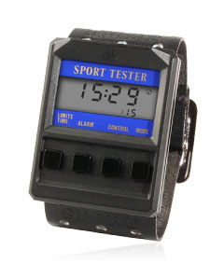
- The first wireless wearable heart rate monitor - Polar Sport Tester PE2000 [3]
Seen by the prism of today's boom of wearables and smart mobile devices we can state that the heart rate monitors were ahead of these trends by about twenty years. Current offer of smart sports watch with heart rate function is very broad. The main leaders in this segment are marks Garmin, Polar and Suunto. All top of their models use GPS signals to specify distance measurements during user activity and collect also other data from a number of internal or external sensors. An individual athlete generates a series of personal data by each of his recorded activity. For instance an 15 km run by moderate pace (6 min/km) with recording every 1s generates approximately 1,2 MB of data.
- Downloadable Apps
As the first described milestone of development was indeed a breakthrough invention, at least in terms of segment of wearable devices, the second represents an opposite trend when the already well-proven concept in the wider mobile segment was introduces in segment of specialized sport devices. At a time when downloadable applications have already been the ultimate standard in smart phones, Suunto first came up with this concept in sports watches in year 2013.
However, this is not just a passive option to download an existing application. The so-called Suunto Apps allow also to create own applications in a proprietary scripting language and add them to the sport modes. Publicly downloadable applications are available in the App Zone of portal movescount.com. A tool called App designer is available on the same portal for the creation of applications. Basic mathematical and logical operators, some mathematical functions and so called Suunto functions are offered (beep, backlight, distance and heading between two points according to the geographical coordinates) and over 200 variables from the device such as the speed characteristics (current speed, average speed, maximum speed, pace, etc.), distance characteristic, heart rate, ambient and many others are available for coding of an app. The basic output of the Suunto script is figure (RESULT) displayed in time format or as anumbers. This output can be supplemented by the text field before and after the output (PREFIX, POSTFIX). Total number of displayable characters together for PREFIX and POSTFIX is only six. There are many limitations resulting from scripting language and the device (very small memory available for application, the limited display capabilities etc.) but on other hand it is very easy to create useful new function to the watches.
The code for a very simple application (to calculate the pace to reach the target half-marathon finish time) can take the form of, for example:
RESULT = ((6000-SUUNTO_DURATION)/(21.1-SUUNTO_DISTANCE));
The following picture shows a more complex Suunto App in App designer.
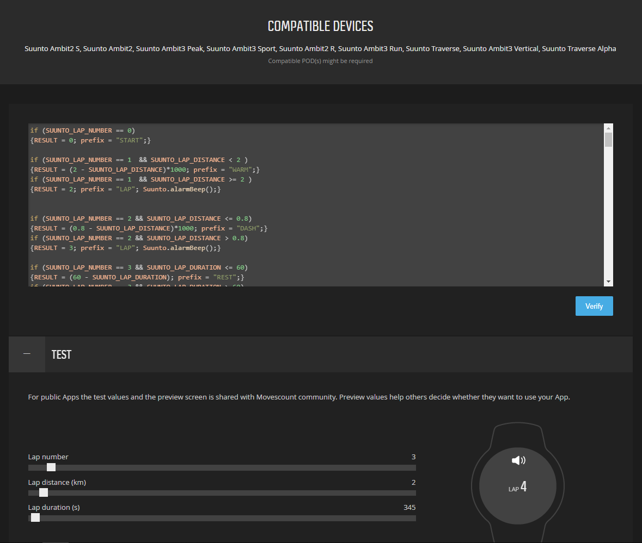
- App designer on movescount.com [5]
About two years later (On September 2014) Garmin introduced competitive concept Connect IQ [6] for Garmin devices with a complex object-oriented programming language Monkey C which is much more powerful and limited only by hardware.
The language Monkey C is working similarly to Java, PHP, Ruby, or Python, and that language is a definite combination of them. Monkey C is an object-oriented language that works with the Monkey Brains virtual machine for easy application development for portable devices. It uses reference counting to automatically clean the memory, so you do not need to focus on memory management. Monkey C requests are dynamically linked to the system. Monkey C can contain arguments that do not need to declare a type. Also, it is not necessary to declare the function return values. The value returns from the function with the return statement. If the function does not return, it returns the last value in the stack. All Connect IQ applications require a manifest file. Manifest file is an XML that determines application properties such as application type and supported products. The manifest file is automatically created for the Eclipse plug-in, but can also be created manually.
Except the above mentioned limitations, main obstacle for market development of this concepts (by Suunto and also by Garmin) is fact that both of them are highly proprietary. These limitations do not provide much perspective for further market development. This is confirmed by the solution and offer of the latest products, especially for Suunto. Polar has a difference strategy in the field of downloadable applications and offers some models with a standardized operating system Wear OS. Even in the case of Polar, it is more a reaction to competition than a major development trend.
- Online training diaries and performance analysis
Downloadable applications and especially proprietary programmable applications for dedicated sports devices do not seem to be a long-term successful solution (at least from a market point of view), however, with the general development of connectivity to the Internet in recent decades, an on-line service for storing, displaying and analyzing sport data plays an increasingly important role. Digitalization of training data is historically closely linked to Polar's first models of hearth rate monitors. Polar released to market first hearth rate analysis software for IBM PCs in year 1986 and continues to be pioneer in this field by introducing training analysis software for MS Windows in 1991 and first own online training diary in year 2001.
There are nowadays dozens of different online services for storage, visualization and analysis of sports data on market. Most manufacturers of wearable sports equipment offer their own solutions of online training diaries together with online settings and customization of given devices. For the three above-mentioned main brands these are: Polar Flow (flow.polar.com), Suunto Movescount (www.movescount.com) and Garmin Connect (connect.garmin.com). There is also wide offer of device/producer independent online services like Strava, Endomodo, Runtastic and many others.
Users (athletes) using wearable devices and other attached external sensors collect a lot of data about their activity, including body data measurements. These data are online or subsequently batch uploaded to the appropriate online storage where they are further processed, visualized and analyzed, both at the level of a single athlete or whole training team, but often also at the population level. Graphically, we can illustrate it as follows.
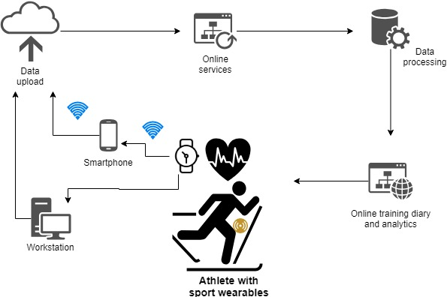
- Collection and processing of data
- Conclusion
This paper discusses with a brief historical excursion three crucial milestones in history of ICT solutions for mass amateur sports. These three milestones represents also three different layers from the perspective of ICT architecture. First wearable device fits to hardware layer. Downloadable applications and their development fits to application software layer. And online training diaries fits to external online (cloud) services layer.
From the point of view of development of hardware devices, we can expect some minor improvements of accuracy of measured values and device power consumption. And gradually also the development of additional sensors to measure body characteristics and motion characteristics.
It is difficult to predict future developments in the software area. Individual manufacturers will try to maintain and develop their own proprietary solutions. There is no expectation of a development analogous to the smartphone segment, because the sports wearables is rather narrow and specialized segment so the market tendencies are quit different.
The greatest development can be expected in the field of online storage, visualization and, in particular, data analysis. Training data, movement data and body characteristics data are really “big data” with considerable potential for further use. Even basic regular heart rate measurement and evaluation can be used as an indicator of the health of the user in longer term period.
With the aging of today's generation of "sensored” amateur athletes as well as aging of populations in general, it will become more important to track body data with respect to the general health of the individual. From the viewpoint of motion monitoring, remote monitoring of patients or seniors in general will be important. Today, such products and services can be found on the market, but certainly not in the range of sports devices and online services. We expect this to change gradually towards a wide range of wearables and online services for health monitoring.

Acknowledgements
This article was created with the subsidy of the means of institutional support for long-term conceptual development of science and research at Faculty of Informatics and Statistics, University of Economics, Prague.

Literature
- BAUM, P., ABADIE, F. Market Developments – Remote Patient Monitoring and Treatment, Telecare, Fitness/Wellness and mHealth. (p.35). Luxembourg: Publications Office of the European Union, 2013. ISBN 978-92-79-25708-7.
- PARKER, S. History of Heart Rate Monitors. Retrieved from: http://www.articlesbase.com/healtharticles/history-of-heart-rate-monitors-253755.
- www.polar.com
- NOVOTNÝ, J, WINKLEROVÁ, M. How Programmer Plans Training? International Journal of Advanced Computer Science and Information Technology Vol. 3, No. 4, 2014, Page: 379-389, ISSN: 2296-1739
- www.movescount.com
- www.garmin.com
- www.suunto.com
- MUSIL, M. – SMRČKA, F. – NOVOTNÝ, J. Development of apps for sports wearables devices – Suunto, Garmin, Recon. LOGOS POLYTECHNIKOS. 2016, vol. 7, 4, s. 57-70. ISSN 1804-3682.
- RAY, P. P. Internet of Things for Sports (IoTSport): An architectural framework for sports and recreational activity. 2015 International Conference on Electrical, Electronics, Signals, Communication and Optimization (EESCO) (2015): 1-4.

Summary
The paper focuses on the main development milestones in segment of personal ICT market for mass amateur sports and tries to derive more general trend for the given segment of ICT from it. The most widely used specialized sport device historically and also nowadays are hearth rate monitors which represents first milestone discussed in the paper. The first hearth rate monitor offered on the market was device Sport Tester PE2000 introduced by Polar. From the point of view of today's boom of wearables and smart mobile devices we can state that the heart rate monitors were ahead of these trends by about twenty years. The second discussed milestone is concept of downloadable application and their development environment for dedicated sport devices. Existing solutions have a lot of limitations and do not provide much perspective for further market development. The last discussed milestone are online services of training diaries and performance analysis. The paper concludes that the greatest development can be expected just in this field. Training data, movement data and body characteristics data are really “big data” with considerable potential for further use and it will become more important to track body data with respect to the general health of the individual.
Key words: Sports wearables; hearth rate monitors; downloadable applications; training data; online services; health monitoring.

