
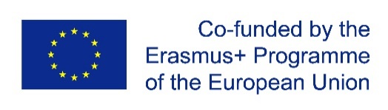
has successfully participated at the
International Study Programme Week (ISP)
of the Erasmus+-Project SHARPEN - SMEs Human resource attraction, retention and performance enhancement network
under the Erasmus+ Programme Key Action 2 Strategic Partnership - 2016-1-CZ01-KA203–023916
at Westsächsische Hochschule Zwickau/Germany - University of Applied Sciences
Faculty for Economics and Business Administration
from April 3rd to April 7th, 2017

CONFIRMATION
Sending organisation
University of Huddersfield
Queensgate, Huddersfield HD1 3DH, United Kingdom
…………………………………………………………………………...
Representative of the organisation
In Zwickau April 8th 2017
Receiving organisation
Westsächsische Hochschule Zwickau
Dr. Friedrichs-Ring 2A, 08056, Zwickau, Germany
…………………………………………………………………………...
Representative of the organisation
In Zwickau April 8th 2017
Name Surname






