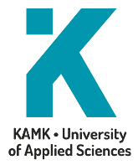
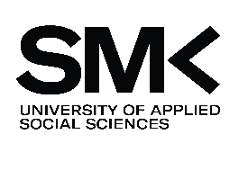
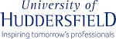


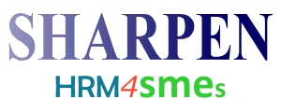
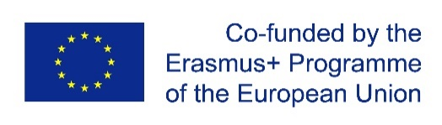
SMEs Human Resource Attraction, Retention and Performance Enhancement Network
under the Erasmus+ Programme Key Action 2 Strategic Partnership - 2016-1-CZ01-KA203–023916

…………………………………………………………………………...
Kateřina Maršíková
SHARPEN Project Manager
Technical University of Liberec
…………………………………………………………………………...
prof. Ing. Miroslav Zizka, Ph.D.
Dean of the Faculty of Economics
Technical University of Liberec
Name Surname

FOR
successful completion of educational programme:
Human Resource Management for Small and Medium-sized Enterprises
under the Erasmus+ Project SHARPEN
CERTIFICATE OF COMPLETION

AWARDED TO

