SHARPEN: where cultures and minds meet to increase
human resource management effectiveness for SMEs

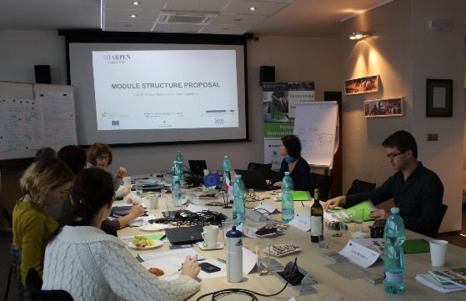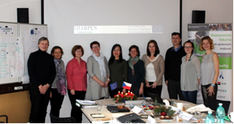
An exciting project is coming to 5 European Universities (Liberec, Zwicka, Kajaani, Klaipeda and Huddersfield)!
If you are interested in people management topics, and like to know more about Small Medium-size Enterprises (SMEs), this would be a super interesting learning opportunity for you!

SHARPEN stands for ‘SMEs HRM Attraction, Retention and Performance Enhancement Network'. This is a 3-year project starting 1st September 2016 to the 31st August 2019 funded by the Erasmus+ Strategic Partnerships for Higher Education projects. The project consists of 5 partner institutions, namely Kajaani University of Applied Sciences (KAMK) Finland, Technical University Liberec (TUL) Czech Republic, Zwickau Westachsische-Hochschule (ZUAS) Germany, The University of Huddersfield (UoH) the United Kingdom and Socialiniu Mokslu Kolegija Klaipeda (SMK) Lithuania.
Many SMEs in the home region of the institutions are facing similar challenges about human resource management (HRM) issues. Thus, the primary objectives of this project is to leverage on the people management knowledge, experiences and competencies of all the partner universities to develop a specialization course using technology, innovative delivery methods, and creative resourcing through unique, interactive learning activities. Also, the project supports the attunement of curricula to the current and emerging labor market needs in the partner regions through research collaboration with a handful of key business organizations such as the Chambers of Commerce, Entrepreneurs Association, and local SMEs. The project also aims to increase the digital proficiencies, cultural and language competencies of the partner institutions, both staff and students to better fit in today’s globalized and digitalized economy. The partners will join forces to develop an e-learning module which is divided into three phases.
MODULE of HRM in SMEs - Phase 1 of the module is run simultaneously across five partner universities, teaching similar syllabus through virtual courses, video lectures, webinars, contact hours and independence studies. In phase 2, five outstanding participants will have a chance to participate in the ‘Intensive Study Program’ (ISP) in one of the partners university location where all representatives from different universities will meet and participate in workshops, cultural activities, seminars to deepen their knowledge based on the information developed in the first phase. During the ISP, cross-border project teams will be formed and they will continue to work together from their respective location to produce practical tools which the project team hopes will bring insights and effective solutions that will improve the process or knowledge of the SMEs in the aspect of human resource management as the final output for Phase 3. In this way, the students will have in-depth knowledge about SMEs, and deeper knowledge about HRM topics and the application with hands-on experiences. The students will also gain more awareness to manage people more effectively in SMEs and multi-cultural environments.
Not only is to support students, but also to develop cooperation with SMEs and local authorities the aim of our project. An intensive 3 years work should lead to creation of e-Handbook for SMEs as well as carry out a survey and research with the aim to provide unique comparable international set of data on specifics of HR processes in SMEs in project partner´ countries to help understand this environment and develop tools to help SMEs attract perspective employees.

