1. Introduction to HRM and Specific Aspects of SMEs

The aims of the section are to:
- Introduce HRM: main approaches, processes, current issues etc. (framework/overview).
- Explain trends in globalisation, digitalisation and demographic developments.
- Present specific aspects of SMEs compared with large companies (qualitative aspects).
- Emphasise the special contexts of HRM in the five SHARPEN project regions and the special situation of regional SMEs.
- Explain particular aspects of HRM and performance in SMEs.
- Provide quantitative data on HRM for SMEs (specifics from SHARPEN research).
- Introduce a SHARPEN research case study about on-boarding processes for a student activity.


Key words
Human resource management, trends, specific aspects of SMEs, corporate social responsibility, human resource strategy, performance.

Required knowledge
Knowledge of basic human resource management terms.

Time requirements
Total time recommended to study this chapter: 1.5-2 hours.

Contents
Introduction to Human Resource Management 3
Defining Human Resource Management 3
Important activities covered by Human Resource Management 3
Aims of Human Resource Management 4
HRM - special aspects in SMEs 4
HRM: Approaches, processes, current issues etc. 5
Trends in globalisation, digitalisation and demographic developments 6
Specific aspects of SMEs compared to large companies (qualitative aspects) 7
The special contexts of HRM in the five SHARPEN project regions and the special situation of regional SMEs 9
Specifics of HRM and Performance in SMEs 10
HRM and performance management: special aspects in SMEs 11
HRM for SMEs in numbers (specifics from SHARPEN research) 11
SHARPEN research case study 14
Company information - Lasertac AG 14
Your task: 14
Summary 16
Section review questions 17
Video links 17
Dictionary 18
Further Reading 20


Introduction to Human Resource Management
Human Resource Management (HRM) refers to a collection of policies used to organise work in the employment relationship. It centres on the management of work and the management of people who undertake this work. Despite its universal application in companies, there is still no universally agreed definition of its meanings (Beardwell & Thompson, 2017). It also includes the management of people who are not in paid employment in the workforce such as volunteers.

Defining Human Resource Management
Human resource management can be defined as a strategic, integrated and coherent approach to the employment, development and well-being of the people working in organizations (Armstrong & Taylor, 2014). Another definition is offered by Banfield, Kay & Royles (2018: 429) who describe HRM as “a late twentieth-century approach to the management of employees, which sees people as a key organizational resource what needs to be developed and utilized to support the organization’s operational and strategic objectives”.

Important activities covered by Human Resource Management
Human Resource Management covers many different activities. Examples are Ethics, Recruitment, Diversity management and strategic positioning. The variety of activities is visualised in Figure 1 (Foot, Hook & Jenkins, 2016).
Figure 1. HRM activities
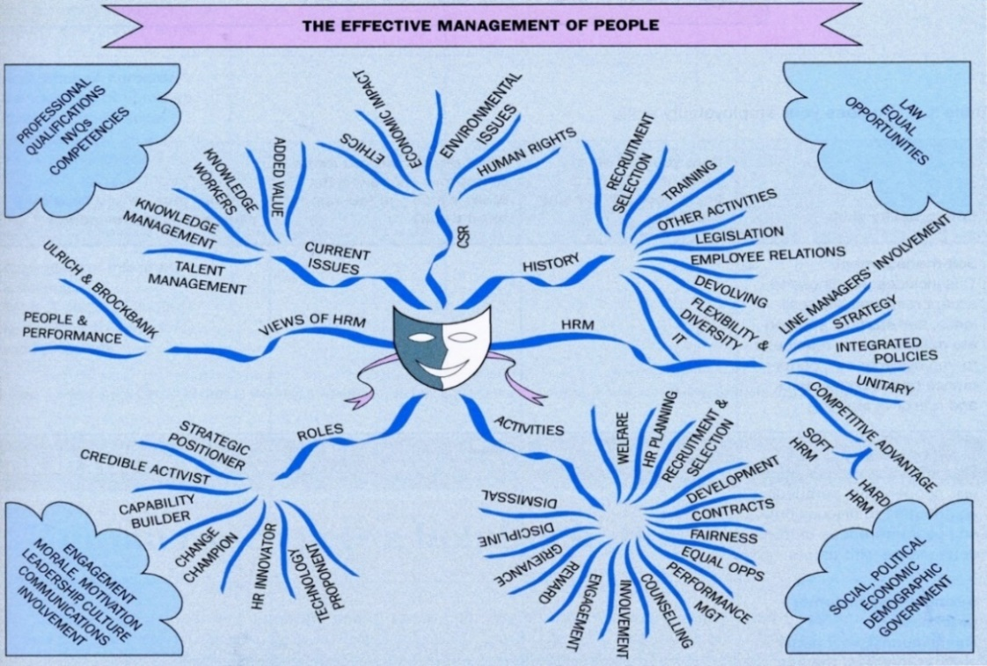
Source: Foot, Hook & Jenkins (2016)
Some of the most important activities can be seen in Figure 2 (Armstrong & Taylor, 2014).
Figure 2. Important HRM activities

Source: Armstrong & Taylor (2014)

Aims of Human Resource Management
The main aim of HRM is to support the organisation in achieving its objectives by developing and implementing human resource (HR) strategies that are integrated with the business strategy (strategic HRM) (Armstrong & Taylor, 2014).
Other important aims are contributing to the development of a high-performance culture, ensuring that the organization has the talented, skilled and engaged people it needs, creating a positive employment relationship between management and employees and a climate of mutual trust and encouraging the application of an ethical approach to people management. (Armstrong & Taylor, 2014)

HRM - special aspects in SMEs
- HRM in SMEs is usually performed by the owners or senior managers
- SMEs usually do not have a lot of internal HR expertise or skills
- As organisational size increase, HR becomes more formalised and the presence of an HR department is more likely (Prouska & Psychogios, 2019)

HRM: Approaches, processes, current issues etc.
The matching model of HRM illustrates the different aspects that must be considered in a company (see Figure 3). The company itself must match its mission and strategy with the organisation structure and Human resource management. However, there are also outside factors that must be kept in mind, namely political forces, economic forces and cultural forces (Beardwell & Thompson, 2017).
Figure 3. The matching model of HRM
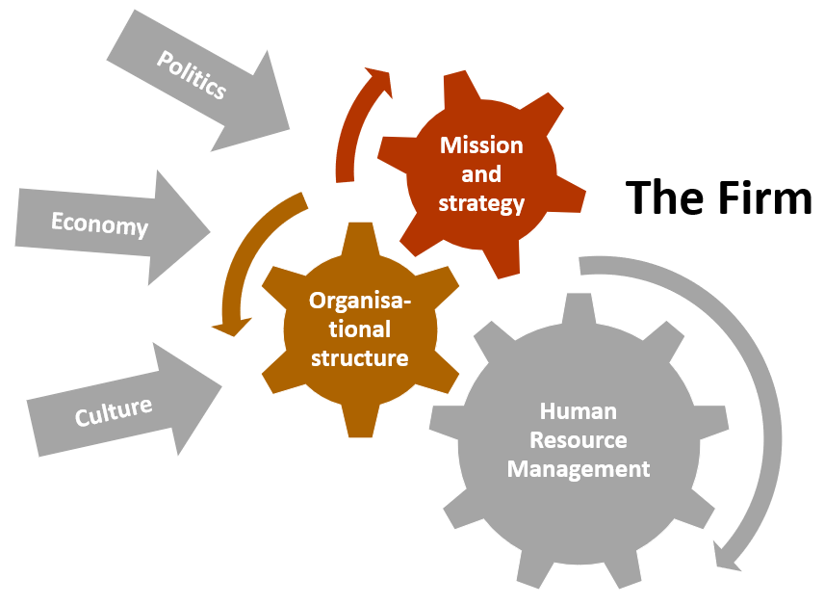
Source: Beardwell & Thompson (2017)
The Bath People and Performance model also shows the complexity of HRM in companies. It illustrates how commitment, motivation and satisfaction are impacted by different factors (see Figure 4). Factors can originate from a wide range of areas such as work-life balance and recruitment processes (Beardwell & Thompson, 2017).
Figure 4. The Bath People and Performance model
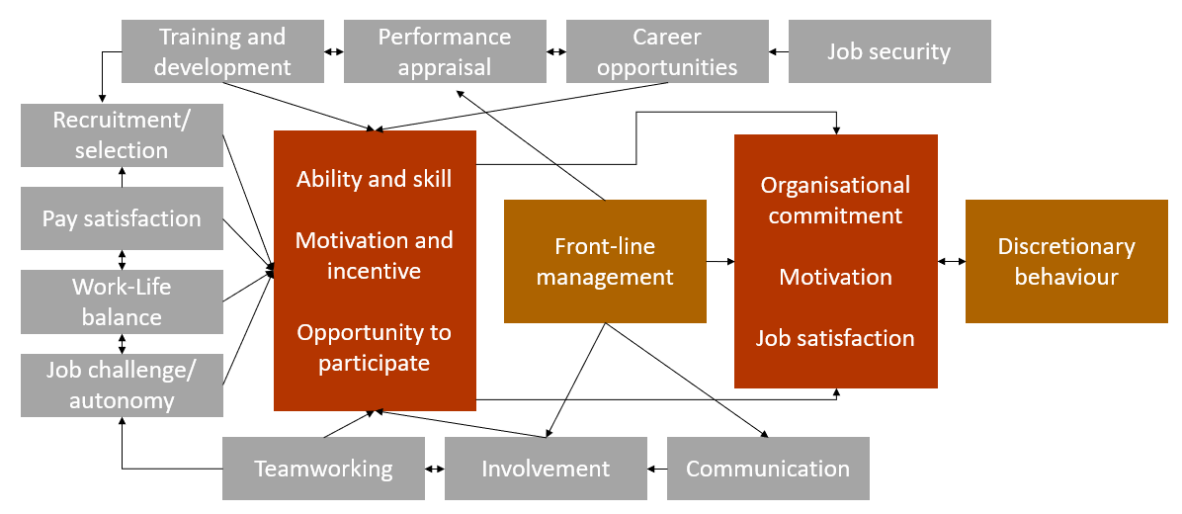
Source: Beardwell & Thompson (2017)

Trends in globalisation, digitalisation and demographic developments
Megatrends in HRM are trends shaping work and working lives all over the world. Some megatrends are de-industrialisation, globalisation, changing employment relationship and demographic change CIPD (2019). Often these (mega)trends can be categorised into demography, scarcity of resources, globalisation, digitalisation and change of values. Figure 5 illustrates how these categories influence one another.
Figure 5. Trends impacting trends
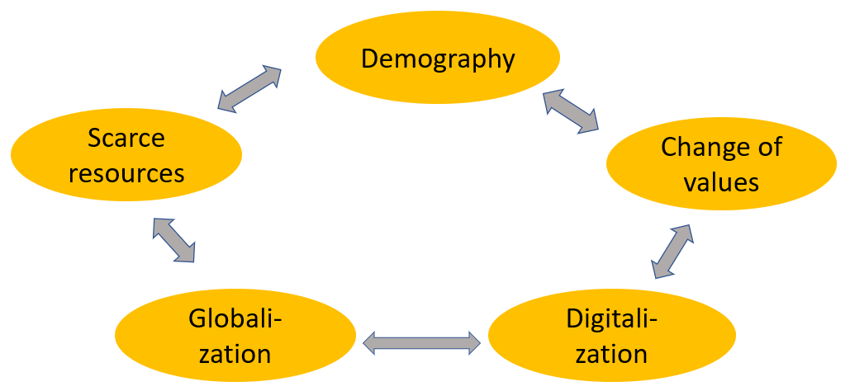
Source: Own elaboration
Globalisation trends concern culture, environment, economy, politics, and society while digitalisation trends refer to new information technologies, marketing, sales and service, innovation and product development, organisation, change and leadership and Industry 4.0. Maybe there could even be Human Resources Management 4.0 in the future?
Demographic and migration trends in Europe encompass aging, a shrinking population and the development that few young people are funding the pensions and healthcare of many old people. Migration usually takes place from the countryside to cities. The change of values is shown in Figure 6 and concern group values, individual values and societal values. As values change it is important to note that they vary between different generations as can be seen in detail in Table 1 (Kriegler, 2012).
Figure 6. Changing values: group values, individual values and societal/community values
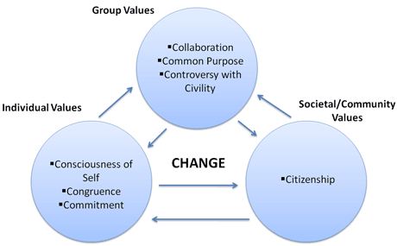
Source: University of Wisconsin (2019)
Table 1. Different values in different generations
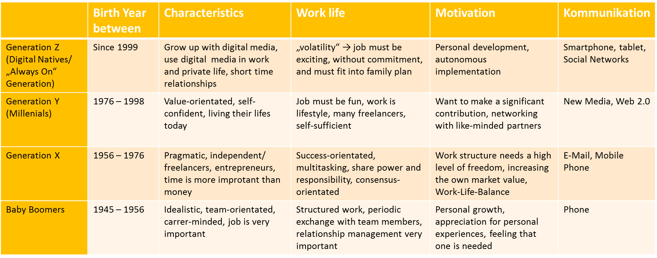
Source: Kriegler (2012)
Limited or scarce resources also influence HRM and other trends such as demography. Examples for limited resources are energy / fossil fuels, natural resources, young, well-qualified human resources, water / fresh air and food.

Specific aspects of SMEs compared to large companies (qualitative aspects)
The definition of SMEs by the EU can be seen in Table 2. Enterprises are divided in three magnitudes:
- Microenterprises: Less than 10 employees and an annual balance sheet with a maximum of two million Euro or a maximum of two million Euro of the company’s annual turnover.
- Small enterprises: Less than 50 employees plus an annual balanced sheet and an annual turnover with a maximum of 10 million Euro.
- Medium-sized enterprises: less than 250 employees and an annual balance sheet with a maximum of 42 million Euro or a maximum of 50 million Euro of the organisation’s annual turnover (OECD, 2005).
Table 2. EU definition of SMEs
Enterprise category | Staff headcount | Turnover | or |  | Balance sheet total
Medium-sized | < 250 | ≤ € 50 m |  | ≤ € 43 m
Small | < 50 | ≤ € 10 m |  | ≤ € 10 m
Micro | < 10 | ≤ € 2 m |  | ≤ € 2 m
Source: European Commission (as cited in Komulainen et al., 2019)
According to Wapshott & Mallett (2015), people management models mainly consider large firm experience in HRM as typical and rarely talk about the SME perspective. We need to understand that SMEs are different in order to have a complete understanding of current employment relationships and practices (Wapshott & Mallett, 2015).
In some SMEs, HRM does not appear to exist. When the first HR manager in an SME is appointed, how do they encourage the owner-manager or whoever was responsible for HR to loosen the reins? How will they ensure formal systems are implemented without alienating line managers? Through key working alongside them, drafting policies for managers to adapt (Wapshott & Mallett, 2015).
The specific qualitative characteristics of SMEs compared with large companies can also be seen in Table 3. Characteristics often associated with SMEs are a high degree of informality which can exist in various ways when it comes to the employment relationship and practices, e.g. an ad-hoc way of organising tasks, spatial and social proximity (managers and employees may share a workspace and often there is a greater degree of familiarity). SMEs might also suffer from resource poverty (considering that SMEs often do not have the resources of large companies - "resource poverty" describes the challenges faced by SMEs in particular, and is a regular theme of understanding these companies) (Wapshott & Mallett, 2015).
Table 3. Specific qualitative characteristics of SMEs
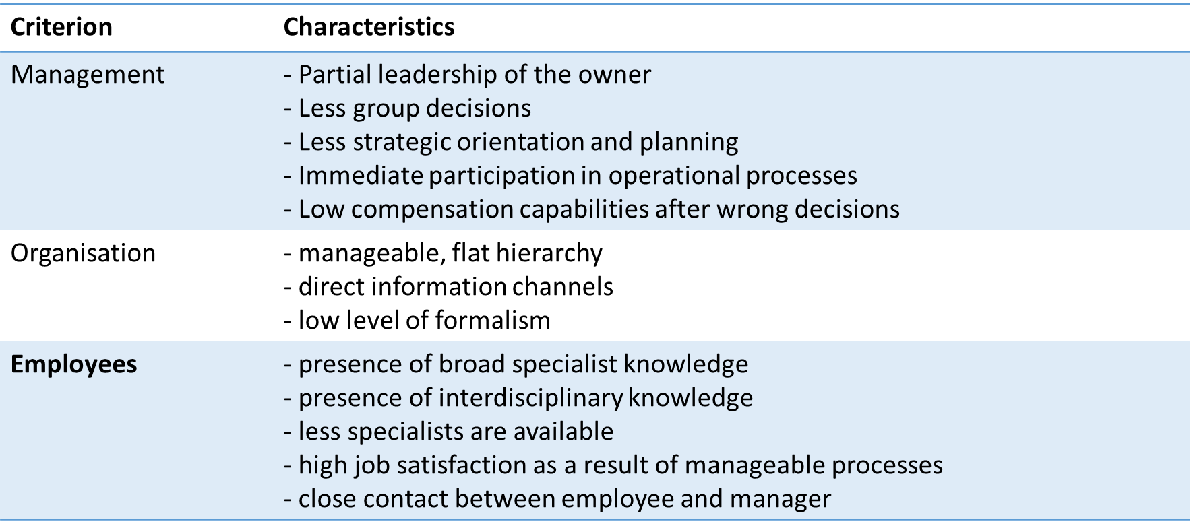
Source: Bergman & Crespo (2009)

The special contexts of HRM in the five SHARPEN project regions and the special situation of regional SMEs
The five regions involved in SHARPEN illustrate similarities and differences shown in Table 4.
Table 4. Regional similarities and differences of SHARPEN project SMEs
Similarities | Differences
(highly) industrialised: many SMEs (with available jobs) | SMEs of different sizes (e. g. in Germany there is a very large number of SMEs with more than 200 employees)
Demography: shrinking and aging population | economic structure (very diverse sectors)
Big distance to metropolitan centres | Structure of skilled employees (different numbers of highly qualified specialists)
Universities with many students (Generation Y) | Historical development of SMEs
Emigration of students after graduation
Source: own elaboration
Regional challenges are impacting companies and employees in different ways:
- increasingly differentiated requirements of domestic and foreign customers for products and services
- growing international division of labour and collaboration
- need to develop even more specialised technical knowledge and experience
- new requirements for linguistic, social and cultural competences among enterprises and human resources
- significantly negative value between young professionals and employees who drop out on account of ageing in Saxon enterprises.
There are also reasons for the increasing demand for qualified employees:
- rapid scientific-technical development
- growing requirements of international markets
- effects of the induced ‘demographic trap’ by the structural change after 1990
- growing, world-wide competition for the best brains
- high specialisation in many SMEs
- profound societal changes regarding technical understanding, career choice and ethical concepts.
Overall, it becomes clear that the regions involved in the SHARPEN project have both similarities and differences.

Specifics of HRM and Performance in SMEs
Armstrong & Baron (2004) refer to performance management as an HRM strategy relating to the various organisational activities (HRM policies, culture, style and communications systems). The strategy depends also on the company culture. The performance cycle and principle activities of performance management are shown in Figure 7. Principal activities are: communicating a shared vision of the purpose of the organisation, defining expectations of what must be delivered and how, ensuring that employees are aware of what height performance means and how they can achieve it, enhancing levels of motivation an enabling employees to monitor their own performance and understand what needs to be done to improve their overall level of performance (Beardwell & Thompson, 2017).
Figure 7. Performance cycle and key activities of performance management

Source: Beardwell & Thompson (2017)
SMEs can use and communicate the above-mentioned characteristic features to their advantage in terms of performance by emphasizing their special characteristics offered to employees, e.g.
- Communicate family working atmosphere internally and externally to attract and retain young candidates (corresponds to an important value of generation Y).
- A high degree of informality enables creative work and increases motivation.
- Flat hierarchies enable interdisciplinary work.
- Innovative ideas of employees can be implemented more quickly.
All characteristics of SMEs for all HRM tasks must be considered in the development of the HR strategy as there are limited resources available, in recruiting due to the importance of establishing employer brand and in pay and reward management e.g. by including non-financial rewards to stay competitive.

HRM and performance management: special aspects in SMEs
SMEs can use and communicate the characteristic features by emphasizing their special characteristics offered to employees, e.g.
- Communicate family working atmosphere to attract and retain young candidates
- A high degree of informality enables creative work and increases motivation.
- Flat hierarchies enable interdisciplinary work.
- Innovative ideas of employees can be implemented more quickly (Prouska & Psychogios, 2019).
All characteristics of SMEs for all HRM tasks have to be considered!
- in the development of the HR strategy limited resources available
- in recruiting importance of establishing employer brand
- in pay and reward management include non-financial rewards to remain competitive (Prouska & Psychogios, 2019).

HRM for SMEs in numbers (specifics from SHARPEN research)
During the SHARPEN project, SMEs from all the five observed countries were asked about their HRM approach. According to the results depicted in Figure 8, the availability of HR departments in SMEs varies from country to country. SMEs in Finland (6%) and the Czech Republic (18%) have the lowest percentage of SMEs with HR departments, compared to the UK (33%), Lithuania (45%) or Germany (54%).
Figure 8. Does your organisation have an HR department?
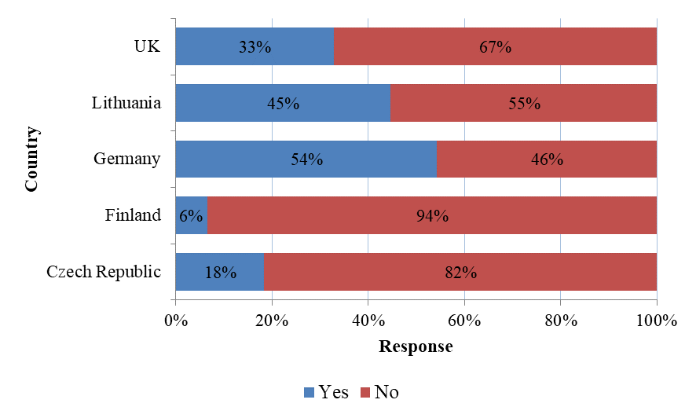
Source: Maršíková et al. (2019)
This observation partly relates to the number of employees of the SMEs (see Figure 9). The countries with the lowest percentage of SMEs equipped with HR departments also have the highest percentage of SMEs employing only up to nine staff. These are namely Finland, the Czech Republic and Lithuania. These countries also appear to have less medium-sized SMEs (employing 50 to 249 staff), with percentages ranging from 7% (Finland) to 34% (Czech Republic).
Figure 9. How many staff (Full Time Equivalent) do you employ in your organisation?
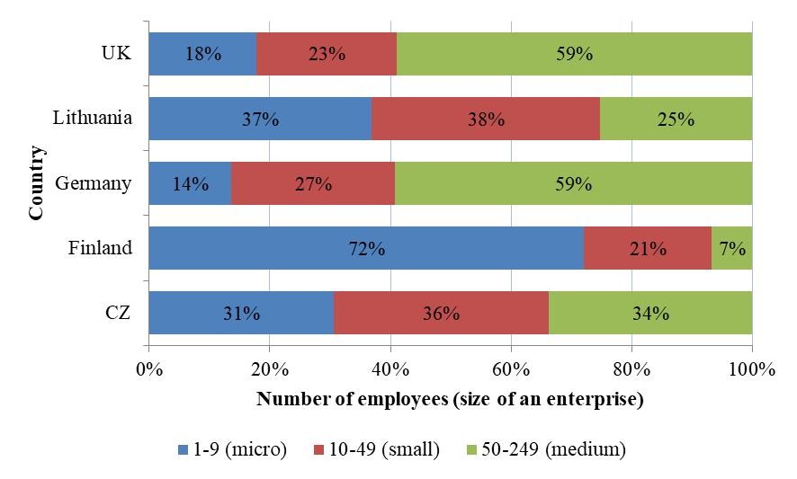
Source: Maršíková et al. (2019)
According to the SHARPEN research, the administrative HRM tasks in SMEs are mostly performed by the business owner or an HR specialist (see Figure 10). Sometimes HRM administration is also done by line managers, accountants or administrative workers. The distribution of HR administrative work varies somewhat between the surveyed countries. However, a general pattern of who mostly performs HRM administration can be observed.
Figure 10. Who performs HRM administration in your organisation?
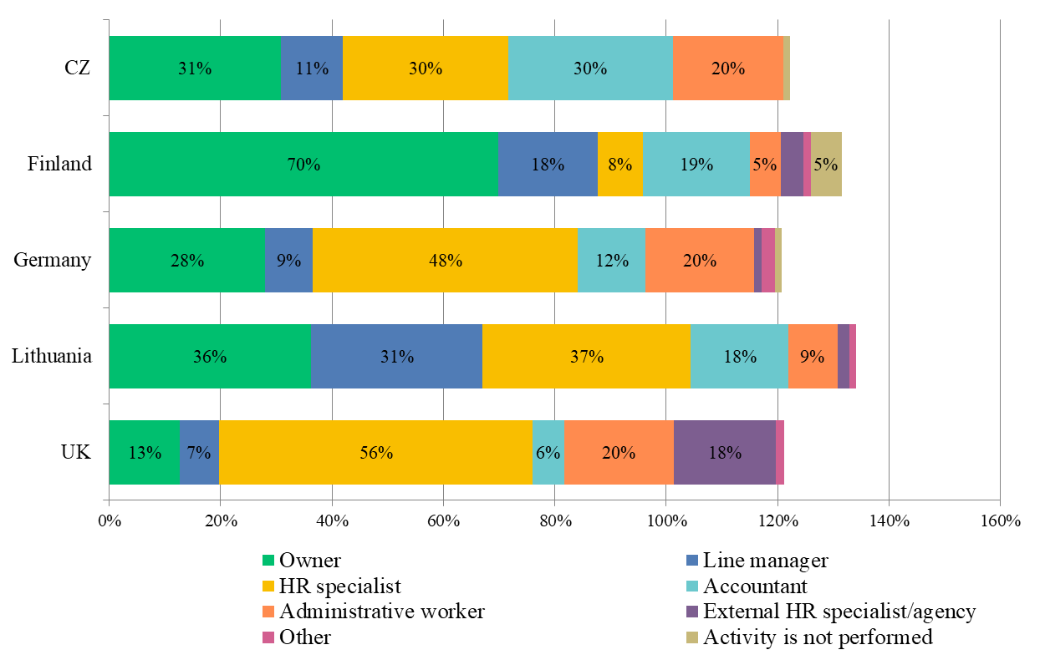
Source: Maršíková et al. (2019)
Note: respondents could choose more than 1 option
In general, the most relevant HRM activities for SMEs seem to be HR administration, employee recruitment and selection, induction processes (e.g. welcome packages for new employees), reward management and employee satisfaction and engagement. Activities rated as less important for SMEs included Using personnel information systems, monitoring KPIs (key performance indicators) in HR, career management and employee termination.
You can find more information about the SHARPEN research in our research publication:
Maršíková, K., Rajander, T., Clauß, A.-M., Medžiūnienė, I., Meschitti, V., Štichhauerová, E, Davies, J., Dulkė, D., Komulainen, R., Macháčková, V., Richter, M., Schumann, C.-A., Moš, O., & Forkel, E. (2019). People management challenges for SMEs in five European regions: Spotlighting the (in)visible and the (in)formal and embedding SME HR issues firmly in
the business and knowledge environment. Huddersfield, UK: University of Huddersfield. ISBN: 978-1-86218-168-7
Link: https://sharpen.ef.tul.cz/upload/PublicationHRMinSMEs_research.pdf

SHARPEN research case study
This case study describes an HR issue relating employer branding in a medium-sized enterprise in Saxony, Germany. The research problem is to find ways how a regionally attractive employer can also become attractive on the international labour market and what contribution HR in the company can make to this. The case study aims at establishing a process to help SMEs on-boarding international employees.
The practical part of this case study focuses on applying theoretical HR knowledge to the case study company and to establish a step-by-step instruction for an ideal on-boarding process.

Company information - Lasertac AG
- SME located in a city of Saxony, Germany
- team of specialists who develop machinery, processes and systems at the highest technical and technological level
- systems have been effectively implemented in different high-tech industries worldwide
- 190 employees
- average age of the employees is 36.5 years
- Organisational structure: hierarchal relationship where the CEO is the head of the organisation, Head of Human Resource Management supervised by the CFO, two employees working in the HR-department.

Your task:
The company struggles with keeping contact between the signing of the contract and the first working day, especially when it comes to the contact between the company and foreign employees, which has to be improved.
Specific HR need for the company:
Successful on-boarding
Keeping in contact between signing of the contract and first day of work
Findings and solutions: On-boarding
After the process of recruitment and the final decision for an applicant after several job interviews, it is very important to put effort into keeping contact with future employees. The aspect of keeping in contact with the employees can be depicted in the following model (see Table 5).

Table 5. Introduction of new employees
Successful on-boarding
First Phase:  After signing  the contract and before the  first working day | Second Phase:  The first working day | Third Phase:  Probation and induction
• Preparation of the  working place  • Keeping in contact  with the employee  • Delivery of current  information | • Offer orientation  • Offer information  • Offer mentoring system | • Construct induction  plan  • Regular Feedback  • Coaching, Training,  Mentoring,  Evaluation
Source: Stein (2015)
According to this model, keeping in contact is part of phase one of the on-boarding process. Positive working relations between employees and employer already start after the signing of the contract. On one hand, it is necessary and a matter of politeness to inform the applicant that was not chosen for the job, of the declination. On the other hand, the applicant who is best suited for the job needs to be informed and provided with the most important information about the workplace he or she will be working at, including contracts, certificates or time schedules, to influence the employee and the future working atmosphere positively. This exchange of information takes place through many different platforms. These aspects will make the employee feel more confident, when starting the new job, which can always just benefit the company, the co-workers and the Human Resource Department. Only with effective preparation of both, employers and employees, can a satisfactory employment relationship start.

Summary
- Presently, many European countries (as well as the Federal State of Saxony) are facing similar demographic developments that will provoke fundamental changes in the respective labour markets in years to come.
- This situation will especially affect small and medium-sized enterprises (SMEs) that are based in rural regions with rapidly increasing numbers of retirees and an equally rapidly shrinking population of young people.
Necessary: Increase the attractiveness of SMEs as an employer for the young generation
- The available theoretical HRM approaches and models are suitable for the conditions in large companies. However, SMEs are not "small" large enterprises, but they have specific characteristics that affect all HRM processes.
- Characteristics that can be developed into advantages for SMEs (especially regarding the young generation) include a positive working atmosphere, close cooperation between supervisors and employees, flat hierarchies and a high degree of flexibility in the implementation of innovations.
- HR Management varies from one SME to another and depends very much on the regional context. An SME in a metropolitan region needs a different approach to HRM than one in a rural region.
- That is why the student project tasks are the core of our project. Students select a regional SME and describe the context of this SME, its internal constraints and, above all, the specific needs of HR Management in this SME. On this basis, students apply their theoretical HRM knowledge by modifying HR approaches and models for this selected SME.

You can find more practical information and advice in our publication:

Komulainen, R., Maršíková, K., Davies, J., Srėbaliūtė, I., Clauß, A.-M., Moš, O., Muschol, H., Rydvalová, P., Forkel, E., & Štichhauerová, E. (2019). A Good Practice Guide to Managing Human Resources in Regional SMEs. Huddersfield, UK: University of Huddersfield.
ISBN: 978-1-86218-167-0
Link: https://sharpen.ef.tul.cz/upload/HRM4SMEs_Handbook.pdf


Section review questions
- How can HRM be defined and what important activities does it cover?
- What are the aims of HRM?
- How do globalisation, demographic development and digitalisation affect HRM?
- What impact do the changing values of different generations have on HRM in SMEs?
- What are important expectations of graduates on their first job after graduation?
- What are the specific qualitative characteristics of SMEs (compared to large companies)?
- Which characteristics are often associated with SMEs by Wapshott and Mallett?
- What are the similarities and differences in the five regions of the SHARPEN project?
- What impact do the changing conditions have on companies and employees in your region?
- What are the reasons for the increasing demand for qualified employees?
- Which of their characteristics can have which advantages for performance management in SMEs?

Video links
About SHARPEN project. Link: https://www.youtube.com/channel/UC4vBKU4RFtRtjISaBrTBjlA
SHARPEN. Managing people in small business. Link: https://www.youtube.com/watch?v=RRUKMQKc9fU

Dictionary
Employer Brand (EB) | The image of the organisation that comprises unique attributes depicting it as a great place to work in the minds of current employees and key stakeholders.
HR Marketing | Human Resource Marketing, also personnel marketing. Using marketing techniques to attract new employees.
HRM/ Human resource management | Human resource management is the process (practice) of recruiting, hiring, deploying and managing an organisation's employees in compliance with labour laws of the land.
SME/Small and medium-sized enterprises | SMEs are businesses whose staff headcount (number of employees) fall below certain limits and fulfils also other criteria (EU criteria are mentioned in the beginning of this chapter).
Strategic objectives | The specific financial and non-financial objectives and results an enterprise aims to achieve over a specific period of time. Also called organisational goals.
Strategic planning | Strategic planning is an organisational management activity that is used to set priorities, focus energy and resources, strengthen operations, ensure that employees and other stakeholders are working toward common goals for long-term sustainability.


References
Armstrong, M. & Taylor, S. (2014). Armstrong’s handbook of human resource management practice (13th ed.). London, United Kingdom: Kogan Page.
Armstrong, M. & Baron, A. (2004). Managing Performance: Performance Management in action (Developing practice) (2nd ed.). London, United Kingdom: CIPD, Kogan Page.
Banfield, P., Kay, R. & Royles, D. (2018). Introduction to human resource management (3rd ed.). Oxford, United Kingdom: Oxford University Press.
Beardwell, J. & Thompson, A. (2017). Human Resource Management: A contemporary Approach (8th ed.). Harlow, United Kingdom: Pearson.
Bergman, L. & Crespo, I. (2009). Einfluss der Merkmale und Eigenschaften kleiner und mittlerer Unternehmen auf die Modernisierung. Berlin, Deutschland: Springer.
CIPD. (2019). Megatrends. A focus on the key trends shaping our economies and the world of work. [cit. 2019-07-14]. Retrieved from: https://www.cipd.co.uk/knowledge/work/trends/megatrends.
European Comission. (2019). What is an SME? [cit. 2019-07-28]. Retrieved from: http://ec.europa.eu/growth/smes/business-friendly-environment/sme-definition_de.
Foot, M., Hook, C. & Jenkins, A. (2016). Introducing Human Resource Management (7th ed.). Harlow, United Kingdom: Pearson.
Komulainen, R., Maršíková, K., Davies, J., Srėbaliūtė, I., Clauß, A.-M., Moš, O., Muschol, H., Rydvalová, P., Forkel, E., & Štichhauerová, E. (2019). A Good Practice Guide to Managing Human Resources in Regional SMEs. Huddersfield, UK: University of Huddersfield.
Kriegler, W. R. (2012). Praxishandbuch Employer Branding - mit Arbeitshilfen online: Mit starker Marke zum attraktiven Arbeitgeber werden. Freiburg im Breisgau, Deutschland: Haufe Lexware.
Maršíková, K., Rajander, T., Clauß, A.-M., Medžiūnienė, I., Meschitti, V., Štichhauerová, E, Davies, J., Dulkė, D., Komulainen, R., Macháčková, V., Richter, M., Schumann, C.-A., Moš, O., & Forkel, E. (2019). People management challenges for SMEs in five European regions: Spotlighting the (in)visible and the (in)formal and embedding SME HR issues firmly in the business and knowledge environment. Huddersfield, UK: University of Huddersfield.
OECD. (2005). Small and Medium-Sized Enterprises (SMEs). [cit. 2019-07-11]. Retrieved from: https://stats.oecd.org/glossary/detail.asp?ID=3123.
Prouska, R., & Psychogios, A. G. (2019). Managing People in Small and Medium Enterprises in Turbulent Contexts (1th ed.). Oxford, United Kingdom: Routledge.
Stein, G. (2018). Einarbeitung neuer Mitarbeiter: Das 3-Phasen-Modell. [cit. 2019-07-14]. Retrieved from: https://www.wirtschaftswissen.de/personal-arbeitsrecht/mitarbeiterfuehrung/fuehrungsinstrumente/einarbeitung-neuer-mitarbeiter-nach-dem-3-phasen-modell/.
University of Wisconsin. (2019). Social Change Model. [cit. 2019-07-01]. Retrieved from: https://www.uwsp.edu/centers/CASE/pages/leadership/social-change-model.aspx.
Wapshott, R. & Mallett, O. (2015). Managing human resources in small and medium-sized enterprises: Entrepreneurship and employment relationships. London, United Kingdom: Routledge.

Further Reading
Devi, R. B. & Banu, V. P. (2014). Introduction to Recruitment. SSRG International Journal of Economics and Management Studies, 1(2), 5-8. [cit. 2019-07-24]. Retrieved from: http://www.internationaljournalssrg.org/IJEMS/2014/Volume1-Issue2/IJEMS-V1I2P102.pdf.
Dowling, P. J., Festing, M. & Engle, A. D. (2017). International Human Resource Management (7th ed.). Hampshire, United Kingdom: Cengage Learning EMEA.
TechTarget. (2017). Essential guide: TechTarget. [cit. 2019-07-22]. Retrieved from: http://searchfinancialapplications.techtarget.com/essentialguide/Talent-management-systemessential-guide.

The project has been funded by the Erasmus + KA2 Strategic Partnership programme. Project agreement number: 2016-1-CZ01-KA203-023916.

Legal notice:
The views expressed in this publication are the sole responsibility of the authors and do not necessarily reflect the views of the European Union, of the ERASMUS programme national agencies nor of the project partner universities. The Union, the national agencies and the universities are not liable for any use that may be made of the information contained therein.

