
2. Strategic Workforce Planning and People Resourcing in Regional SMEs
This section aims to:
- stimulate discussions about strategic workforce planning and people resourcing in small regional firms.

- highlight the need for professional HR practices in regional and ethnic minority small enterprises (EMSEs) to support local growth, social inclusion, and the quality of working life with decent work.

Keywords

Strategic workforce planning; people resourcing; professionalisation; growth; regional development; ethnic minority small enterprises (EMSEs).

Required knowledge
Knowledge of basic terms in human resource management and human resource development which can be applied in regional small business contexts.


Time requirements
Total time recommended to study this chapter: 1.5 hours.

Contents
Introduction 3
Strategic Workforce Planning (SWP) in Regional SMEs 3
What is strategic workforce planning and how is it aligned to organisational strategy? 4
Why does workforce planning matter? 4
What are the processes involved in workforce planning? 4
People Resourcing in Regional SMEs 6
Results from the SHARPEN survey 10
Summary 12
Section review questions 13
Video links 13
Dictionary 14
Case studies 15
References 18


Introduction
The purpose of this chapter is to provide an overview of effective strategic workforce planning and people resources to sustain small and medium-sized enterprises (SMEs). We recommend a contingency rather than best practice approach. This suggests that tools and concepts used in large firms need to be adapted to small businesses – there is not necessarily a universal approach.
In particular, we explore the need for strategic workforce planning to align HR plans with business and other functional strategies and to reflect on how people are resourced and developed. Although HR in SMEs is typically characterised as informal and ad hoc, we encourage SMEs to network with professional bodies and universities to develop professional policies and practices to comply with employment law and national regulations. This way, individuals can learn from research studies on HRM in SMEs and the latest thinking, for example on different models, ethics, and social inclusion and the rapid growth of EMSEs (ethnic minority owned/managed small enterprises) in some regions.
We encourage a broad view of the workforce and employment relations in SMEs. This should include older workers, apprentices, volunteers, interns, contract staff, refugees and other non-traditional workers. In this chapter, we consider the benefits and limitations of working in regional SMEs. It is important to understand the challenges for individuals who are responsible for HR strategy, policies and practices, and day-to-day administration, especially in organisations where there are limited resources and regional constraints.
SMEs are very important for the creation of jobs and the development of local, regional, and national economies. Ethnic minority owned SMEs in the UK are growing faster than other SMEs. New university graduates, however, often prefer to work in the capital city and hope to work in large firms, e.g. FAANGs – Facebook, Apple, Amazon, Netflix, Google – rather than for an SME.

Strategic Workforce Planning (SWP) in Regional SMEs
Beaver & Hutchings (2005) argue that SMEs that take a strategic approach to human resource development benefit competitively in the marketplace from being more adaptive to change and external uncertainties. Strategic workforce planning (SWP) is the process to identify the gaps between today’s and tomorrow’s workforce needs using accurate and relevant analytics. It involves data-driven decision-making to inform priorities to ensure that the right people with the right skills are in the right place at the right time. SWP is vital for the long-term sustainability of an organisation, particularly SMEs which may be vulnerable to the loss of key employees and their intellectual capital. This can result in a precarious financial predicament for an SME (Durst & Wilhelm, 2012).
This section looks at the what, why, and how of workforce planning in SMEs. It considers tools, drivers, potential obstacles and key success factors. SWP needs to be predictive, not just descriptive, and responsible and responsive.

What is strategic workforce planning and how is it aligned to organisational strategy?
Workforce planning is about systematically identifying current and future resource needs to help an organisation achieve its goals competitively and adaptively. In a small organisation, managers may be too busy to do this formally. The lack of a people strategy, however, may result in strategic drift and make the organisation vulnerable to the loss of key talent and knowledge and not be able to manage uncertainties, staffing costs and opportunities. Motwani et al. (2006) recommended that irrespective of their size, family-owned businesses should develop a formal succession plan for the CEO, however, Sambrook (2005) explored reasons why planning voluntary succession is difficult. Many organisations in the West are facing demographic challenges with ageing workforces.

Why does workforce planning matter?
Ad hoc, reactive recruitment and selection processes, just replacing someone who leaves automatically without reviewing the job description and person specification or without questioning whether you need to hire someone at all can result in strategic drift. You need to plan how you recruit, retain and develop people who best fit your organisation and culture. Drivers include the need for budgeting, scheduling and changes in new products and services.

SWP includes succession planning for top managers in your organisation and contingencies for sudden sickness absence as well as seasonal peaks and troughs. Do you need contingent workers, part-time, flexible staff, particular expertise for short-term projects, student interns, apprentices, volunteers? Are you planning to grow your own talent, buy it in, or outsource work? Do you keep in touch with former employees who might work with you again or retirees who might help with mentoring, for instance? Do you monitor employee engagement and are you ready to make a counteroffer if someone is offered a better salary by a competitor? Are you proactively looking to poach talented staff from competitors and suppliers and overseas? Are you prepared to coach people out of the organisation and to reconfigure your workforce if necessary?

What are the processes involved in workforce planning?
What workforce do you need for the future success of your organisation? SMEs may rely on a few critical individuals for their survival. If they suddenly leave, become sick or less productive, this may have serious consequences for all employees. Clearly, you need to take time out to reflect and talk through with others the risks to your business of not having enough people with the right skills, knowledge, qualifications and abilities at the right time and in the right place. Those with responsibility for HRM should be proactive about discussing what is the talent in your organisation, what are their skills, and what skill sets will you need in the future. How do you bring this all together beyond just looking at head count to achieve effective workforce planning strategic?
The five-step model in Figure 1 is a useful framework for SMEs to organise their approach to SWP.
Figure 1. Strategic workforce planning model
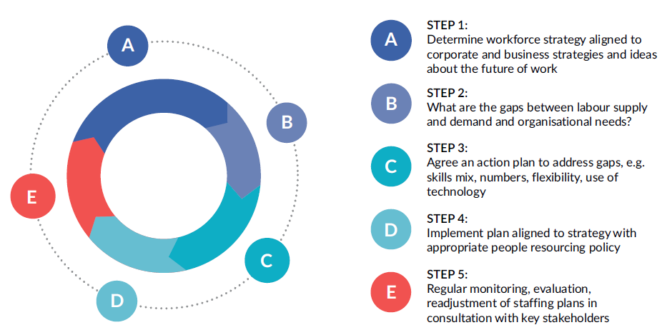
Source: Komulainen et al. (2019)
Regional SMEs should consider the following questions:
(1) What is your organisation’s strategy? This will help shape your people strategy as the corporate and people strategies should be aligned depending, for example, whether there is a focus on growth, downsizing, merger, and internationalisation. For micro-businesses, the question may be do you need to employ someone in addition to yourself? Harrison (2009) observes that many owner-managers of small firms are not aiming for significant growth.
(2) Do you know your workforce? What is the forecast for supply and demand? Collect accurate data to analyse: what are the critical jobs? What are the competences and other data analytics needed? What have been the patterns in the developments of your workforce in terms of hiring, voluntary/involuntary attrition, costs. What is the current labour market? What is the big picture? Then look at the details of specific areas where there may be high or low turnover. Are there issues of people leaving because of poor recruiting, weak line management, or competitors poaching your staff? What is the level of employee engagement and how will you keep staff who might decide to leave?
Consider the current and future demands for your workforce, and the supply for new workers for you to grow and be more efficient and effective. Consult with line managers and produce a grid and a report to identify any people and skills gaps or changes that are needed to support your business plans. Question your assumptions and think creatively about job design.
The following data are worth analysing: Headcount, abilities, skills, knowledge, gender, age and other diversity demographics, talent audit, attrition rates, employee satisfaction, security and engagement, sickness absence rates, intentions to leave, external labour force statistics.
(3) How will you formulate your action plan? Decide who you need to develop, train, redeploy, how you will coach people up or out and hire new employees or contract workers to develop your business goals. How will you develop your pipeline for staff? Consider functional, numerical and adaptational flexibility.
(4) How will you implement your action plan? You need to consider timings and costings to implement your workforce plan and, importantly, how you will do this as obstacles may be presented from staff, unions, employment regulation and a sense of fear about potential job losses or deskilling.
(5) How will you evaluate and revise your workforce plan? You need to do this in the light of on-going developments, clearly aligned to your corporate strategy. Is it valid, relevant and effective? You need to decide how regularly you do this and how it is integrated into corporate planning activities. Are your workforce planning processes effective?
Succession planning is an important issue for all firms due to demographic factors such as the rising number of employees reaching retirement age and the dwindling number of younger workers stepping in to replace them. Small firms can recruit from both internal and external labour markets for junior/middle management roles, but there may be limited numbers of suitable insider candidates. Family firms can also recruit from the family labour market to fill these and executive roles. However, for non-family firms, with no family labour market to from which to hire, identifying and developing successors becomes more acute at the senior level. Key issues include recruiting non family employees or MBA graduates with potential, considering the work/career motives of potential successors and transferring organisational and personal/tacit knowledge from the owner-managers to employed managers or new owners.

People Resourcing in Regional SMEs
People resourcing is about integrating processes that involve recruiting individuals to organisations; managing performance, potential, talent; and releasing individuals from organisations. Different national regions will have different challenges of ageing, depopulation, youth unemployment. It is interesting to reflect on which jobs are future proof and unlikely to be replaced by robots, e.g. health care and education:
https://www.independent.co.uk/news/business/future-proof-careers-what-jobs-survive-future-robots-a8179746.html
Issues of an ageing population are import for regional SMEs to consider as larger firms may attract limited talent: http://visual.ly/ageing-population. The CIPD (2015) Resourcing and Talent Planning report gives some insights into this topic.
Figure 2 shows the key components of people resourcing which need to be integrated. From employee recruitment to termination of employment, effective people resourcing also includes a consideration of the quality of selection, induction, how people in the organisation are rewarded, developed, paid, evaluated and supported for their health and safety, well-being. Conflict and employment relations also need to be managed. Systems may be computerised internally and/or outsourced. Best fit rather than best practice suggests that regulations, policies and practices need to be adapted depending on the context and stakeholders.
Figure 2. Components of effective people resourcing

Source: Own elaboration
Taylor (2002: 1) argues that ‘effective hiring and firing, attracting the best candidates, reducing staff turnover and improving employee performance are fundamental management functions. They are as relevant for a small family business as they are for a major international plc’. Those responsible in SMEs for HRM need to consider the war for talent, changing career patterns, demographics and expectations in different generations and the labour market.
There are different approaches to managing HRM in SMEs, ranging from transactional personnel management (TPM) that is reactive and bureaucratic to strategic approaches that promote change. These approaches depend on resources, expertise, organisational culture and management behaviours (see Figure 3), whether HRM is devolved to line managers or centralised and whether there is a union or employee representative council. Some SMEs share HR services with other SMEs or outsource to a lawyer, in others the CEO or the CEO’s personal assistant are responsible for HR.
Figure 3. A continuum of approaches to managing people in the workplace

Reactive and bureaucratic behaviours |  | Tactical approach |  | Strategic, proactive, innovative
Transactional Personnel Management/Administration |  | HRM | Strategic, Transformational Human Resource Management
Source: Own elaboration
The people resourcing strategy needs to be integrated vertically and horizontally with other strategies in the organisation, as shown in Figure 4.
Figure 4. Employee resourcing activities embedded in corporate and functional strategies

Source: Own elaboration
Time is an important consideration as HR evolves over the life of an organisation and various crises experienced as shown in Figure 5.
Figure 5. Greiner’s organisational growth model
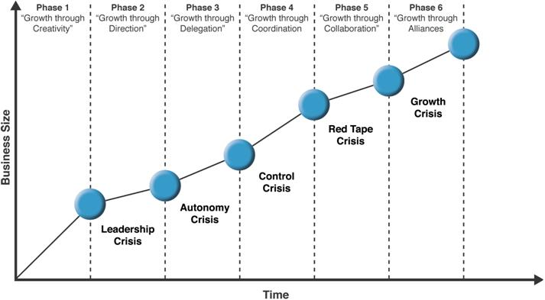
Source: Greiner (1972)
Figure 6 indicates organisational evolution and growth crises in SMEs from their inception through survival, growth and expansion to maturity. These five phases require different approaches to HRM and HRD over time to prevent the organisation from folding and closing.
Managers in SMEs may prefer informal recruitment methods such as word-of-mouth hiring (Carroll et al., 1999). They can be reluctant to use social media and online recruitment tools (Nasreem et al., 2016) which attract a wider pool of candidates and enhance the brand image but are costly in attracting unsuitable candidates and time consuming. Lee (2014) found that high growth SMEs in the UK experienced recruitment problems and skill shortages.
SMEs can be reluctant to employ university graduates (Woods & Dennis, 2009). Yet SMEs provide valuable learning opportunities for university placement students (Walmsley et al., 2006). SMEs benefit from working with local universities (Freeman, 2000) with knowledge transfer and access to government research funding. SME owners/managers need to work with universities to develop business-related skills in university programmes that are relevant to local SMEs (Westhead & Matlay, 2005) and regional needs where firms have local customers.
SMEs may not be progressive in up-skilling current employees (Bowen et al., 2004) and they may be constrained in providing formal training that is not legally required. There is evidence of positive relationships between an organisation’s learning capability and its entrepreneurial orientation (Altinay et al., 2016) and so human resource develop activities are important.

Figure 6. Stages of growth of SMEs
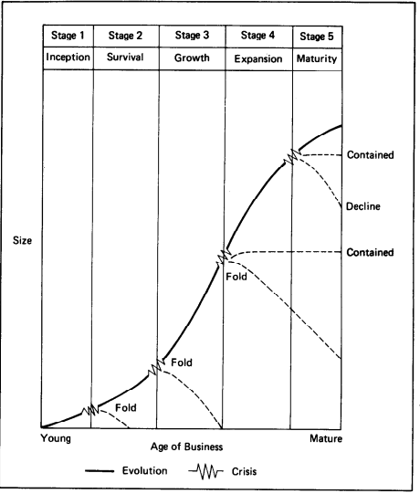
Source: Scott & Bruce (1987, p. 47)

Results from the SHARPEN survey
One of the key aims of the SHARPEN project was to help SMEs to attract and retain members of the younger generation in their region to avoid a talent drain to major cities. This is because of aging populations in mainly western nations, particularly in rural locations, and HR challenges of succession planning which may result in organisational closure because of a lack of skills. It is important for regions to be creative about establishing and promoting favourable conditions for young people to work in and establish local SMEs, to add value and enhance regional competitiveness.

Figure 7. Do SMEs consider employing members of the younger generation?

Source: Maršíková et al. (2019)
Respondents in SMEs were asked if they intended to hire young people over the next three years (see Figure 7). With the exception of Lithuania, we found responses ranging from 81% to 92% by SMEs in four SHARPEN countries.
In Lithuania, the reason for lower intentions (only 45% of respondents) to employ younger workers were identified as:
1) A lack of business confidence in young workers, and, therefore, SMEs not employing them because SMEs consider younger people cannot offer sufficient knowledge, competences because of inadequate specialist training provided by higher education institutions and workplaces.
2) Young people's expectations often exceed business opportunities. For instance, young people want higher wages, to stay in cities and small businesses cannot/do not want to offer these opportunities.
3) Individuals in organisations, which participated in the SHARPEN survey, may already feel they have fully formed teams and do not foresee any urgency to recruit younger employees.
4) Where qualifications are required (not for sales roles, the service industry), SMEs tend not to be inclined to employ people with no experience, and typically young people do not have sufficient experience.
Despite responses from Lithuanian SMEs indicating that the employment of members of the young generation is less attractive for them than in the rest of the regions surveyed, the SHARPEN survey results confirmed the importance of employing this segment of the labour market for succession planning, enhancing the workforce skills mix, and generating ideas for new markets, products, services and customers.

You can find more information about the SHARPEN research in our research publication:
Maršíková, K., Rajander, T., Clauß, A.-M., Medžiūnienė, I., Meschitti, V., Štichhauerová, E, Davies, J., Dulkė, D., Komulainen, R., Macháčková, V., Richter, M., Schumann, C.-A., Moš, O., & Forkel, E. (2019). People management challenges for SMEs in five European regions: Spotlighting the (in)visible and the (in)formal and embedding SME HR issues firmly in
the business and knowledge environment. Huddersfield, UK: University of Huddersfield. ISBN: 978-1-86218-168-7
Link: https://sharpen.ef.tul.cz/upload/PublicationHRMinSMEs_research.pdf

Summary
Overall, this chapter has adopted a contingency (best fit) approach. It encourages a broad view of the workforce to include non-traditional workers. It has emphasized the importance of linking HR policies and practices in regional SMEs to the organisation’s strategy vertically and to other management functions horizontally. We have also outlined the value of workforce planning and key processes, especially evaluation.
We encourage SMEs to enhance professional HR behaviours through networking with professional bodies and universities and to keep up-to-date with recent thinking, ethical approaches and practices in different contexts such as ethnic minority small enterprises. Although HR policies and practices in regional SMEs can be agile with varying degrees of informality, and SMEs can significantly contribute to local economic growth, there are often resource constraints. Finally, we recommend an appreciation of time as small firms grow and experience different crises of growth at various stages of their development which require different approaches to managing people and strategic workforce planning.

You can find more practical information and advice in our publication:

Komulainen, R., Maršíková, K., Davies, J., Srėbaliūtė, I., Clauß, A.-M., Moš, O., Muschol, H., Rydvalová, P., Forkel, E., & Štichhauerová, E. (2019). A Good Practice Guide to Managing Human Resources in Regional SMEs. Huddersfield, UK: University of Huddersfield.
ISBN: 978-1-86218-167-0
Link: https://sharpen.ef.tul.cz/upload/HRM4SMEs_Handbook.pdf


Section review questions

- How can workforce planning be aligned to an SME’s strategy?
- What non-traditional workers should SMEs consider?
- As a student, are you considering working for an SME?
- What do think are the key challenges for SMEs to source workers in your region?
- How can SMEs network with other organisations to enhance your strategic workforce planning and employee resourcing?
- How can ethnic minority SMEs adopt professional practices in HR?
- How sensitive do you think workforce planning strategies and employee resourcing practices should consider the local context?

Video links
SHARPEN. Managing people in small business.
Link: https://www.youtube.com/watch?v=RRUKMQKc9fU

CIPD podcast. The many merits of workforce planning.
Link: https://www.cipd.co.uk/podcasts/workforce-planning

Dictionary
Ethnic minority small enterprises | A small enterprise owned and/or operated by a member of an ethnic minority.
People resourcing | The acquisition, development, retention and exit of employees and other workers such as volunteers and interns.
Strategic workforce planning | A process to plan for current and future supply/demand of labour.
Succession planning | The process of identifying or selecting and developing individuals to replace workers in cases of promotion, resignation, retirement, or death.
Transactional personnel (HR) management | HR activities concerning administrative and day-to-day operations (e.g., keeping employee records, administering employee benefits, processing paychecks)
Workforce | A group of people engaging in work either in an enterprise, area or country.

Case studies
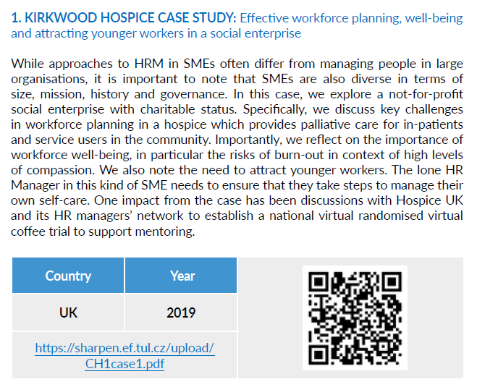
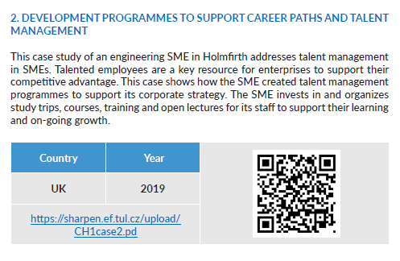

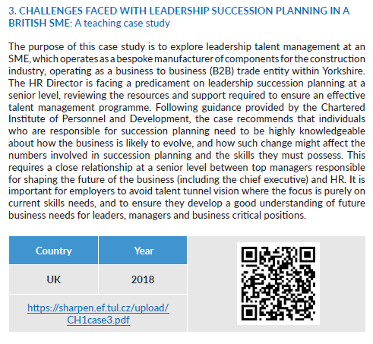
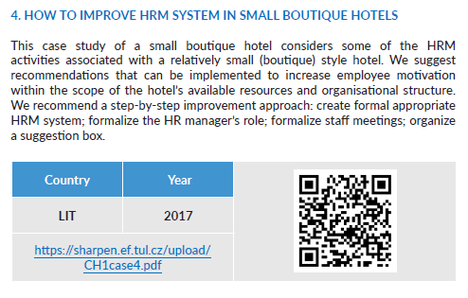

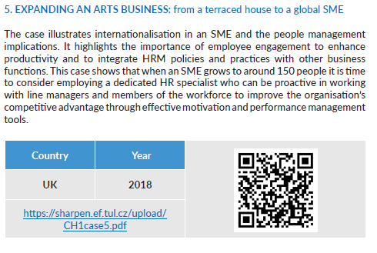


References
Altinay, L., Madanoglu, M., De Vita, G., Arasli, H. & Ekinci, Y. (2016). The interface between organizational learning capability, entrepreneurial orientation, and SME growth. Journal of Small Business Management, 54(3): 871–891.
Beaver, G. & Hutchings, K. (2005). Training and developing an age diverse workforce in SMEs: The need for a strategic approach. Education+Training, 47(8/9): 592–604.
Bowen, E., Lloyd, S. & Thomas, S. (2004). Changing cultural attitudes towards graduates in SMEs to stimulate regional innovation. Industry and Higher Education, 18(6): 385–390.
Carroll, M., Marchington, M., Earnshaw, J. & Taylor, S. (1999). Recruitment in small firms: Processes, methods and problems. Employee Relations, 21(3): 236–250.
CIPD (2015). Resourcing and Talent Planning. Retrieved from https://www.cipd.co.uk/Images/resourcing-talent-planning_2015_tcm18-11303.pdf
Durst, S. & Wilhelm, S. (2012). Knowledge management and succession planning in SMEs. Journal of Knowledge Management, 16(4): 637–649.
Freeman, S. (2000). Partnerships between small and medium‐sized enterprises and universities that add value. Education and Training, 42(6): 372–377.
Greiner, L.E. (1972). Evolution and revolution as organizations grow. Harvard Business Review, 50: 37–46.
Harrison, R. (2009). ‘Learning and development in the smaller organisation’. In Harrison, R. Learning and Development. London, 5th edition: CIPD.
Komulainen, R., Maršíková, K., Davies, J., Srėbaliūtė, I., Clauß, A.-M., Moš, O., Muschol, H., Rydvalová, P., Forkel, E., & Štichhauerová, E. (2019). A Good Practice Guide to Managing Human Resources in Regional SMEs. Huddersfield, UK: University of Huddersfield.
Lee, N. (2014). What holds back high-growth firms? Evidence from UK SMEs. Small Business Economics, 43(1): 183–195.
Maršíková, K., Rajander, T., Clauß, A.-M., Medžiūnienė, I., Meschitti, V., Štichhauerová, E, Davies, J., Dulkė, D., Komulainen, R., Macháčková, V., Richter, M., Schumann, C.-A., Moš, O., & Forkel, E. (2019). People management challenges for SMEs in five European regions: Spotlighting the (in)visible and the (in)formal and embedding SME HR issues firmly in the business and knowledge environment. Huddersfield, UK: University of Huddersfield.
Motwani, J., Levenburg, N. M., Schwarz, T. V. & Blankson, C. (2006). Succession planning in SMEs: An empirical analysis. International Small Business Journal, 24(5): 471–495.
Nasreem, S., Hassan, M. & Khan, T.A. (2016). Effectiveness of e-recruitment in small and medium enterprises of IT industry of Lahore (Pakistan). Pakistan Economic and Social Review, 54(1): 143.
Sambrook, S. (2005). Exploring succession planning in small, growing firms. Journal of Small Business and Enterprise Development, 12(4): 579–594.
Scott, M. & Bruce, R. (1987). Five stages of growth in small businesses. Long Range Planning, 20(3): 45–52.
Taylor, S. (2002). People resourcing (2nd edn). London: CIPD.
Walmsley, A., Thomas, R. & Jameson, S. (2006). Surprise and sensemaking: Undergraduate placement experiences in SMEs. Education and Training, 48(5): 360–372.
Westhead, P. & Matlay, H. (2005). Graduate employment in SMEs: A longitudinal perspective. Journal of Small Business and Enterprise Development, 12(3): 353–365.
Woods, A. & Dennis, C. (2009). What do UK small and medium sized enterprises think about employing graduates? Journal of Small Business and Enterprise Development, 16(4): 642–659.

The project has been funded by the Erasmus + KA2 Strategic Partnership programme. Project agreement number: 2016-1-CZ01-KA203-023916.

Legal notice:
The views expressed in this publication are the sole responsibility of the authors and do not necessarily reflect the views of the European Union, of the ERASMUS programme national agencies nor of the project partner universities. The Union, the national agencies and the universities are not liable for any use that may be made of the information contained therein.

