3. Recruitment and Selection Process

The section aims to:
- Introduce the concepts of recruitment, defining candidate requirements, attracting candidates, job advertisements, job descriptions and person specifications.
- Explain candidate assessment, obtaining references, offering employment.
- Inter-generational workforce differences.
- The importance of social networks for recruitment and selection.
- Discuss what is particular about recruitment and selection policies and practices in SMEs (compared with large organisations).

Key words

Recruitment and selections; attracting candidates; defining job, organisation fit; generations X, Y, Z; social media; SMEs.


Required knowledge
Knowledge of basic human resource management terms.


Time requirements
Total time recommended to study this chapter: 1.5 hours.

Contents
Introduction to recruitment and selection 3
Recruitment processes 3
Methods of recruitment/sourcing candidates 6
Generation Y and recruitment 8
Social media and recruitment 9
Recruitment from the perspective of SMEs 11
Recruitment in SMEs (SHARPEN survey) 14
Summary 16
Section review questions 16
Video links 16
Dictionary 17
Case studies 18
References 21


Introduction to recruitment and selection
An important part of strategic people resourcing are recruitment processes. Employee resourcing, generally known simply as ‘resourcing’ is the term used to describe activities concerned with the acquisition, retention and development of human resources (Armstrong & Taylor, 2014, p. 247).
Recruitment and selection is the process of attracting and hiring candidates to fill vacancies. The overall aim of the recruitment process should be to obtain, at minimum or reasonable cost, the number and quality of employees required to satisfy the human resource needs of the organisation. This requires analysing a vacancy, defining requirements and advertising (Armstrong & Taylor, 2014).

Recruitment processes
Processes for hiring new employees includes several stages. Before an organisation starts to search for new candidates, it is important to define whether the job needs to be redesigned or can be fulfilled differently or with current capacities. If a new person for the job is needed, the organisation has to determine the most appropriate method(s) for advertising the job advertisement and attracting the right person for role or organisation fit.
Line managers need to define requirements for attracting candidates, which can be divided into steps shown in Figure 1.
Figure 1. Recruitment processes

Source: Adapted from Armstrong & Taylor, 2014; Foot, Hook & Jenkins, 2015; Koubek, 2012; Wapshott & Mallett, 2016
Defining requirements
First of all, it is necessary to define workforce requirements. An organisation needs to analyse and plan its recruitment activities and methods. However, there may be unexpected requirements following upturns in orders, new contracts and changing customer demands. The HR department (if there is one) can be under pressure from ad hoc demands to hire new employees quickly (Armstrong & Taylor, 2014).
In the person specification it is important to define essential and desirable candidate requirements and design job advertisements based on an updated job description. When a new position is created, it is also necessary to prepare a job description which should include information about the position, as indicated in Figure 2.
Figure 2. Important information in the job description
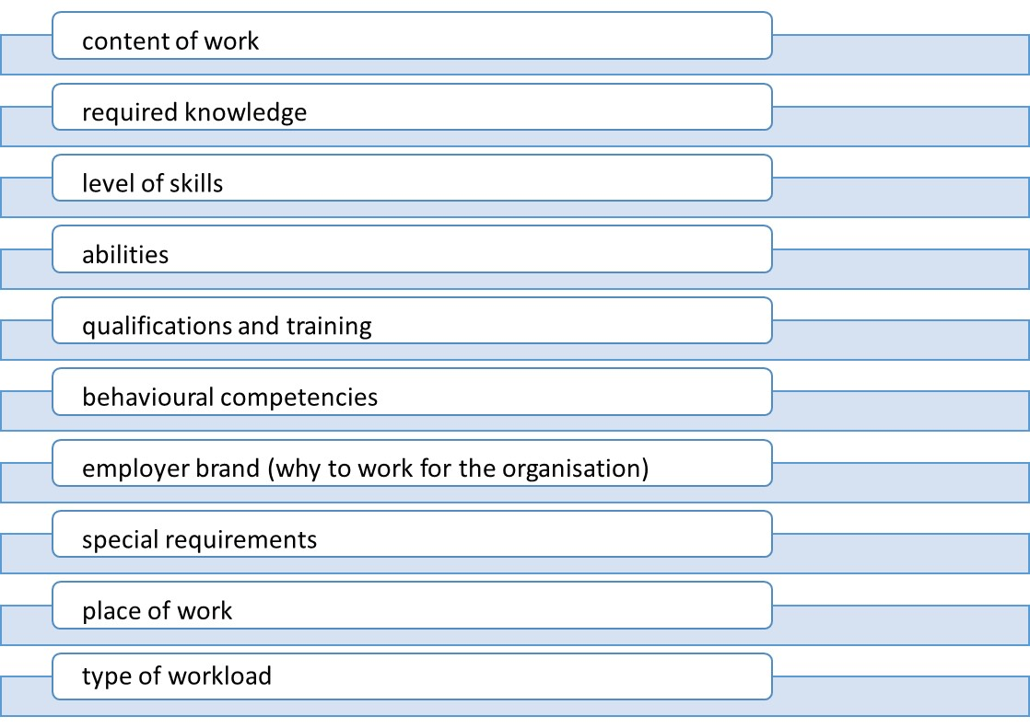
Source: Armstrong & Taylor (2014, p. 227), own elaboration
If the job description already exists, it is important to check it and complete, edit or update before it is posted to search for new candidates (Armstrong & Taylor, 2014).
Considering alternatives (see Figure 1) means thinking about new possibilities in terms of replacing an individual who has left. For example the organisation’s managers can decide that a post is redundant, divide job duties amongst several current employees, change the work load, encourage job sharing, or outsource the tasks of the job completely. A decision needs to be made whether to recruit internally or source candidates externally. Within any of these cases, defining requirements for candidates according to a job description is crucial and to be objective. After this step, managers have to decide HOW to attract candidates (Armstrong & Taylor, 2014; Koubek, 2012).
Attracting candidates
Attracting candidates is an important phase of the recruitment process. The first step is to analyse recruitment strengths and weaknesses to develop an employer value proposition (a unique value which the employer offers to employees which persuades them to work for that particular organisation) and employer brand, i.e. processes that create an ‘identifiable and unique employer identity, and the employer brand as a concept of the firm that differentiates it from its competitors’ (Backhaus & Tikoo, 2004, p. 505). The identification of company´s strengths and weaknesses as an employer can help to attract new candidates. Surveying current employees helps to identify the main advantages and disadvantages of working in the organisation. This can help to promote the employer brand, e.g. the organisational culture, benefits, prospects, development opportunities, working conditions and values. Employer’s strengths are recommended to promote in job adds to attract more candidates. Of course, the hiring process is a mutual arrangement between potential employer and prospective employee (Armstrong & Taylor, 2014; Komulainen at al., 2019).
When an employer analyses requirements for a new candidate, it is important to determine priorities required of the candidate. Job specifications include education, experience, qualifications and skills requirements also job conditions (e.g., wage, benefits, and workload) are related to the job vacancy (Armstrong & Taylor, 2014). Selection tools also need to be determined, e.g. interviews, tasks, in-tray exercises, psychometric tests.
Identifying and choosing methods of candidate attraction are crucial parts of this process. To choose the best tool, it is important to know the target group.
The organisation’s managers need to decide how candidates receive feedback, where to target suitable candidates. However, it is recommended to use several methods of recruitment and to evaluate their effectiveness, e.g. online recruitment (social media), career websites, networking with universities and schools, recruitment agencies, job centres, recruitment consultants, executive search consultants (head hunters) (Armstrong & Taylor, 2014, Komulainen et al., 2019).
How to create an attractive job advertisement
After choosing methods of recruitment, it is necessary to create an attractive but realistic job advertisement and promote it actively. The majority of recruitment methods use some kind of advertisement to inform potential candidates about the vacancy. The advertisement has a layout content of heading which is a job title, short information about employer, basic information about vacancy (load, work place, line management responsibilities), job description, requirements, what the employer offers (terms and conditions) and contact information (Armstrong & Taylor, 2014).
The last phase of the recruitment process is collecting information and documents from candidates. It partly connects with the selection process based on CVs, cover letters and applications. During the pre-selection phase, HR specialists (and line managers) classify candidates according to main requirements and CVs (Koubek, 2012). When employees have been selected and appointed, it is important to induct new recruits to avert an induction crisis and unintended staff turnover.

Methods of recruitment/sourcing candidates
The following section includes short descriptions of recruitment and selection methods and their main advantages and disadvantages. It is really important for managers in SMEs to consider which of these methods is most suitable for attracting and hiring good candidates (Armstrong & Taylor, 2014).

Job centres are mostly public offices, regulated by the national government (with different rules across Europe), where job vacancies of most employers in the region are advertised. They collect and publish vacancies. There are also some consultants who are able to offer advice. However, job centres are mostly useful for hiring manual workers, call centre assistants and clerical or sales workers (Armstrong & Taylor, 2014; Torrington, Hall, Taylor, 2005).

Recruitment agencies and consultants are used mainly to recruit office and sales staff who are registered with them (Armstrong & Taylor, 2014, p. 233). They can produce candidates very quickly, but there can unsuitable pool of candidates, therefore it is very important to give clear requirements about candidates. They can find and short-listed suitable candidates, so it can save time, but costs could be high. It is important to check the reputation and experience of the agency or consultants, it is important to choose a professional agency or consultants (Armstrong & Taylor, 2014; Torrington et al., 2005).

Executive search consultants, also called head hunters, are used for finding candidates for higher, senior or manager positions. They have to find suitable people exactly according to given requirements in briefings. Oftentimes, search firms have to persuade candidates to leave their current employment and join the company, which have hired these head-hunters (Armstrong & Taylor, 2014; Torrington et al., 2005).

For SMEs, also collaboration with universities and secondary schools can be very important for SMEs to find talented students and train them in accordance with the organisation’s needs. Also, trainee programmes can prepare current students for future work (Armstrong & Taylor, 2014; Torrington et al., 2005).

If an SME lacks the capacity, recruitment and selection processes may be outsourced.

E-recruitment is currently one of the most popular sources of job candidates. It means connection between recruitment and technology, using electronic resources for finding candidates for vacancy. For on-line recruitment it is possible to use web sites, career sites, job boards, social media etc. Many recruiters and potential candidates use this recruitment and job search method on the internet. What is more, it can save time and administration. Moreover, employers can promote their employer brand in this way but they must manage their profile carefully for recruitment (Armstrong & Taylor, 2014; Torrington et al., 2005).

Organisations can also use different kinds of advertising. Posting and publishing vacancies and information about job vacancies in media, for example in local newspapers, specialist journals, websites, career sites, on the company notice-boards, at universities, on the Internet, in social media and so on.

Generation Y and recruitment
In recent years, new terms such as Generation Y, Millennials, Generation Next, the Net Generation, Echo Boomers, iGeneration, Generation Me and the Next Great Generation have emerged. Who are these people? What are their interests and dreams? How can organisations recruit and retain them?
All terms mentioned above determine people who were born between 1980 and 1995 (for some experts the range can be between 1980 and 1992 or even different, e.g. PwC gives the range between 1980 and 2000). ‘Gen Y’ers’ have quite different needs and aspirations from previous generations in the workplace and look for a more engaging employee value proposition (EVP) than has perhaps existed in many businesses before now (Hays, 2013).

These people have grown up during times of technological and economic disruption and they have now started their professional careers and entered the labour market. In 2025, the global labour force will comprise 75% of this age group. In future, this group will be in leadership positions and will have a growing influence on decision-making processes in organisations (Horváthová, Bláha & Čopíková, 2016, PwC, 2011).
According to a report by PriceWaterhouse Coopers (PWC), members of Gen Y have several differences compared to the older generations. Generation Y wants to have meaningful work. Their careers are supposed to be one of choice, not chosen out of desperation. Moreover, young people are more flexible than their parents (PwC, 2011).
Generation Y was born into a period of relative peace. People from Generation Y are highly ambitious and interested in jobs full of challenges and freedoms. Their colleagues are more like friends to them. They require a higher standard of living, feel more responsible for their social security and have different priorities in work-life balance (Kazdová, 2012) from their parents.
The major difference between Generations X and Y is in their personal life. For Generation Y, partnerships and family relationships are the most important. They are flexible at work, and prefer to use time also for their own hobbies, sport, and relaxation. They bring new ideas and innovations. They need an individual approach in development and training. Coaching allows them to find their own solutions in their career and personal life. The greatest motivation for them is having meaningful work that they can enjoy and where they can use their creativity. (Kazdová, 2012).
Generation Y has grown up with modern technologies. This generation wants to be online, communicate, respond, publish their opinions, experiences, photos, blogs, podcasts, YouTube videos, use social networks constantly. It is a generation for whom it is important to work in teams, to use modern technology in flexible, global and intercultural working environments (Kazdová, 2012).
HR professionals play an important role in integrating members of Generation Y into the workforce. Also, line managers must be prepared for this generation joining their teams (Horváthová, Bláha & Čopíková, 2016). For SMEs, it is important to point out, that managing the often conflicting views and needs of a diverse multi-generational workforce encompassing Baby Boomers, Generation X and millennials can be a significant challenge for many organisations (PwC, 2011). According to Horváthová, Bláha & Čopíková (2016), the current workplace includes Baby Boomers, Generation X and Generation Z.
“Baby Boomers”
Members of the Baby Boomer Generation were born between 1946 and 1964. They grew up in comparatively safe times and in a period of economic prosperity. They are also called “the Happy Generation”. Many of these people are working and want to work even during their retirement age either because they derive joy from work, they have a need for friendship or they fear full retirement as an unknown experience. These people appreciate career growth and the need for work. They are loyal to their companies and motivated by teamwork and responsibility. They want to be valued for long hours spent at work and their strong work ethic.
“Generation X”
Members of Generation X were born between the years 1965 and 1982. Generation X can be described as people who grew up in the midst of financial, family, and social anxiety. Generation X individuals are hardworking, feel a responsibility towards work and show loyalty. This generation likes a stable environment, spending significant time at work. They often experience burnout. To retain this generation, it is good to offer them self-determination, options and paths for career development, as well as flexibility (Saileela & Thiruchanur, 2017). The divorce rate has dramatically increased in this Generation and they do not like conflict. They may be portrayed as less able to work with modern technologies as the younger generation. One of the most typical features of Generation X is their experience of long-term employment.
“Generation Z”
Generation Z are people born between 1996 and 2010, which means they are digital natives. They spend a great deal of their time on social networks. They are the first generation that cannot imagine their life without a mobile phone, computer, the Internet, or wireless connection. They tend not to be loyal to one form of social media or employer. They believe in their ability to solve any problem in their own way. This generation is self-confident, inclined to be impatient and they have high self-esteem. They can analyse information very effectively. They appreciate their peers’ opinions more than the opinions of older generations (Kukelková & Kubátová, 2013).

Social media and recruitment
Nowadays, social networks are becoming more and more important in everyday life. The number of users has been rising rapidly. Social networking can be used within an organisation for internal communication among employees, between employees and management, and also between the organisation and its clients. Social networks can be also used also for recruitment (Horváthová, Bláha & Čopíková, 2016). As Armstrong and Taylor (2014) point out, the use of social media means applying Web 2.0 technologies to search for recruits and find out more about them online on sites such as LinkedIn and Facebook. Potential recruits sometimes provide blogs as testimonials from existing employees covering their experiences in working for the organisation (Armstrong & Taylor, 2014) which creates peer-to-peer trust.
What makes social media unique is that it allows the users to make a public profile and make their social network visible to others. It can offer a significant advantage for the user (including SMEs) but also it also includes the risk of inappropriate communication and also misuse. It is easy to destroy an organisation’s reputation through social media and not easy to verify information presented via social media. From the point of view of recruitment processes, there is also some uncertainty related to social media and the number of qualified applicants for any particular position. There is also some speculation that the use of social media leads to a higher number of unqualified applicants.
Communication via social media primarily takes place with people who are already part of some social network. This can help active job seekers find a job and help employers find job seekers. Nevertheless, if social media is capable of destroying an organisation’s reputation, it should also be useful to build positive organisational reputations. Social media advantages for organisations include free, unlimited use and shorter response times (Roper et al., 2013). The most commonly used social media for recruitment include LinkedIn, Facebook and Twitter and Instagram. For details how to use social media in recruitment, please see Komulainen at al. (2019), chapter 2.
Facebook
Facebook is the world’s largest social network. It allows individuals to create a company profile which can be used effectively in the recruitment process and to support the employer brand (Komulainen at al., 2019). It includes many tools such as the ability to create groups, to embed videos, photos, discussion forums, and so on. It also includes PPC (Pay per Click) ads with accurate user targeting (Facebook, 2017; Horváthová, Bláha & Čopíková, 2016).
Twitter
Twitter is a popular platform where both regular customers and large companies engage each other. It was founded in 2006 in San Francisco and quickly spread globally. It is available in multiple language versions. Users can insert messages Tweets of up to 280 characters (except in China, Korea and Japan), and includes photos, videos, and conversations. Twitter offers a useful medium to communicate with potential job candidates quickly about new events or news (Horváthová, Bláha & Čopíková, 2016).
LinkedIn
LinkedIn is the world’s largest social network for professionals, mainly used in Europe and the USA. LinkedIn is also helpful for HR professionals, expert information, work, employees, making deals, finding contacts, etc. However, many professionals are passive candidates not actively job seeking. They may be professionals who would consider the life-changing role you have for them if they are looking to move from the ‘rat race’ of a large firm and would be interested in working for an SME closer to home. Working with LinkedIn (Premium), organisation can contact potential candidates easily. The profile of an organisation is often a candidate’s first interaction with the organisation, so it should be inspiring. The more an organisation can show off its brand and values, the easier it is for candidates to engage with the enterprise and determine whether or not the organisation might be an excellent fit for them (Lock & Reilly, 2018). LinkedIn Jobs offers relevant potential candidates through automatic matching algorithms and via professional communities sharing them. To learn more about using LinkedIn for recruitment in SMEs, see: https://business.linkedin.com/talent-solutions#; Horváthová, Bláha & Čopíková (2016); Komulainen at al. (2019).
Instagram
Instagram (IG) is a social network for sharing photos. The basic principle is that people share photos or short videos of up to 60 seconds (mostly using interesting filters which can make it look more attractive). It is not possible to use IG without photos (or videos) (Komulainen et al. 2019).
The main sources used by employers, as established by the 2013 CIPD survey, were:
- own corporate website – 62 per cent;
- recruitment agencies – 49 per cent;
- employee referral scheme – 33 per cent;
- professional networking, e.g. LinkedIn – 32 per cent;
- commercial job boards – 32 per cent.

Recruitment from the perspective of SMEs
The aim of effective recruitment and selection is to choose the candidate who best fits a job and the organisation, not necessarily the best qualified or the smartest person, to ensure an appropriate workforce within budget. SMEs often try to use also informal and inexpensive ways to announce a job vacancy and hire new employees, however, it is important to meet employment law requirements and to consider innovative methods using social media where appropriate.
Informal methods of recruitment in SMEs
The organisational success of the firm depends on the people who are hired. Therefore, selecting the right employees is essential and challenging. Recruitment of staff in SMEs often takes place through networks and informal contacts. Also, many small firms employ members of the owner´s family through a sense of filial obligation. Smaller organisations tend to adopt informal approaches to the recruitment of staff (Wapshott & Mallett, 2016). Gamage (2014) advocates a systematic recruitment process to identifying vacancies, job analysis, job description, person specification and advertising. A systematic selection process involves the recruiting process, gathering information about qualified applicants, evaluating the qualification of each applicant and making decisions about employment. Yet many SMEs adopt informal processes for recruiting and selecting employees (Gamage, 2014).
SMEs often find word-of-mouth personal referrals highly effective, however, there are risks of nepotism and in-breeding. In small firms, candidates are often familiar before an interview with the staff or the manager, which can facilitate recruitment processes and reduce hiring costs (Gamage, 2014).
Recruitment and selection practices used by small organisations may differ significantly from larger enterprises in terms of greater informality and less structure. Employers of small businesses may consider an applicant’s personality characteristics such as honesty, integrity, potential and interest in the job more important than ability, aptitude or attainment.
Recruitment of graduates in SMEs
Holden et al. (2002) investigated the importance of university qualifications for recruitment and selection in a survey of 18,561 SMEs. They found that 77 per cent of the sample believed that ‘attitude and character’ were important factors for recruitment followed by experience (64 per cent) and an industry related course (41 per cent). However, only 9 percent of the sample believed that a university qualification was an important requirement for employee selection. 70 percent of employers in Holden et al’s (2002) survey of 104 companies believed that university degrees were devalued as a means of measuring employability. In Ofori & Aryeeetey’s (2011) survey, 51 percent of respondents felt that graduates were not necessarily better equipped for the workplace when compared with non-graduates of the same age.
SMEs have also tended to claim that it is expensive to employ and train graduates particularly given the risk that they will leave after training to go to a larger organisation.
Typically, owners of micro-enterprises do not believe their business to be appropriate for graduates. One view is that graduates do not stay in long-term jobs, they lack relevant experience and demand higher salaries. On the other hand, graduates can be more creative, with higher levels of IT skills and effective communication skills than non-graduates (Ofori & Aryeeetey, 2011).
The topics bellow are important findings about the value of hiring graduates in SMEs:
• The intake for graduates seemed more likely to occur in SMEs where a graduate has responsibility for recruitment.
• The main perceived benefits of recruiting graduates cited were being good with clients, having well developed management skills and bringing new ideas.
• There was also a general perception that a graduate’s additional knowledge and enhanced skills would be advantageous.
• Employing former placement or vacation students to full-time permanent positions, following their graduation can be effective and economical (Ofori & Aryeeetey, 2011).
Recruitment using social media in SMEs
Web-based recruitment tools and Apps are now common and a wide range of organisations use them with different levels of integration. SMEs tend not to have the same tools as their larger competitors but they can work with recruitment agencies that use sophisticated digital platforms, e.g. GlassDoor, Monster and Apps such as Jobr and Shapr.
Social networking media can be used to find suitable candidates and help HR managers to connect and easily communicate with applicants. There are three primary reasons for using social media to hire workers: posting available jobs, searching candidates and reviewing them (Sameen & Cornelius, 2015).
In addition, employers can gain insights from the magnitude of data available on these networks, which cannot be included in or evaluated through a resume or CV (Sameen & Cornelius, 2015).

- Time and cost savings: Due to the fast exchange of information and the low cost of recruitment compared with traditional methods;
- Reducing the administrative burden for the HR department: Lowering bureaucracy using automation;
- Possible to reach international knowledge: The number of foreign hires is increasing, especially in regions with under-employment or higher employment rates. Furthermore, it can be easier to find specific knowledge or skills that the local applicants do not have;
- Reach passive job seekers: They may have an interest in finding a job with more benefits or changing their career path but not be looking actively for a new job;
- Positive impact of the corporate website: Create interactive and informative web pages to attract candidates;
- Decentralisation of HR activities: To improve the process without constant supervision of the HR manager;
- Technology shift: New tools help to integrate people and technology in organisations (Deillon, 2014).

- Budget constraints: The initial investment and maintenance cost of e-recruitment tools is high;
- Risk of project failure: The need for constant development and changes and awareness of risks of technical issues;
- Quantity and quality of applicants: Online tests can be used to categorise applicants, including psychometrics tests and questions about motivation;
- Cultural change: It is necessary to train the team, preparing them about possible issues, the new method and how the new process will work;
- Increased labour force mobility among competitors: There is a risk of competitors poaching employees;
- Potential discrimination: The human resource department should choose which roles do not need online tests, otherwise the SME might lose good candidates who are less interested in online recruitment;
- Data security and confidentiality: The company has to certify that the information it is receiving from the candidates is strictly confidential;
- Negligence of personal interaction: Balancing the online phases of recruitment and the human interaction (Deillon, 2014).

Recruitment in SMEs (SHARPEN survey)
How do SMEs deal with recruitment issues? We draw on findings from the SHARPEN project survey carried out in 2018 across five European regions: the Liberec region in the Czech Republic; Kajaani region, Finland; Zwickau region, Germany; Klaipeda region, Lithuania and West Yorkshire (Kirklees) in the United Kingdom.
This research was conducted amongst SMEs during 2018. The survey involved more than 400 SMEs in five selected European regions. Recruitment was identified by respondents in all these regions as an important human resource management activity.
Additionally, this survey confirmed that social media currently play a key role in communication with all stakeholders including employees and potential candidates. However, based on results, social media for HR purposes in SMEs is not used as much as it might. As Figure 3 shows, except for the UK, less than 50% of SMEs confirmed they used social media for recruitment.
Figure 3. Use of social media/networks for recruitment in SMEs in the five SHARPEN regions

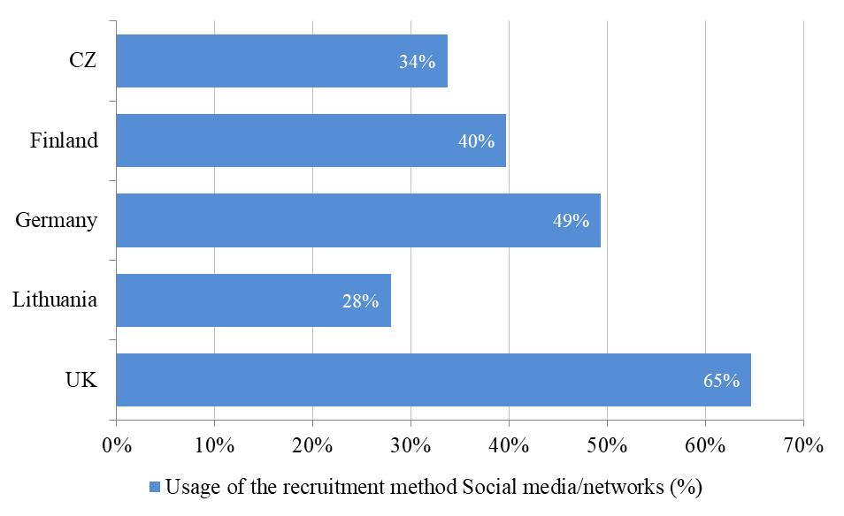
Source: Maršíková at al. (2019)
SME respondents also confirmed that they use a variety of methods for recruitment. Table 1 shows methods differ across countries.

Table 1. Recruitment methods in the five SHARPEN regions
Recruitment methods | Responses
Recruitment methods | CZ | Finland | Germany | Lithuania | UK
Recruitment methods | % | % | % | % | %
Career webpage (e.g. Career section on your website) | 43.75 | 36.99 | 80.72 | 25.81 | 60.29
Internet job portals | 51.25 | 23.29 | 80.72 | 69.89 | 61.76
Personnel agencies | 23.75 | 17.81 | 44.58 | 34.41 | 48.53
Temporary agencies (employing temporary agency workers) | 12.50 | 32.88 | 31.33 | 9.68 | 39.71
References/recommendations from current employees (employee referral programme) | 68.75 | 42.47 | 78.31 | 56.99 | 41.18
Employment agency/office (job centre) | 61.25 | 52.05 | 75.90 | 45.16 | 17.65
Social media/networks | 33.75 | 39.73 | 49.40 | 27.96 | 64.71
Recruitment at educational institutions (schools) | 31.25 | 24.66 | 54.22 | 16.13 | 17.65
Support of existing employees for internal recruitment | 31.25 | 16.44 | 39.76 | 8.60 | 44.12
Executive search (headhunting) | 27.50 | 21.92 | 25.30 | 12.90 | 20.59
Other (please specify) | 6.25 | 5.48 | 10.84 | 3.23 | 4.41
Source: Maršíková at al. (2019)
However, the most commonly used recruitment processes include references/recommendations from current employees (employee referral programme), employment agency/office (job centre) and Internet job portals. In terms of social media usage for recruitment and selection, it was highest in the UK where almost 65% of SMEs confirmed that they use social media for recruitment.

You can find more information about the SHARPEN research in our research publication:
Maršíková, K., Rajander, T., Clauß, A.-M., Medžiūnienė, I., Meschitti, V., Štichhauerová, E, Davies, J., Dulkė, D., Komulainen, R., Macháčková, V., Richter, M., Schumann, C.-A., Moš, O., & Forkel, E. (2019). People management challenges for SMEs in five European regions: Spotlighting the (in)visible and the (in)formal and embedding SME HR issues firmly in the business and knowledge environment. Huddersfield, UK: University of Huddersfield. ISBN: 978-1-86218-168-7
Link: https://sharpen.ef.tul.cz/upload/PublicationHRMinSMEs_research.pdf

Summary
Stereotypes about generational differences may be discriminatory and untrue. Different forms of age, gender, class, national cultural, neuro and other forms of diversity should be taken into consideration when hiring new workers. We argue that recruitment is context sensitive and changes over time and depending on the growth stages of an SME. It is, therefore, really important to regularly check the needs and expectations of those employees that we are interested in hiring, including former employees.
What is effective today may not be effective tomorrow and social media are changing. Members of today’s generation may prefer particular social media while the next generation prefers others. Corporate social communications and recruitment need to be professionalised and should not disenfranchise or discriminate against potential candidates.

You can find more practical information and advice in our publication:

Komulainen, R., Maršíková, K., Davies, J., Srėbaliūtė, I., Clauß, A.-M., Moš, O., Muschol, H., Rydvalová, P., Forkel, E., & Štichhauerová, E. (2019). A Good Practice Guide to Managing Human Resources in Regional SMEs. Huddersfield, UK: University of Huddersfield.
ISBN: 978-1-86218-167-0
Link: https://sharpen.ef.tul.cz/upload/HRM4SMEs_Handbook.pdf



Section review questions
- How can we define recruitment?
- Which social networks do you know?
- Do you know what are the most suitable social networks for recruitment in the job(s) you are aiming to be hired for?
- Discuss suitable guidelines and protocol to use social networks in companies and for recruitment and selection.

Video links
SHARPEN. Recruitment theory. Link: https://www.youtube.com/watch?v=Dyr4U2R8Ltw
SHARPEN. Dealing with responsibility: a recruitment tool. Link: https://www.youtube.com/watch?v=Ec4Qand_Xq0&t=59s

Dictionary
Employee referral | When your current employee recommends your organisation to a potential candidate whom he/she knows.
Employee value proposition (EVP) | What you offer your employees in return for their hard work, skills and experience.
Employer branding | The act of building a positive employer brand that attracts and retains good employees.
External recruitment | Filling vacancies with people from outside the organisation.
Internal recruitment | Filling vacancies with current employees of the organisation.
Job analysis | The process of identifying the relevant information needed to create a job description, person specification and advertisement.
Job description | Detailed description of the job position in the organisation (includes duties, responsibilities, rewards, workload, essential and desirable qualifications and experiences etc. relevant to the job).
Recruitment channels | The channels used for recruiting prospective employees. These includes newspaper, magazine, internet recruitment agency, employment agency, social media, university relations, head hunters, executive search agency etc.
Social media | LinkedIn, Facebook, Instagram, Twitter etc.
Vacancy | A vacant position in an organisation resulting from resignation, restructuring, business growth or other reasons.

Case studies
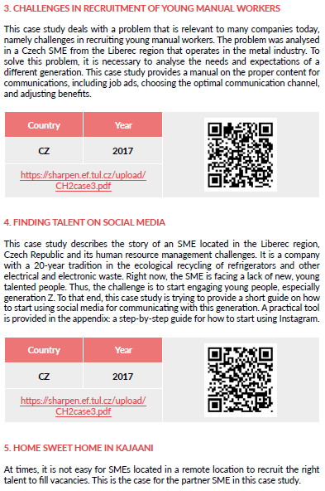
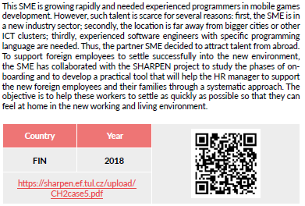

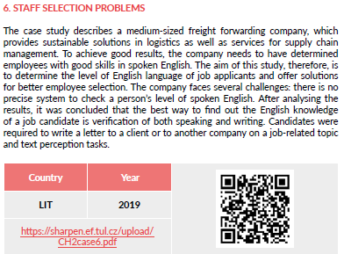
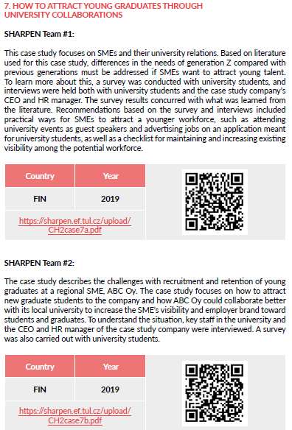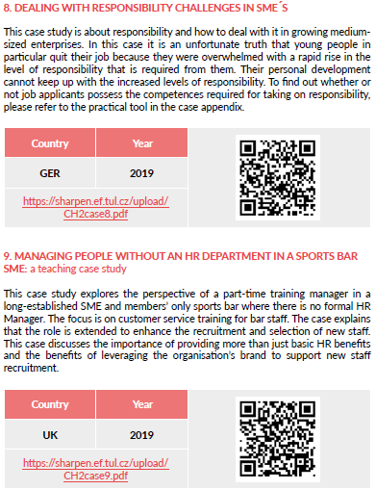


References
Armstrong, M. & Taylor, S. (2014). Armstrong's handbook of human resource management practice (13th ed.). London, UK: Kogan Page.
Backhaus, K., & Tikoo, S. (2004). Conceptualizing and researching employer branding. Career Development International, 9(5), 501–517.
Deillon, C. (2014). The advantages and challenges of turning towards e-recruitment for small and medium sized businesses (SME). (Bachelor’s thesis). Fribourg, Germany: University of Fribourg. Retrieved from: https://diuf.unifr.ch/main/is/sites/diuf.unifr.ch.main.is/files/documents/student-projects/S-2014_Celine_Deillon_0.pdf.
Foot, M., Hook, C. & Jenkins, A. (2015). Introducing human resource management (7th ed.). Harlow, UK: Pearson.
Hays. (2013). Gen Y and the world of work. A report into the workplace needs, attitudes and aspirations of Gen Y. Retrieved from: https://social.hays.com/wp-content/uploads/2013/10/Hays_Report_V4_02122013_online.pdf.
Horváthová, P., Bláha, J. & Čopíková, A. (2016). Řízení lidských zdrojů. Nové trendy (13th ed.). Prague, Czech Republic: Management Press.
Gamage, A.S. (2014). Recruitment and selection practices in manufacturing SMEs in Japan: An analysis of the link with business performance. Ruhuna Journal of Management and Finance, 1(1), 37-52.
Kazdová, A. (2012). Premiéra HR Innovation: Jak pracovat s generací Y? Human Resource Management, 6, 1-2. Retrieved from: https://ziladoc.com/download/jak-pracovat-s-generaci-y_pdf.
Komulainen, R., Maršíková, K., Davies, J., Srėbaliūtė, I., Clauß, A.-M., Moš, O., Muschol, H., Rydvalová, P., Forkel, E., & Štichhauerová, E. (2019). A Good Practice Guide to Managing Human Resources in Regional SMEs. Huddersfield, UK: University of Huddersfield.
Koubek, J. (2012). Řízení lidských zdrojů: Základy moderní personalistiky (4th ed.). Prague, Czech Republic: Management Press.
Kubátová, J. & Kukelková, A (2013). Interkulturní rozdíly v pracovní motivaci generace Y: příklad České republiky a Francie. 1. vyd. Olomouc: Univerzita Palackého v Olomouci.
Lock, M. & Reilly, K. (2018). Recruiting for small businesses: The Ultimate LinkedIn Guide. Retrieved from: https://business.linkedin.com/talent-solutions/c/14/8/modernrecruitersmb.
Maršíková, K., Rajander, T., Clauß, A.-M., Medžiūnienė, I., Meschitti, V., Štichhauerová, E, Davies, J., Dulkė, D., Komulainen, R., Macháčková, V., Richter, M., Schumann, C.-A., Moš, O., & Forkel, E. (2019). People management challenges for SMEs in five European regions: Spotlighting the (in)visible and the (in)formal and embedding SME HR issues firmly in the business and knowledge environment. Huddersfield, UK: University of Huddersfield.

Ofori, D. & Aryeetey, M. (2011). Recruitment and selection practices in small and medium enterprises: Perspectives from Ghana. International Journal of Business Administration, 2(3), 45-60. doi: 10.5430/ijba.v2n3p45.
PricewaterhouseCoopers. (2011). Millennials at work. Reshaping the workplace. Retrieved from: https://www.pwc.com/co/es/publicaciones/assets/millennials-at-work.pdf.
Roper, S., de Carvalho, L.V., Guzman, F., Sivertzen, A.M., Nilsen, E.R. and Olafsen, A.H. (2013). Employer branding: employer attractiveness and the use of social media. Journal of Product & Brand Management, 22(7), 473-483. https://doi.org/10.1108/JPBM-09-2013-0393.
Saileela, K. & Thiruchanur, S. (2017). Capturing the nature of generations at workplace. International Journal of Advanced Research and Development, 2(11), 95-106. Retrieved from: https://www.researchgate.net/publication/329337372_Capturing_the_Nature_of_Generations_at_Workplace.
Sameen, S. & Cornelius, S. (2015). Social networking sites and hiring: How social media profiles influence hiring decisions. Journal of Business Studies Quarterly, 7(1), 27-35. Retrieved from: https://search.proquest.com/docview/1719405262?accountid=17116.
Torrington, D., Hall, L. & Taylor, S. (2005). Human resource management (6th ed.). Harlow, UK: Financial Times Prentice Hall.
Wapshott, R. & Mallett, O. (2016). Managing human resources in small and medium-sized enterprises: Enterpreneurship and the employment relationship. London, UK: Routledge.

The project has been funded by the Erasmus + KA2 Strategic Partnership programme. Project agreement number: 2016-1-CZ01-KA203-023916.

Legal notice:
The views expressed in this publication are the sole responsibility of the authors and do not necessarily reflect the views of the European Union, of the ERASMUS programme national agencies nor of the project partner universities. The Union, the national agencies and the universities are not liable for any use that may be made of the information contained therein.

For more about EVP, see Komulainen at al. (2019).
For more information about employer branding, please see the handbook: Komulainen, R., Maršíková, K., Davies, J., Srėbaliūtė, I., Clauss, A.-M., Moš, O., Muschol, H., Rydvalová, P., Forkel, E., & Štichhauerová, E. (2019). A good practice guide to managing human resources in regional SMEs. Huddersfield, UK: University of Huddersfield. ISBN: 978-1-86218-167-0

