4. Motivating Employees and Reward Management in SMEs

The aims of this section are:
- To introduce motivation theories and types of motivation as the basis of reward management.
- To explain the concept of reward management, its strategic and detailed aims and its philosophy.
- To describe the processes and activities of reward management.
- To identify the main differences between financial and non-financial reward systems and to outline the developments of reward strategies and principles of total reward and their uses in SMEs.
- To provide an overview of reward and recognition practises in SMEs.


Keywords
Reward management, motivation theories, reward strategy, reward systems, financial reward, nonfinancial reward, total reward, incentive system, merit-pay systems.


Required knowledge
Knowledge of basic terms in human resource management and behavioural psychology.


Time requirements
Total time recommended to study this chapter is three hours.

Contents
Introduction to employee motivation 3
Motivation Theories 3
Instrumentality Theory 3
Contents or Needs Theory 3
Process Theory 5
Expectancy model 5
Goal theory 6
Equity theory 7
Types of Motivation 7
Intrinsic Motivation 7
Extrinsic Motivation 7
Introduction to Reward Management 8
Objectives 8
Developing Reward Strategy 8
Financial and non-financial rewards 9
Rewarding Individuals or Teams 10
Principles of Total Reward 11
Specifics of employee motivation and reward management in SMEs 11
Survey results from SHARPEN - Employee remuneration/reward management 13
Summary 14
Section review questions 15
Video links 15
Dictionary 15
Case studies 16
References 19
Appendix 21


Introduction to employee motivation
Motivations are factors that affect the behaviours of people in certain ways in terms of the strength and direction of behaviours. People have motivations when they expect that a set of actions will lead to the achievement of goals and valued rewards, which satisfies people’s needs and wants. According to Armstrong & Taylor (2014), there are three components of motivation: direction, effort, and persistence. The direction identifies what actions a person is trying to do, while effort measures how hard a person is trying. Meanwhile, persistence is the degree of how long a person keeps on trying. Motivation theories are based on the concept that people do things to earn some tangible or intangible achievements, satisfying needs and wants, and to avoid unwanted responses such as punishments (Armstrong & Taylor, 2014).

Motivation Theories
Motives are defined as the internal drives and energies of an employee; they direct behaviour, which results in outcomes. They are characterised by a certain level of willingness on the part of the employee to increase efforts in order to satisfy imbalanced needs or desire. An understanding of motivation is important within reward management and the development of reward strategies because when employees are happy and motivated, they are more likely to be more productive and able to serve customers better. In addition, rewards which reinforce the right behaviour will ensure the employees will align their interests in achieving organisational goals and strategic objectives. Rewards can emphasize the development of the right organisational culture to align employee performance and organisational priorities (Armstrong & Taylor, 2014).

Instrumentality Theory
This states that if one action is taken it will lead to another. Thus, using rewards or punishments (carrots or sticks) can ensure people behave or act in desired ways. The theory emphasizes the need to rationalize work and economic outcomes. It assumes that a person will be motivated to work if rewards and penalties are tied directly to his/her performance (Armstrong, 2006a).

Contents or Needs Theory
Contents or needs theory helps us to understand what people will and will not value as work rewards; they attempt to identify specific factors that motivate people. The assumption is that employees have needs which they seek to satisfy inside and outside of work, i.e. to answer the question ‘HOW to satisfy these needs?’
Content theory explains motivations through an employee’s needs. Unsatisfied need creates desires to satisfy needs to reach equilibrium. By identifying these needs, creating rewards that can satisfy those needs, and providing employees with opportunities to be rewarded through better performance, managers can create appropriate motivations for people to achieve higher performance as well as organisational goals. Needs theory was originated by Maslow (see Figure 1). The Hierarchy of Needs model was originally developed by Maslow (1954). This comprises five major need categories starting from fundamental physiological needs and leading through a hierarchy of safety, social and esteem needs to the need for self-fulfilment, the highest need of all, as illustrated in Figure 1.
At the basic level are physiological needs where survival factors are the key for employees such as to receive a salary to meet basic needs. Once this level is achieved, employees seek to fulfil their safety needs such as work safety, stable work environment. When these safety needs are satisfied, employees seek affiliation. Having good peers, collaborative colleagues and a good boss are some examples. When these lower needs are fulfilled, according to the pyramid employees will move further up the hierarchy for higher needs such as esteem and self-actualisation. At these levels, employees expect to be respected and recognised for the values they bring. This includes recognition through rewards, praises, appropriate job titles and perks. In the final level, employees are concerned about achieving their potentials. They look for more autonomy, development opportunities and deepen their expertise in specific areas. This model has been critiqued for being too linear and several scholars have argued that Maslow never actually created a pyramid (Bridgman et al., 2019).
Figure 1. Maslow’s hierarchy of needs

Source: Adapted from McLeod (2007)

Process Theory
Process theory concentrates on the psychological or mental factors that affect the employees’ motivation. Based on the process theories, managers can set up a performance-based reward system that is valuable to the employees. This is concerned with the psychological processes which affect motivation by reference to expectations (Porter & Lawler, 1968; Vroom, 1964), goals (Lathom & Locke, cited in Armstrong, 2006b) and equity theory (Adams, cited in Armstrong, 2006a).
- It emphasizes on psychological processes
- It is also known as a cognitive theory because it concerns people’s perceptions of their work environment and the ways in which they interpret and understand it
- The processes manage:
- Employees’ expectations
- Goal achievement (Armstrong, 2006a)
- Feelings of being treated fairly

Expectancy model
Vroom's (1964) theory explains the connection between an employee’s effort, performance and rewards. In this model, employees first have some expectations that the efforts they expend will lead to a level of performance outcome. If the employee believes his or her efforts will not lead to the desired level of performance, then the person is unlikely to expend much effort to try. If the employee believes his or her efforts will lead to the desired performance outcome, then he or she will put in the effort believing he or she will achieve the desired outcome. The more likely their efforts will lead to the desired performance level, the more motivated they are to make an effort.
Next, the performance outcome must lead to rewards. Rewards may be either positive or negative. The more positive the reward the more likely the employee will be highly motivated to achieve the performance level given. On the contrary, the more negative the reward the less likely the employee will be motivated. The employees make decisions of their efforts based on estimates of how well the expected results of a given behaviour will lead to the performance level they desired that is linked to the rewards that bring positive value to them (Vroom, 1964) – see Figure 2.

Figure 2. The expectancy model
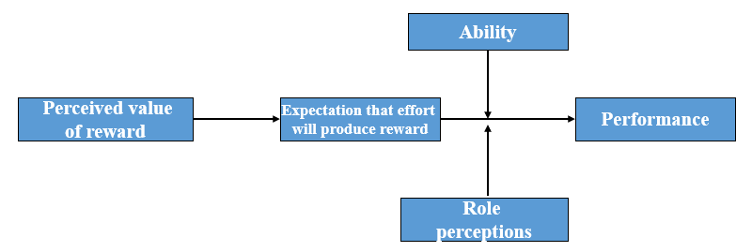
Source: Adapted from Vroom (1964); Porter & Lawler (1968)

Goal theory
This theory states that motivation and performance are higher when employees are given specific goals. The goals can be stretched but when accepted and feedback on performance are given the goals will provide directions and motivate the employees to achieve. Thus, goals provide a useful framework for managing motivation. In an organisation, the managers and employees can set goals for themselves and then work toward them. A collaborative goal-setting process through which organisational goals are translated into personal job objectives would create common interests of both sides. These should be reinforced with the right rewards to increase the commitment and motivation of the employees to execute and accomplish the goals.
Goals should be SMART, i.e. specific, measurable, achievable, relevant and time bound. For example:
- ‘Increase sales revenue from the children’s clothing brand by 10% in the next six months’;
- ‘Reduce overhead costs by 5% by the end of this year’ (see Figure 3).

Figure 3. Goal setting
Goals provide:
- Direction
- Encourage efforts and persistency
- Set priorities
- Guide action plans
- Basis of measurement
Set SMART Goals
Enhance Performance

Continuous performance feedback

Source: Adapted from Latham & Locke (as cited in Armstrong, 2006b)

Equity theory
This states that people will be better motivated if they are treated equitably and demotivated if they are treated inequitably. To be dealt with equitably is to be treated fairly in comparison with other people (a reference group) (Adams cited in Armstrong, 2006a).

Types of Motivation

Intrinsic Motivation
Intrinsic motivation means that the individual's motivational stimuli are coming from within. The individual has the desire to perform a specific task, because its results are in accordance with his belief system or fulfil a desire and therefore importance is attached to it. In an organisation context, some examples include job enrichment, job enlargement giving more responsibilities, decision making authorities or involvement in key activities such as direct interactions with customers or take part in strategic discussions etc. Recognition for accomplishments or a job well done, positive work atmosphere that triggers enjoyment at work place or satisfying derive in completing a task successfully etc. are additional examples. Some amount of challenges with realistic stretch goals is one way to create opportunities for employees to accomplish more with an appropriate level of support and the right competencies, skills set, right tools and perceived ability.

Extrinsic Motivation
Extrinsic motivation means that the individual's motivational stimuli are coming from outside. In the organisation context, some examples include bonuses, praises and recognitions, promotions and other forms of financial and non-financial rewards.

Introduction to Reward Management
A good reward system motivates employees and in turn their performance improves. Many factors come to play in developing a reward system that is acceptable to the employees, influences the performance of the employees and are aligned to the organisation’s interest. There are four important cornerstones to create an effective reward system:
- Policies are the guidelines to managing rewards in an organisation
- Reward practices to offer financial and non-financial rewards should be encouraged in an organisation as a way to recognise employees with positive contributions
- Processes must be in place to evaluate the relative size of jobs (job evaluation), and assessing individual performance (performance management) to ensure the system is equitable and fair
- Procedures are needed to maintain the system to ensure it operates efficiently and flexibly

Objectives
The main aims to create an effective reward system are to:
- Reward people according to what the organisation values
- Reward people for the value they create.
- Align reward practices with both business goals and employee values.
- Reward the right things to convey the right message about what is important in terms of behaviours and outcomes.
- Offer rewards that are valued by the employees and satisfy the different needs
- Facilitate the attraction and retention of the skilled and competent people the organisation needs.
- Help in the process of motivating people and gaining their commitment and engagement.
- Support the development of a performance culture.
- Develop a positive employment relationship and psychological contract.

Developing Reward Strategy
It is important to align the employees’ interests with the employers’. It is also important to design rewards that will reinforce the right values, cultures and execute the right priorities for the organisation. Thus, it is in the best interests of the organisation especially SMEs not to leave employees’ performance and motivation to chance. The connection is showed in the Figure 4.
- The owners/managers of the SME and workers must have some ideas where it is going, how it will get there, and how to measure whether it has arrived successfully.
- There is a positive relationship between rewards and performance, thus it is absolutely important to understand how to strengthen the link.
- In order to increase the organisation’s performance, it is absolutely critical to develop a strategic framework which links reward processes with its HR processes so that they are more coherent and mutually supportive.

Figure 4. Total reward management

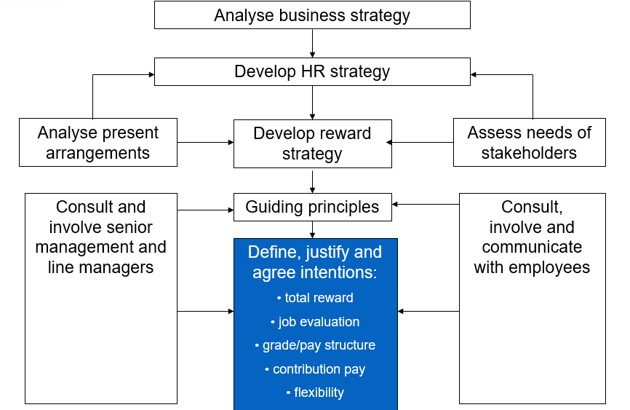
Source: Armstrong (2006b)

Financial and non-financial rewards
Rewards can be categorised into financial and non-financial rewards. It is worth highlighting that Money is always a powerful factor directly or indirectly leading to the satisfaction of needs. However, it is not effective with the people with intrinsic motivation, and people who have no expectation of achieving the financial rewards. This is an important factor for consideration especially in SMEs context when financial resources are limited while SMEs have many other qualities which can differentiate its reward system from those with deep pockets. Some examples include a positive working atmosphere, job enrichment and enlargement, empower employees in key decisions, involving them in key business activities, offering recognition to employees with achievement through praises and thank you notes etc. (see Figure 5).

Figure 5. Reward systems
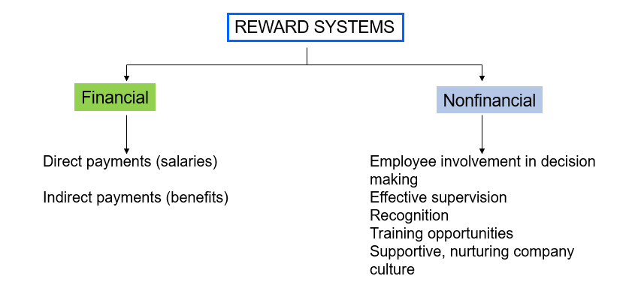
Source: Armstrong (2006a)

Rewarding Individuals or Teams
One of the key questions when exploring the subject of rewards and recognition is the identification of an individual or a team-based rewards system. This is an important consideration in a SMEs because unhealthy competition may result in poor work atmosphere, deter transfer of knowledge and finally creates unnecessary peer competition. On the other hand, it is also important to recognize a star performer or an outstanding employee without damaging his or her relationship with their peers. Thus, depending on the firm’s culture and value, it is important to consider this aspect when designing the reward system (see Figure 6).

Figure 6. Total rewards
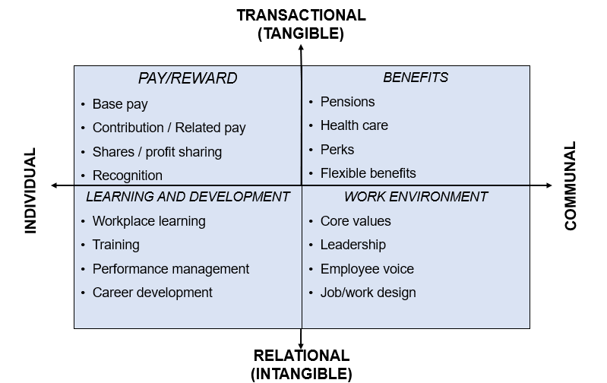
Source: Armstrong & Brown (1999)

Principles of Total Reward
Total reward takes into account what an employee values from their employment relationship, which not only includes monetary benefits such as the main salary, but other rewards that are linked to their achievements, personal growth and working environment (see Table 1).
Table 1. Reward categories and examples
Monetary rewards/pay in-kind benefits | Non-monetary rewards and incentives
- Basic salary  - Bonus schemes  - Stock options  - Profit sharing plans  - Gainsharing plans  - Discounts on company’s or partner company’s products and services  - Free coffee  - Subsidised or free gym and other memberships  - Shopping vouchers  - Luncheon vouchers | - Job enrichment  - Job rotation  - Flexible hours  - Good working atmosphere  - Pleasant and safe work environment  - Empowerment through delegation  - Job security  - Praise and recognition  - Work-life balance  - Training and development opportunities
Source: Adapted from CIPD and Armstrong & Taylor (as cited in Komulainen et al., 2019)

Specifics of employee motivation and reward management in SMEs
Many SMEs have overlooked the importance of motivating and rewarding their employees. This can be a problem to developing a sustainable workforce in SME where workers are younger or older, less well-trained and more likely to change work places compared with in larger where there may be more opportunities for internal promotion and professional development. Also, closer social-working relationships may be a significant factor to enhance SME workers’ satisfaction.
Thus, we hope this chapter will reiterate the importance of rewarding employees and provide some basic tools for SMEs to incorporate as practices to consider when designing and implementing their human resource management strategies.

Many SME managers may feel that fewer resources constrain their competitiveness to reward their employees in comparison with larger corporations. However, from this chapter, it is evidenced that there are many other factors for consideration to motivate employees with the right rewards. There are many non-financial options which can be more effective than higher pay or a bigger bonus such as a family friendly culture. For example, compensating employees fairly, support to help employees tap their potentials, a good design of job which can enrich their personal developments, providing appropriate recognition and praises, planning their developments, empowering them with a voice etc. are actions an SME can explore with some extra managerial resources but little financial impact on its costs. When done right, this will result in better staff retention, increased staff motivation and productivity, improved organisation culture and work atmosphere which will result in better customer experience, thus the positive impact on the company’s bottom line!
Also, it is worth highlighting that in SMEs there is an advantage for rewarding their employees over larger companies. This is commonly known as the owner-manager prerogative. The owner is often seen as a central figure in pay arrangements and also in employment relationships and practices. In addition, they are focused as respondents in HRM practice research, targets of government support and policies, and as strategic heads. When determining rewards, owner-managers can use their prerogative over employees. For example, instead of financial rewards, employees might receive other non-financial rewards such as paternity/maternity leave that is longer that statutory requirements, late morning starts and flexible working.
It is also observed that some SMEs find it difficult to implement a formal performance-reward linked system or make them work effectively. Limited resources and competencies to carry out such formal reviews are two common problems.
Reward and recognition processes are dynamic, they vary from firm to firm and change over time. Owner-managers and employees accommodate, adapt to, and potentially struggle with one another in developing employment relationships. SME practices are produced by a mixture of external and internal influences. External factors such as legislation and national regulations interact with internal organisational processes.

Survey results from SHARPEN - Employee remuneration/reward management
Many SMEs questioned in the SHARPEN project survey confirmed that reward management is not a task for one person in the organisation. Responses vary across countries in Europe. As Table 2 shows, responsibility for reward management in SMEs is often undertaken by owners (however, it varied from 34% in the Lithuanian region of Klaipeda to more than 85% in the German region of Zwickau. The responsibility is usually shared with line managers. The process support can be also provided by an HR specialist. In Lithuania and Finland (Kajaani), accountants also participated in reward management (probably mainly in relation to regular wages/salaries payments).
Table 2. Who undertakes employee remuneration/reward management (%)
Country |  | Who undertakes employee remuneration/reward management (%)
 |  | Owner |  | Line manager |  | HR specialist |  | Accountant |  | Admin. worker |  | External HR specialist / agency |  | Other |  | Activity is not performed
CZ | 52.50 |  | 55.00 |  | 11.25 |  | 2.50 |  | 3.75 |  | 0.00 |  | 3.75 |  | 2.50
Finland | 79.45 |  | 19.18 |  | 4.11 |  | 17.81 |  | 0.00 |  | 5.48 |  | 2.74 |  | 4.11
Germany | 85.54 |  | 32.53 |  | 38.55 |  | 1.20 |  | 0.00 |  | 1.20 |  | 4.82 |  | 1.20
Lithuania | 34.07 |  | 50.55 |  | 13.19 |  | 16.48 |  | 4.40 |  | 1.10 |  | 2.20 |  | 8.79
UK | 45.07 |  | 28.17 |  | 43.66 |  | 9.86 |  | 1.41 |  | 0.00 |  | 4.23 |  | 8.45

Source: Maršíková et al. (2019)
Note: respondents could choose more than 1 option
You can find more information about the SHARPEN research in our research publication:
Maršíková, K., Rajander, T., Clauß, A.-M., Medžiūnienė, I., Meschitti, V., Štichhauerová, E, Davies, J., Dulkė, D., Komulainen, R., Macháčková, V., Richter, M., Schumann, C.-A., Moš, O., & Forkel, E. (2019). People management challenges for SMEs in five European regions: Spotlighting the (in)visible and the (in)formal and embedding SME HR issues firmly in the business and knowledge environment. Huddersfield, UK: University of Huddersfield. ISBN: 978-1-86218-168-7
Link: https://sharpen.ef.tul.cz/upload/PublicationHRMinSMEs_research.pdf

Summary
Reward management is concerned with the strategies, policies and practices required to ensure that the value of people and the contribution they make to achieving organisational, departmental and team goals are recognised and rewarded. Reward management includes not only pay and employee benefits, but also non-financial rewards such as appreciation, learning and development opportunities and increased job responsibility.
The aims of reward management are: to reward people according to what value they create and what the organisation values, align reward practices with both business goals and employee values, reward the right things to convey the right message about what is important in terms of behaviours and outcomes, facilitate the attraction and retention of the skilled and competent people the organisation needs, help in the process of motivating people and gaining their commitment and engagement, support the development of a performance culture and develop a positive employment relationship and psychological contract.
The aims of reward management are achieved by developing and implementing strategies, policies, processes and practices that are founded on a philosophy, operate in accordance with the principles of distributive and natural justice, function fairly, equitably, consistently and transparently, are aligned to the business strategy, fit the context and culture of the organisation, are fit for purpose and help to develop a high-performance culture.
The determination and maintenance of a fair and effective reward system within an enterprise is one of the most important and most difficult tasks. Designing a pay system involves striking a balance between the objectives of employer and employee, however, in small regional SMEs with limited resources we advocate a best fit rather than best practice approach.

You can find more practical information and advice in our publication:

Komulainen, R., Maršíková, K., Davies, J., Srėbaliūtė, I., Clauß, A.-M., Moš, O., Muschol, H., Rydvalová, P., Forkel, E., & Štichhauerová, E. (2019). A Good Practice Guide to Managing Human Resources in Regional SMEs. Huddersfield, UK: University of Huddersfield.
ISBN: 978-1-86218-167-0
Link: https://sharpen.ef.tul.cz/upload/HRM4SMEs_Handbook.pdf


Section review questions
- What is reward management?
- What are the main aims of reward management?
- What is a reward system?
- What is the meaning of reward?
- How does reward impact on performance?
- What are the differences between financial and non-financial rewards?
- What reward systems may be appropriate for SMEs?

Video links
SHARPEN. Practical Tool for SMEs – Reward and Incentive Scheme. Link for video 1: https://youtu.be/PpoDwxSBnqA and for video 2: https://youtu.be/abz7B7Veqgc.
SHARPEN. Rewards and Incentive for SMEs. Link: https://www.youtube.com/watch?v=8Fz8SHedBnQ.
SHARPEN. Employee motivation practical tool. Link: https://www.youtube.com/watch?v=xtJnb4UG8eo

Dictionary
Extrinsic motivation | External factors which affect the motivation of a person such as recognition, praise, performance-based bonus.
Intrinsic motivation | Internal individual drivers e.g. the satisfaction arising as a result of accomplishing a challenge or an output for which the person is proud.
Motivation | The factors that drive an individual to act or behave in a specific way.
Rewards | These can be monetary or non-monetary incentives given to employees. Examples include recognition, praises, promotion, enriching the person’s job, providing greater autonomy and decision-making power (non-monetary) or pay rise, bonuses etc. (monetary)

Case studies
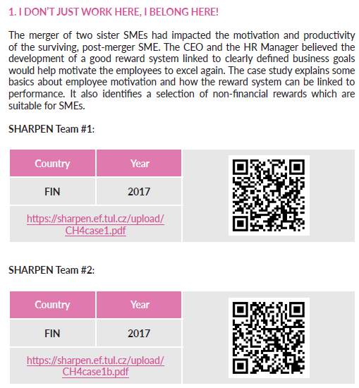

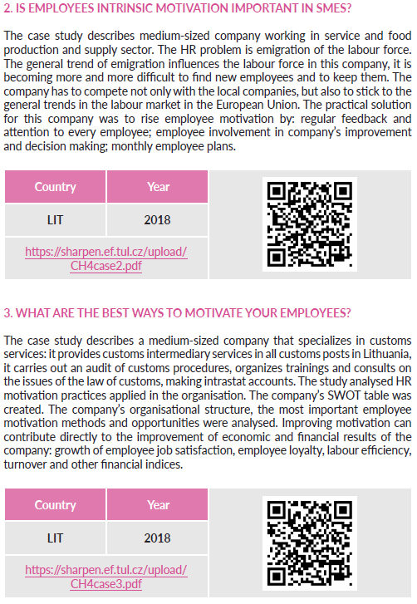

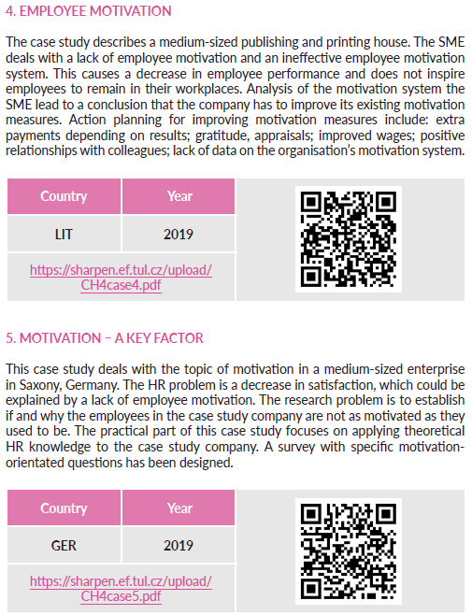


References
Armstrong, M. & Brown, D. (1999). Paying for contribution: Real performance-related pay strategies. London, United Kingdom: Kogan Page.
Armstrong, M. (2006a). A Handbook of human resource management practice (10th ed.). London, United Kingdom: Kogan Page.
Armstrong, M. (2006b). Strategic human resource management: A guide to action (3rd ed.). London, United Kingdom: Kogan Page.
Armstrong, M. & Taylor, S. (2014). Armstrong's handbook of human recource management practise (13th ed.). London, United Kingdom: KoganPage.
Bridgman, T., Cummings, S., & Ballard, J. (2019). Who built Maslow’s pyramid? A history of the creation of management studies’ most famous symbol and its implications for management education. Academy of Management Learning & Education, 18(1), 81-98.
CIPD. (2013). Reward management annual survey report 2013. [cit. 2018-08-19]. Retrieved from: https://www.cipd.co.uk/Images/reward-management_2013_tcm18-11381.pdf.
Komulainen, R., Maršíková, K., Davies, J., Srėbaliūtė, I., Clauß, A.-M., Moš, O., Muschol, H., Rydvalová, P., Forkel, E., & Štichhauerová, E. (2019). A Good Practice Guide to Managing Human Resources in Regional SMEs. Huddersfield, UK: University of Huddersfield.
Maršíková, K., Rajander, T., Clauß, A.-M., Medžiūnienė, I., Meschitti, V., Štichhauerová, E, Davies, J., Dulkė, D., Komulainen, R., Macháčková, V., Richter, M., Schumann, C.-A., Moš, O., & Forkel, E. (2019). People management challenges for SMEs in five European regions: Spotlighting the (in)visible and the (in)formal and embedding SME HR issues firmly in the business and knowledge environment. Huddersfield, UK: University of Huddersfield.
McLeod, S. A. (2007). Maslow's Hierarchy of Needs. London: HCC Certificate in Counselling Skills. [cit. 2018-08-29]. Retrieved from: http://highgatecounselling.org.uk/members/certificate/CT2%20Paper%201.pdf.
Porter, L. W. & Lawler, E. E. (1968). Managerial attitudes to performance. Homewood: Irwin-Dorsey.
SHARPEN. (2017). I don’t just work here, I belong here! Motivating employees through rewards and incentives. [cit. 2018-06-14]. Retrieved from: http://fliphtml5.com/kpig/zslj.
Vroom V. H. (1964). Work and motivation. Oxford, United Kingdom: Wiley.
Wapshott, R. & Mallett O. (2016). Managing human resources in small and medium-sized enterprises: Enterpreneurship and the employment relationships. London, United Kingdom: Routledge.

The project has been funded by the Erasmus + KA2 Strategic Partnership programme. Project agreement number: 2016-1-CZ01-KA203-023916.

Legal notice:
The views expressed in this publication are the sole responsibility of the authors and do not necessarily reflect the views of the European Union, of the ERASMUS programme national agencies nor of the project partner universities. The Union, the national agencies and the universities are not liable for any use that may be made of the information contained therein.

Appendix
Table 3. Reward approaches part 1
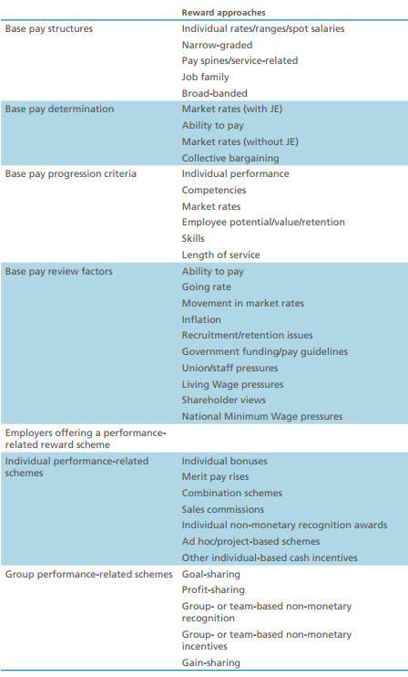
Source: CIPD (2013)

Table 4. Reward approaches part 2
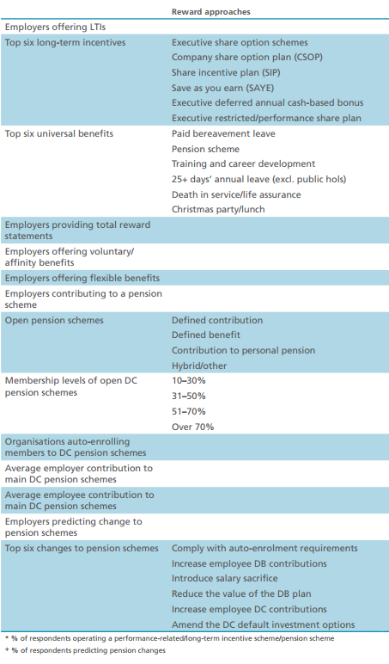
Source: CIPD (2013)

