5. Risks of Employee Turnover

This section aims to:
- Introduce the concept of employee turnover and risks associated with turnover and retention.
- Stimulate discussion about staff turnover and retention in small medium enterprises for HRM.
- Explain the main reasons associated with employee turnover and strategies for controlling churn.
- Emphasize the importance of organisations in maintaining high retention and to develop productive working relationships that require constant engagement between line managers and employees and employee voice.


Keywords
Employee turnover, voluntary, involuntary, employee turnover index, risk management and retention in HRM and SMEs.


Required knowledge
Knowledge of basic human resource management terms.


Time requirements
Total time recommended to study this chapter: two hours.

Contents
Introduction to employee turnover 3
Reasons for employee turnover 4
Merits and limitations of employee turnover 6
Measuring employee turnover 7
Definition and concepts of risk management 7
Retention 8
Strategies to address retention 9
Specifics of employee retention in SMEs 10
Employee retention in numbers (SHARPEN survey) 10
Summary 13
Section review questions 13
Video links 13
Dictionary 14
Case studies 15
References 18


Introduction to employee turnover
Employee turnover is a very important concept in Human Resource Management because employees are an organisation’s most important asset (Fursso, 2015). Losing a key person can impact disproportionately on an organisation. It has been said that there is no such thing as a job for life and that the employees that a company wants to retain the most are the ones on the verge of handing in their resignation or ready to dash out of the door for a better offer (Armstrong, 2017).
This creates a major challenge for organisations to retain the workforce as a lot of costs are incurred directly or indirectly. Because employees are the building blocks of any organisation, the focus has to be directed towards their retention as the companies they work for need to maintain a competitive advantage over the other firms. In today’s business competitive world, it is of esteem importance that organisations manage their staff turnover as it essentially correlates to achieving high productivity and overhead goals (Fursso, 2015).
Defining employee turnover
There are several definitions of staff turnover but simply put, Employee turnover can be defined as the percentage of employees in a workforce that leave during a certain period of time and are replaced by new employees (Armstrong, 2017). Alternatively, Abassi & Hollman (2000) define employee turnover as the rotation of workers around the labour market, between jobs, firms, and occupations and between states of employment and unemployment.
People leave organisations for several reasons and staff turnover can occur in any firm. Employee turnover that may occur in any enterprise may be either voluntary or involuntary. Investigations have shown that the latter is generally good for an organisation’s interest but voluntary turnover may prove detrimental (Loquecio, 2005).
Voluntary Turnover
When an employee decides to leave an organisation or position voluntarily. Usually this type of turnover results in other competing firms hiring the departing employee creating a more critical situation since the departure of a key person may result in the exposure of the knowledge they have acquired on the job being used by the competitor. In research and development, exposure of information is eminent as is it embodied in the employee.
Involuntary Turnover
The decision or action taken by the employer to remove an employee from a position or organisation, e.g. because of redundancy, misconduct.

Reasons for employee turnover
Several reasons can be attributed to employee turnover. Usually, voluntary turnover can occur due to the following (see Figure 1):
Figure 1. Reasons for the employee turnover
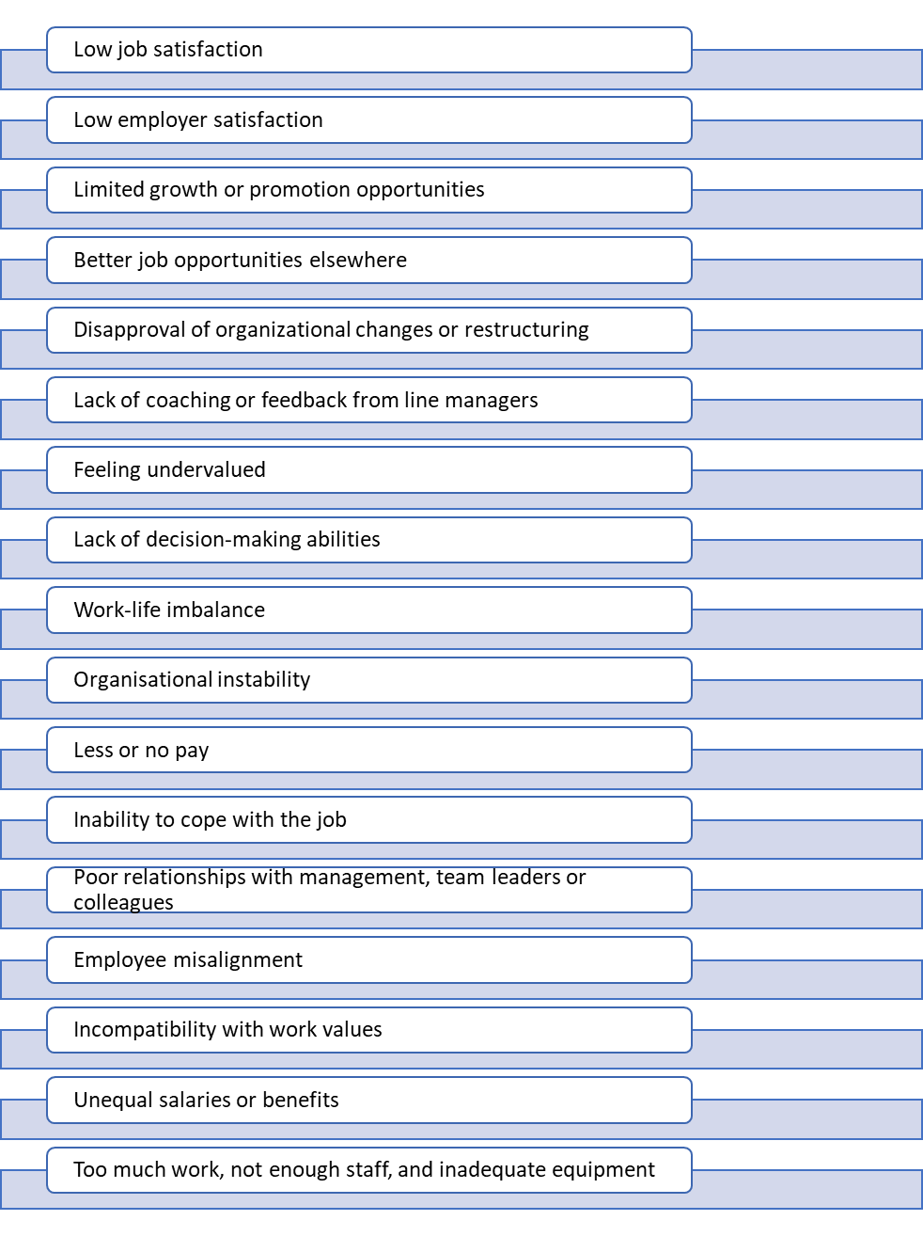Source: Foot et al. (2016), Armstrong & Taylor (2014), own elaboration
Voluntary employee turnover is generally considered as a negative event for small organisations because it may be that ‘most of the small firm's assets reside in human capital (Wapshott & Mallet, 2015). This means that when employees leave, the business could be losing some of the attributes on which it trades. This, in turn, creates a vicious cycle among employees resulting low productivity or no result orientation as Figure 2 demonstrates.
Figure 2. Process of an employee turnover
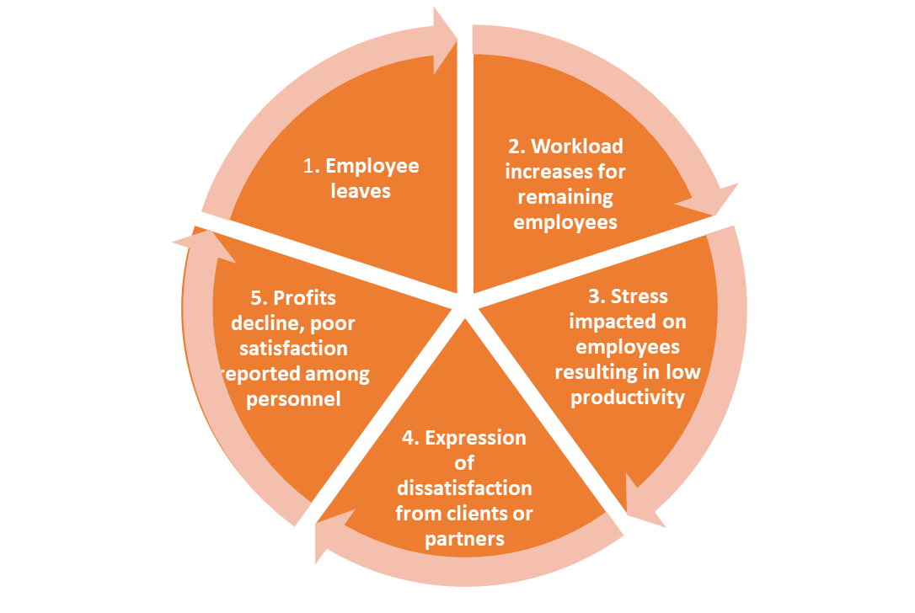
Source: Foot et al. (2016), own elaboration
Not all workforce turnover can be controlled by the enterprise but voluntary turnover should be a major priority for managers. Voluntary turnover can be further differentiated into a functional and dysfunctional turnover (Fursso, 2015). Functional turnover is the resignation of a substandard performer while dysfunctional turnover refers to the exit of an effective performer, which is of concern to management due to its negative effects on the organisation’s general performance.
Functional and dysfunctional turnovers could be further classified as avoidable and unavoidable. Avoidable turnover refers to exit initiated by low compensation or poor working conditions while unavoidable turnover is that caused by terminal illness, death or the relocation of a worker (Taylor, 1998). An organisation has little or no control over this type of turnover (see Figure 3).

Figure 3. Types of employee turnover
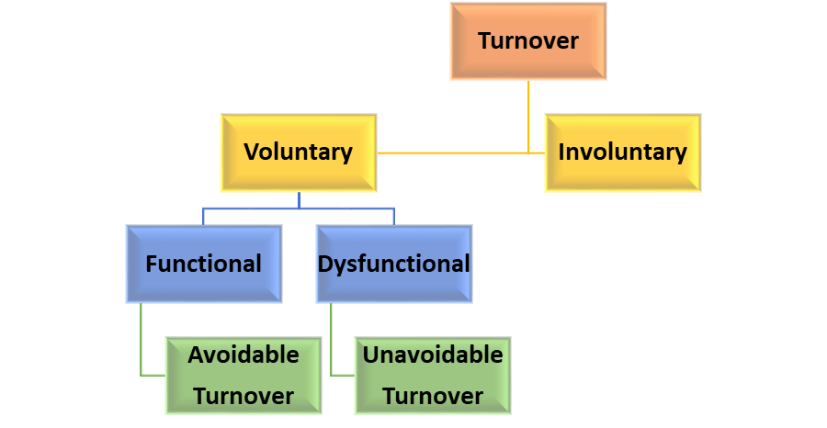
Source: Adapted from Griffeth & Hom (as cited in Komulainen et al., 2019)

Advantages and disadvantages of employee turnover
High turnover across an industry might portray the sector as undesirable for future employees but not all turnover is associated with negative impacts (Griffeth & Hom, 2001). A short overview of advantages and disadvantages related to employee turnover is shown in Table 1.
Table 1. Advantages and disadvantages of employee turnover
Advantages  - Talent infusion which enables the ability to cover any existing knowledge gap  - Efficiency as a result of an updated work process and fresh perspective  - Improved morale  - Stimulation of new working practices  - Cost saving for the firm. Longstanding employees result in demanding higher wages and pension benefits  - Lower benefit rates for insurance  policies | Disadvantages  - High costs associated with hiring and training new employees  - Disruptive  - Loss of knowledge especially if the key person moves to a competing firm thereby benefiting rival business  - Dampens enthusiasm among workers about who will be dismissed next  - Hamper's success of business especially for small firms’ dependent on specialist knowledge  - Social aspects are affected especially by a maintained client relationship
Source: Adapted from Griffeth & Hom, 2001; Armstrong, 2017

Measuring employee turnover
Employee turnover is measured using an index known as the employee turnover index (see Figure 4). It is sometimes referred to as the ‘labour wastage index’. The traditional index is usually calculated annually and is measured because it enables calculations of the future forecast of losses for planning ahead purposes and identification of the reasons for turnover (Armstrong, 2017).
Figure 4. The employee turnover index
Number of employees leaving during a period
------------------------------------------------------------- X 100
Average number employed during a period
Source: Adopted from Armstrong (2017)
There are a couple of factors to consider when calculating this index, some of which include;
- The direct cost of recruiting replacements e.g., interviews and advertising
- The direct cost of introducing replacements – Induction
- The direct cost of training in the necessary skills
- The leaving cost of HR and Administration
- The opportunity cost of the time spent by HR and HR managers for recruiting
- Loss of output during the waiting period of finding a replacement
- The loss of output while training new recruits

Definition and concepts of risk management
As stated earlier, the departure of a key person in an organisation can be detrimental both in the short and long run. The essence of risk management is to ensure that departure is controlled. Ardiphine (2015) defines risk management as the identification, analysis, assessment, avoidance, minimization or elimination of unacceptable risk.
The risk of employee turnover
The risks of employee turnover can be easily associated with its demerits. These risks are the downside of turnover to organisations large or small and some of them include;
- The exposure of information or knowledge.
- The loss of a key person or worker to a competing firm can be detrimental to the enterprise especially if this person joins a rival business.
- There are high expenses associated with hiring, recruiting and training of new staff.
- Hampers the success of the business for small firms’ dependent on the knowledge and skill set of a particular employee. This eminent especially in the professional service business.
- Disrupted social aspects with whom a client relationship was maintained for example consultants or suppliers.
- High turnover across an industry may portray the sector as an unattractive career path.
- SME’s especially struggle to find replacements after a turnover, especially for key roles. The reason is that they are not a first choice employer to work for if one is looking to progress in their career.
- High staff turnover results in businesses having a limited number of employees who understand risk management and are able to transfer this knowledge to the new recruits.
- The shortage of staff then results in the need for formal training which is usually externally sourced and is expensive. This then makes organisations reluctant to invest in formal training assuming the investment will ‘’Exit’’ the business resorting to on the job training approach.

Retention
Retention is defined as the number of employees who stay in an organisation annually (Armstrong, 2017). Low levels of employee turnover are treated as an indicator of effective human resource management (Wapshott & Mallet, 2015). But to put across a contrasting viewpoint, what then happens to the employees who lack viable and available alternatives elsewhere in the job market? In the case where dissatisfied employees find themselves stuck in an organisation creates a ‘’staff retention’’ problem. The retention of an unhappy, dissatisfied and unproductive staff unable to leave an organisation has potential to cause debilitating effects, especially in small firms (Wapshott & Mallet, 2015).
There several reasons why employees choose to stay in an organisation. Some of these are attributed to the following:
- Feeling valued.
- Job considerations e.g., number of days leave.
- Commitment to the employers or organisation.
- Availability of alternatives.
Factors affecting retention
The propensity to stay or leave is affected by the stage of the employees’ career and their age (Armstrong, 2017), therefore, retention strategies should be based on understanding the factors that affect whether or not employees stay or leave and should be personalised. Some of these include:
- The company image or employer brand.
- What the employer offers in the shape of terms and conditions of employment and what has been called the ‘the quality of working life’.
- The effectiveness of recruitment, selection, and deployment into the suitable job.
- Leadership: good employees do not leave good organisations, they leave poor managers. Employees join companies and leave managers.
- Social factors: the extent to which individuals get along with their co-workers.
- Learning and career opportunities.
- Performance recognition and awards.

Strategies to address retention
The main reason for addressing employee retention is to ensure that the loss of competent employees in an organisation does not occur as it results in lower productivity and poor service delivery (Samuel & Chipunza, 2009). Retention activities or strategies may be defined as a sum of all activities aimed at increasing organisational commitment of employees, giving the overall ambition and myriad of opportunities where they can grow by outperforming others (Bogdanowicz & Bailey, 2000). Some of these strategies are shown in Figure 5.
Figure 5. Examples of retention activities and strategies
Source: Armstrong (2017)

Specifics of employee retention in SMEs
For SMEs there might be significant risk of key employees leaving for a rival business or setting up their own venture. SMEs should use their strength to maximise the employee retention. It may seem to be harder for SMEs to keep employees engaged, content and motivated to perform well for both themselves and the company comparing to large corporations. However, SMEs should benefit from familiarity between employees, more and direct feedback, easier and more direct communication on all levels. SMEs can also offer very often the capacity to offer faster career progression to their eager employees which can be considered as very attractive factor for motivate employees. Often, SMEs are more opened to flexible working as flexitime, telecommuting, shift swapping. In SMEs we can also find more space for regular catch-ups and meetings. For retention also reward management system is very important (Smallbusiness.co.uk, 2016).

Employee retention in numbers (SHARPEN survey)
Based on the survey carried out in the SHARPEN project, we compared some factors of employee turnover and retention in SMEs across five European regions.
Because one of the important aspects of employee retention is to use effective system of performance evaluation (appraisal), it is interesting to compare employee performance appraisals used in SMEs from the SHARPEN survey results carried out in five European regions in 2018. Figure 6 shows that, for instance, Czech SMEs use performance appraisal mainly for further training and development and also career planning and reward management.
Figure 6. Why SMEs use performance appraisal – case of Czech SMEs in the Liberec region

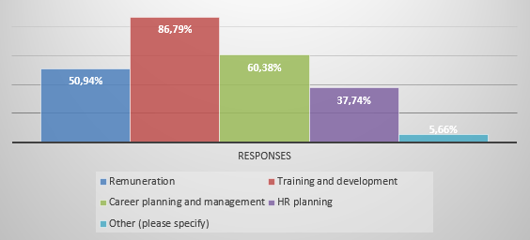
Source: Own elaboration

To retain employees, it is important to look after them when they are part of the enterprise and thus to support SMEs’ employer brand. It helps to decrease employee turnover and the costs of recruitment and supports employee retention.

Employer branding (EB) is important to support an organisation’s image to its own employees and to those who are associated with the organisation from the outside. As the Figure 7 shows, in some regions (e.g. CZ, UK) this activity was confirmed as very important, in others as not important. For activities related to EB, mainly the owner or HR specialists are responsible. For internal EB, line managers also are involved.
Figure 7. Who performs employer branding (responses relative in %) in SMEs in five European regions
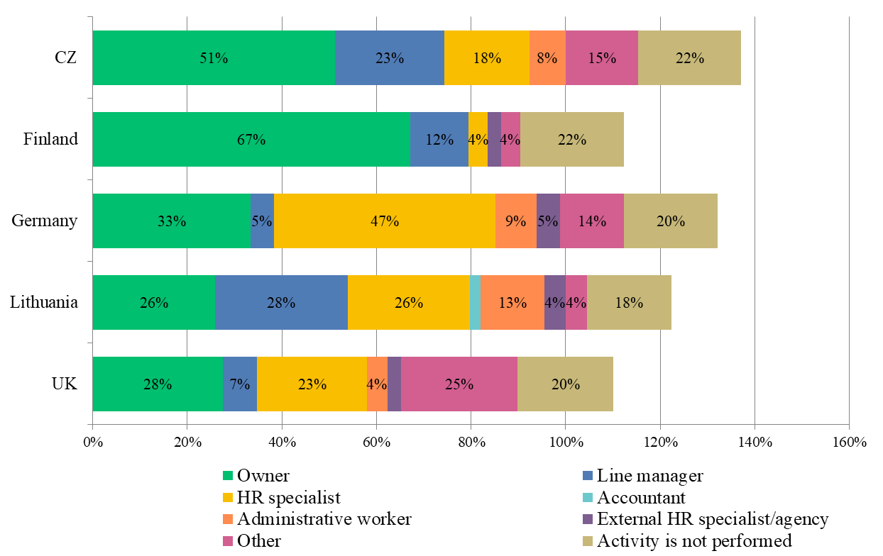

Source: Maršíková et al. (2019)
Most of the HR processes influence the retention and rate of turnover of employees. From the Table 2 it is interesting to see the SMEs across five regions see the importance of HRM activities differently (see Table 2). In comparison induction process is seen as important by SMEs in all five regions.

Table 2. Importance of selected HRM activities for SMEs in five European regions
HRM activity | Average importance
HRM activity | CZ | FIN | GER | LIT | UK
Induction process (e.g. welcome packages for employees) | 3.20 | 3.39 | 3.58 | 3.18 | 3.59
Creation of HR strategy | 2.43 | 3.06 | 3.07 | 2.85 | 3.14
Employee performance evaluation | 3.30 | 3.29 | 3.14 | 3.05 | 3.41
Employee remuneration/reward management | 3.46 | 3.46 | 3.23 | 2.89 | 3.24
Employee training and development | 2.96 | 3.17 | 3.33 | 3.08 | 3.54
Employee well-being | 3.20 | 3.70 | 3.03 | 3.11 | 3.55
Monitoring KPI (key performance indicators) in HR | 1.85 | 2.73 | 2.51 | 3.13 | 3.12
Employer branding | 3.01 | 2.89 | 2.79 | 2.95 | 3.09
Career management | 2.57 | 2.79 | 2.59 | 2.93 | 2.97
Employee satisfaction and engagement | 3.24 | 3.64 | 3.48 | 3.08 | 3.49

Note: Classification criteria for Table 2
Importance | INTERVAL
Below average | 1.00 | - | 1.99
Average | 2.01 | - | 2.99
Above average | 3.00 | - | 4.00
Source: Maršíková et al. (2019)
The turnover rate belongs to one of the key KPI indicators, however, SMEs in Czech, Finish and German regions stated that they do not see a monitoring KPI (key performance indicators) in HR as important.
You can find more information about the SHARPEN research in our publication:
Maršíková, K., Rajander, T., Clauß, A.-M., Medžiūnienė, I., Meschitti, V., Štichhauerová, E, Davies, J., Dulkė, D., Komulainen, R., Macháčková, V., Richter, M., Schumann, C.-A., Moš, O., & Forkel, E. (2019). People management challenges for SMEs in five European regions: Spotlighting the (in)visible and the (in)formal and embedding SME HR issues firmly in
the business and knowledge environment. Huddersfield, UK: University of Huddersfield. ISBN: 978-1-86218-168-7
Link: https://sharpen.ef.tul.cz/upload/PublicationHRMinSMEs_research.pdf

Summary
As much as an organisation’s work environment can be pleasant and rewarding, there are still certain problems or factors that might still push people away. Unfortunately, most organisations cannot counter pull the market, simply put, they cannot shield their employees from aggressive recruiters and attractive opportunities. With this regard, the goal of human resource needs to evolve, from the traditional aim of minimizing the number of overall employee turnover to influencing who leaves and when they leave. Because in today's highly competitive and globally interactive world, there is no such thing as a job for life.

You can find more practical information and advice in our publication:
Komulainen, R., Maršíková, K., Davies, J., Srėbaliūtė, I., Clauß, A.-M., Moš, O., Muschol, H., Rydvalová, P., Forkel, E., & Štichhauerová, E. (2019). A Good Practice Guide to Managing Human Resources in Regional SMEs. Huddersfield, UK: University of Huddersfield.
ISBN: 978-1-86218-167-0
Link: https://sharpen.ef.tul.cz/upload/HRM4SMEs_Handbook.pdf


Section review questions
- How would you define employee turnover?
- What is the difference between voluntary and involuntary turnover?
- What are some of the factors attributed to positive turnover?
- How is employee turnover measured?
- Why do SMEs struggle to retain employees?
- Name some strategies that could be used to retain staff.
- Define the term ‘risk management’ and explain why is it important in HRM.

Video links
SHARPEN. Employee Turnover and Retention. Link: https://youtu.be/kSEcl0gULRE
SHARPEN. Learning and Development (important process as a part of employee retention). Link: https://www.youtube.com/watch?v=2JCa_QNlGu4

Dictionary
Employee retention | Current staff remaining with the organisation.
Employee turnover | The measurement of the number or rate of employees who leave an organisation during a specified time period, typically one year.
Inducement | An enticement that persuades or leads someone to act.
Involuntary turnover | When an employer chooses to terminate an employee’s employment contract, possibly because of poor performance, toxic behaviour, or other reasons.
Organisational climate | The individual employee’s perception of the psychological impact of the work environment on his or her own well-being.
Retention management plan | A systematic effort by employers to create and foster an environment that encourages current employees to remain at the same employer, having policies and practices in place that address their diverse needs.
Retention strategies | Policies and practices that organisations follow to reduce employee turnover and attrition and ensure employees are engaged and productive long-term.
Turnover prediction | Data analysis to forecast employee turnover.
Voluntary turnover | Any instance in which an employee actively chooses to leave an organisation of their own accord. This can happen as a result of better job opportunities elsewhere, conflict within the workplace, disengagement, and more.

Case studies
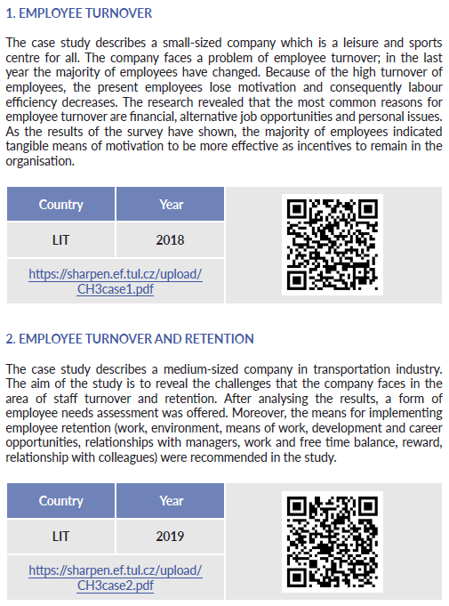
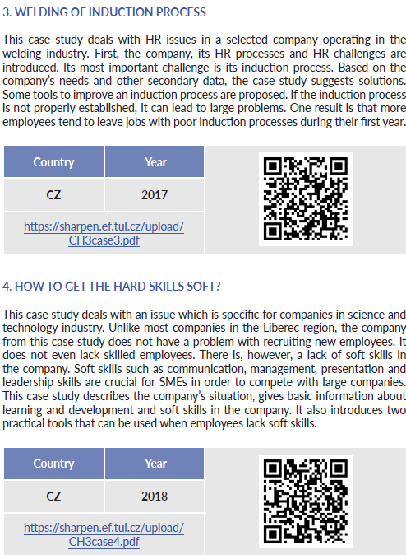

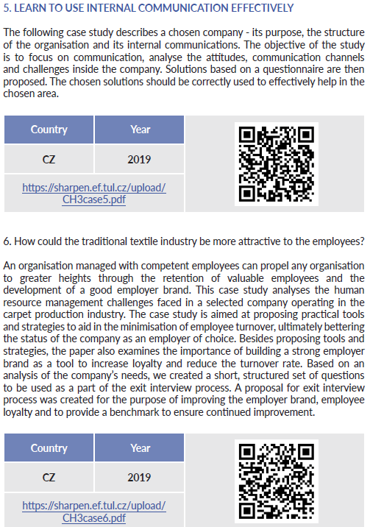


References
Abbasi, S. M. & Hollman, K. W. (2000). Turnover: The real bottom line. Public Personnel Management, 29(3), 333-342. doi: 10.1177/009102600002900303.
Ardiphine, R. M. (2015). The loss of a “Key Person”: Risk to the enterprise; How to manage it? Journal of Business and Management, 17(2), 38-44. [2019-06-13]. Retrieved from: http://iosrjournals.org/iosr-jbm/papers/Vol17-issue2/Version-3/D017233844.pdf.
Armstrong, M. & Taylor, S. (2015). Armstrong’s handbook of human resource management practices: Modern concepts and procedures (13th ed.). London, United Kingdom: Kogan Page.
Armstrong, M. (2017). Armstrong´s handbook of human resource management practice (14th ed.). London, United Kingdom: Kogan Page.
Bogdanowicz, M. S. & Bailey, E. K. (2000). The value of knowledge and values of new knowledge worker: generation X in the new economy. Journal of European Industrial Training, 26 (2/3/ 4), 125 – 129. doi: 10.1108/03090590210422003.
Fursso, A. R. (2015). The causes and effects of employees’ turnover: The case of Oromia water works design and supervision enterprise. (Master’s Thesis). Addis Ababa university in Addis Ababa. Retrieved from: http://etd.aau.edu.et/bitstream/handle/123456789/13224/Aman%20Racho.pdf?sequence=1&isAllowed=y.
Foot, M., Jenkins, A. & Hook C. (2016). Introducing Human Resource Management 7th ed. Edinburg. UK: Pearson Education Limited.
Griffeth, R. W. & Hom, P. W. (2001). Retaining valued employees. Thousand Oaks, United States: Sage.
Komulainen, R., Maršíková, K., Davies, J., Srėbaliūtė, I., Clauß, A.-M., Moš, O., Muschol, H., Rydvalová, P., Forkel, E., & Štichhauerová, E. (2019). A Good Practice Guide to Managing Human Resources in Regional SMEs. Huddersfield, UK: University of Huddersfield.
Loquercio, D. (2005). Staff Turnover: How it affects humanitarian aid agencies, what can be done. Unpublished MSc dissertation, University of Manchester.
Maršíková, K., Rajander, T., Clauß, A.-M., Medžiūnienė, I., Meschitti, V., Štichhauerová, E, Davies, J., Dulkė, D., Komulainen, R., Macháčková, V., Richter, M., Schumann, C.-A., Moš, O., & Forkel, E. (2019). People management challenges for SMEs in five European regions: Spotlighting the (in)visible and the (in)formal and embedding SME HR issues firmly in the business and knowledge environment. Huddersfield, UK: University of Huddersfield.
Samuel, M.O. and Chipunza, C. (2009) Employee Retention and Turnover: Using Motivational Variables as a Panacea. African Journal of Business Management, 3, 410-415.
Smallbusiness.co.uk. (2016a). Staff retention: Five ways SMEs can keep quality employees. [2018-06-19]. Retrieved from: https://smallbusiness.co.uk/staff-retention-five-ways-smes-can-keep-quality-employees-2534059/
Smallbusiness.co.uk. (2016b). Employee retention strategy: A three-step guide. [2018-06-19]. Retrieved from: https://smallbusiness.co.uk/employee-retention-strategy-a-threestep-guide-2505656/
Wapshott, R. & Mallet, O. (2015). Managing human resources in small and medium-sized enterprises: Entrepreneurship and employment relationships. London, United Kingdom: Routledge.

The project has been funded by the Erasmus + KA2 Strategic Partnership programme. Project agreement number: 2016-1-CZ01-KA203-023916.

Legal notice:
The views expressed in this publication are the sole responsibility of the authors and do not necessarily reflect the views of the European Union, of the ERASMUS programme national agencies nor of the project partner universities. The Union, the national agencies and the universities are not liable for any use that may be made of the information contained therein.

