6. Performance Management

The aims of the section are to:
- Give an overview of performance management including performance management theories, aims, cycle, assessment and impact.
- Provide theoretical information about performance management, but rather to highlight the importance of performance management in SME’s.


Keywords
Objectives, performance, management, appraisal, assessment, rating, reward, feedback.


Required knowledge
Knowledge of basic terms in human resource management and basic terms of motivation and behavioural psychology.


Time requirements
Total time recommended to study this chapter: three hours.

Contents

Introduction to performance management 4
Performance management theories 4
Goal theory 5
Control theory 5
Social cognitive theory 5
Aims of performance management 5
Guiding principles of performance management 6
Personal appraisal and performance management 7
The performance management cycle 8
Performance planning – performance agreement 9
Role profiles 10
Key performance indicators 10
Performance goals 10
Action planning 10
The performance management cycle in SMEs 11
Criteria for objectives 12
Managing performance throught the year 13
Performance review 13
Dealing with Underperformers (5 Steps) 15
Performance management issues 15
Performance management issues in SMEs 15
Performance assessment 16
Overall assessment 16
Rating 17
Visual assessment 18
Performance management as a reward process 19
Performance measurement models for SMEs 19
Performance management in SMEs (SHARPEN survey) 22
Summary 23
Section review questions 24
Video links 24
Dictionary 24
Case studies 25
References 27


Introduction to performance management
Performance management (PM) is a process of identifying, measuring and developing the performance of individuals and teams and aligning performance with the strategic goals of the organisation (see Figure 1). According to Armstrong & Taylor (2014), PM comprises five elements: agreement, measurement, feedback, positive reinforcement and dialogue.
It is important to highlight that performance management and reward management are closely associated topics that play an important part in achieving one of the key goals of HRM – to contribute to the development of a high-performance culture. Performance is concerned with how well a task or output is achieved and reward is about recognising individuals for their achievements (Armstrong & Taylor, 2014).
Figure 1. Performance management definition
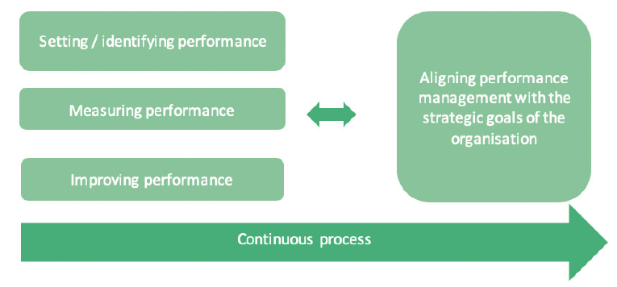
Source: Armstrong & Taylor (as cited in Komulainen et al., 2019)

Performance management theories
Figure 2. Performance management theories
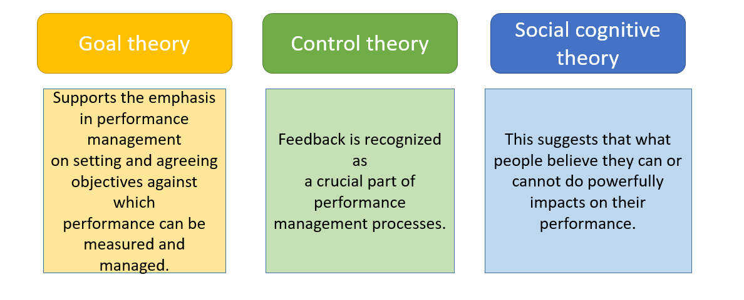
Source: Adapted from Armstrong & Taylor (2014)

Goal theory
Goal theory, as developed by Latham & Locke (1979), highlights four mechanisms that connect goals to performance outcomes:
1) they direct attention to priorities;
2) they stimulate effort;
3) they challenge people to bring their knowledge and skills to bear to increase their chances of success;
4) and the more challenging the goal, the more people will draw on their full repertoire of skills.
This theory supports the emphasis in performance management on setting and agreeing objectives against which performance can be measured and managed.

Control theory
Control theory focuses attention on feedback as a means of shaping behaviour. As people receive feedback on their behaviour, they appreciate the discrepancy between what they are doing and what they are expected to do and take corrective action to overcome the discrepancy. Feedback is recognized as a crucial part of performance management processes.

Social cognitive theory
Social cognitive theory was developed by Bandura (1986). It is based on his central concept of self-efficacy. This suggests that what people believe they can or cannot do powerfully impacts on their performance. Developing and strengthening positive self-belief in employees is, therefore, an important performance management objective (see Figure 2).

Aims of performance management
The overall objective of performance management is to develop and improve the performance of individuals and teams and, therefore, organisations.
The aim is to develop the capacity of people to meet and exceed expectations and to achieve their full potential to the benefit of themselves and the organisation. It is about ensuring that the support and guidance people need to develop and improve is readily available.
Effective performance management has two other important purposes. First, it can communicate to employees the strategic goals of the enterprise and specify what the organisation expects from them in terms of behaviour and results in order to achieve those goals. This means defining what doing a good job entails. Second, it can help with relationship building between employees and their managers. Involving both managers and their staff in performance planning and review can widen the dialogue between them and enhance inter-personal trust.
A summary of what management and individuals can gain from performance management is given in Table 1.
Table 1. What management and individuals can gain from performance management?
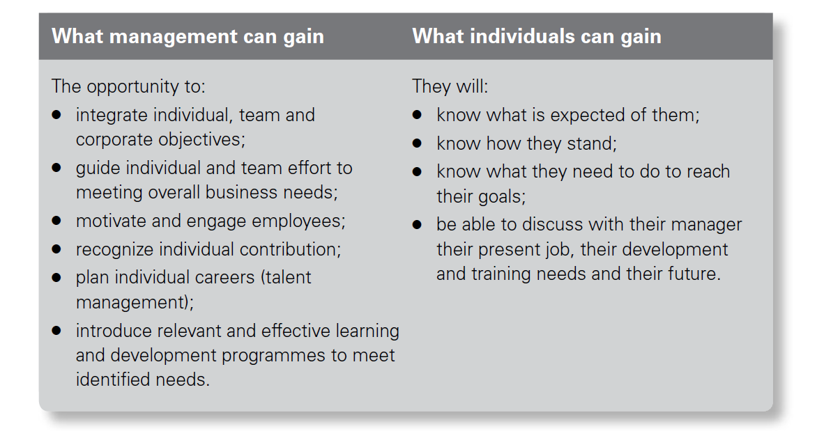
Source: Armstrong (2015)

Guiding principles of performance management
The overarching principles governing effective performance management were defined by Egan (1995, p. 35): “Most employees want direction, freedom to get their work done, and encouragement not control. The performance management system should be a control system only by exception. The solution is to make it a collaborative development system, in two ways. First, the entire performance management process – coaching, counselling, feedback, tracking, recognition, and so forth – should encourage development. Ideally, team members grow and develop through these interactions. Second, when managers and team members ask what they need to be able to do to do bigger and better things, they move to strategic development”.
Strebler et al. (2001) suggested that the following principles are required for performance management to work effectively:
• Have clear aims and measurable success criteria.
• Be designed and implemented with appropriate employee involvement.
• Be simple to understand and operate.
• Make its use fundamental to achieving all management goals.
• Allow employees a clear ‘line of sight’ between their performance goals and those of the organisation.
• Focus on role clarity and performance improvement.
• Be closely allied to a clear and adequately resourced training and development infrastructure.
• Make crystal clear the purpose of any direct link to reward and build in proper equity and transparency safeguards.
• Be regularly and openly reviewed against its success criteria.

Personal appraisal and performance management
It is sometimes assumed that performance appraisal is the same thing as performance management. But there are significant differences. Performance appraisal can be defined as the formal assessment and rating of individuals by their managers at, usually, an annual review meeting. In contrast, performance management is a continuous and much wider, more comprehensive and more natural process of management that clarifies mutual expectations, emphasizes the support role of managers who are expected to act as coaches rather than judges, and focuses on the future.
Performance appraisal has been discredited because too often it has been operated as a top-down and largely bureaucratic system owned by the HR department rather than by line managers. It has been perceived by many commentators (e.g. Townley, 1989) as solely a means of exercising managerial control. Performance appraisal tended to be backward looking, concentrating on what had gone wrong, rather than looking forward to future development needs. Performance appraisal schemes existed in isolation. There was little or no link between them and the needs of the business. Line managers have frequently rejected performance appraisal schemes as being time-consuming and irrelevant. Employees have resented the superficial nature with which appraisals have been conducted by managers who lack the skills required, tend to be biased and are simply going through the motions annually. It is better, probably, to ensure regular conversations for feedback rather than rely on annual appraisals. As Armstrong & Murlis (1998, p. 253) assert, performance appraisal too often degenerated into ‘a dishonest annual ritual’. The differences between them are summed up by Armstrong & Baron (2004) which are set out in Table 2.

Table 2. Performance appraisal compared with performance management
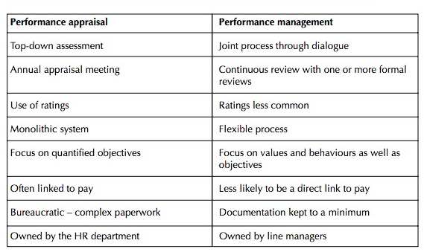
Source: Armstrong & Baron (2004)

The performance management cycle
Performance management is a natural process of management: it is not an HRM technique or tool. As a natural process of management, the performance management cycle corresponds with plan-do-check-act model (see Figure 3).
Figure 3. Performance management cycle
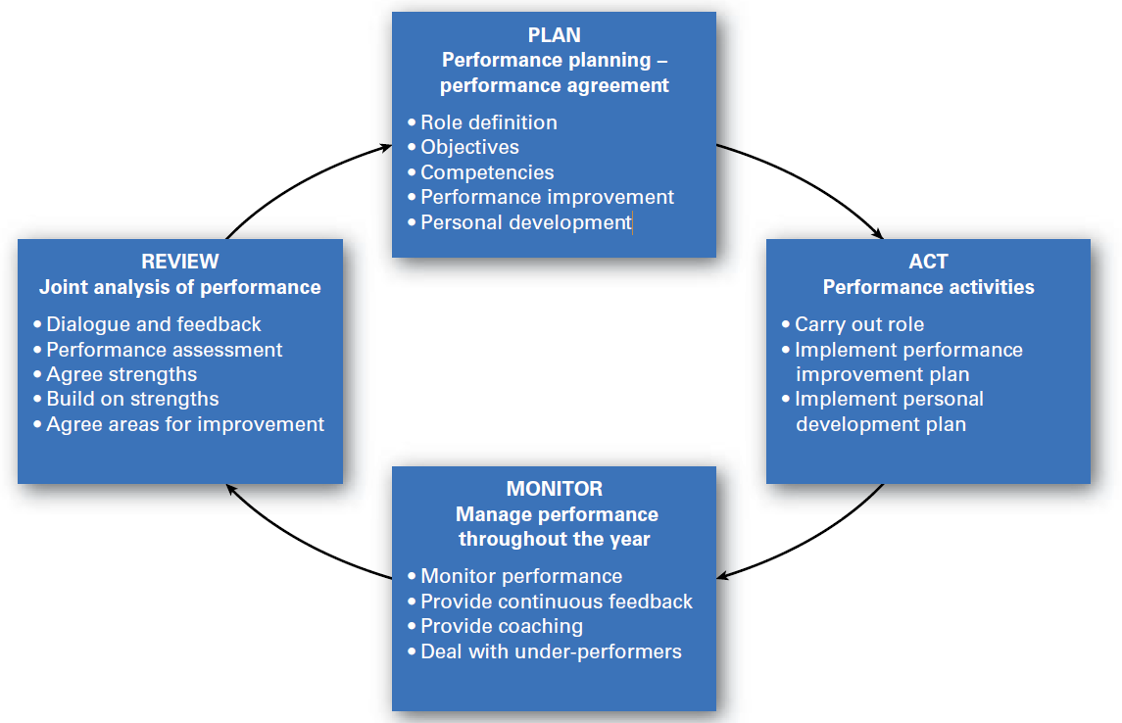
Source: Armstrong & Taylor (2014)

Performance management includes processes of: performance planning, managing performance, performance reviews and performance assessment recording the agreement and review, and the use of web-enabled technology (see Table 3).
Table 3. Summary of performance management activities over the year

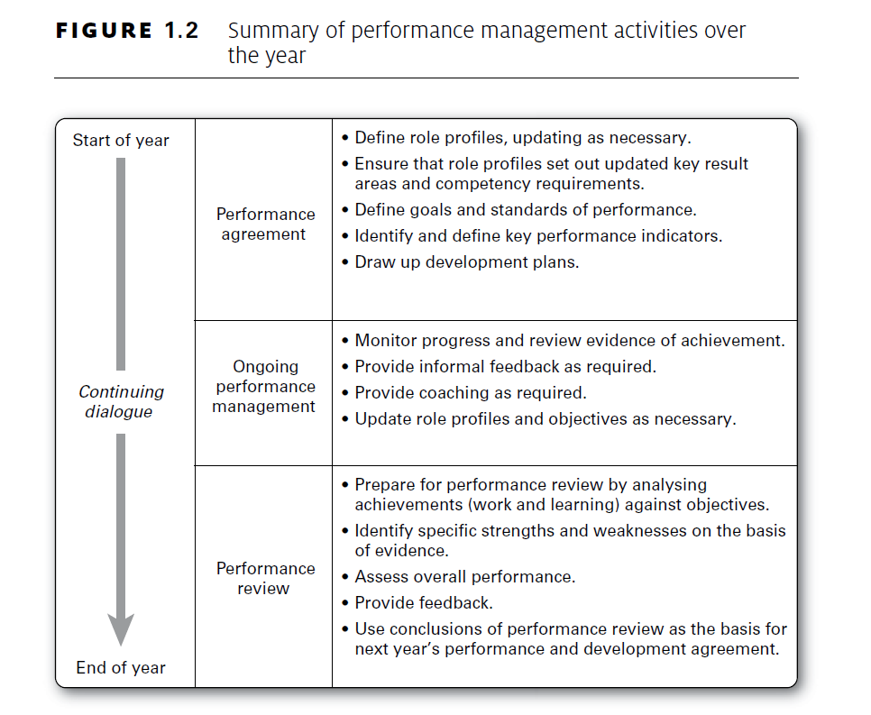
Source: Armstrong & Taylor (2014)

Performance planning – performance agreement
A performance agreement is the outcome of the decisions made jointly by the manager and the individual during the planning part of the performance management sequence. It provides a foundation for managing performance throughout the year and for guiding improvement and development activities. It is used as a reference point when planning and reviewing performance and is therefore a key component of a performance management system. It contains agreements on expectations in the form of the results, competencies and actions required, defined as performance and learning goals, and on action plans to develop performance and abilities. The basis for these agreements is a role profile which is jointly developed by the two parties (Armstrong, 2015).

Role profiles
An important part of performance planning is the agreement or updating of a role profile for the role holder. A full role profile defines:

- Overall purpose – what the role exists to achieve.
- Key result areas – elements of a role for which clear outputs and standards exist, each of which makes a significant contribution to achieving its overall purpose. It is best to restrict KRAs to no more than five or six.
- Knowledge and skill requirements – what the role holder should know and be able to do.
- Behavioural competency requirements – the types of behaviour required for the successful performance of a role.

However, the process may be made less complex for line managers by grouping together knowledge and skill and behavioural competency requirements under the heading of ‘critical success factors’ or ‘role requirements’ meaning those aspects of a role that must go well to ensure success.

Key performance indicators
Key performance indicators (KPIs) are the metrics or other sources of information which indicate how outcomes can be measured or recognised.

Performance goals
Performance goals define the results individuals are expected to achieve. The expected results will be defined within the framework of the role profile and by reference to the key performance indicators established for key result areas. Wherever possible, goals are quantified as targets which indicate what has to be achieved over a period of time in terms of quantified results or the completion of a project. But they can be expressed as qualitative performance standards which state that a key aspect of the job will have been well done if something specific happens.

Action planning
- Achieving goals – any actions required by the individual and the manager to achieve the overall objectives of the job.
- Performance development plans – these will spell out what employees in conjunction as necessary with their managers, need to do I specified areas of their jobs such as reaching sales or productivity targets, working accurately, providing services to internal customers, cutting costs, reducing waste, meeting deadlines. In any development area, goals are set on what has to be done and by when, and agreement reached on how the expected results will be achieved. If there are any behavioural performance problems such as being uncooperative or lack of effort, plans are agreed on how the problems can be overcome. The plan should be focused; too many goals will only dissipate improvement efforts.
- Personal development plans – learning plans to achieve learning goals for which individuals are responsible with the support of their managers and the organisation.

The performance management cycle in SMEs
For SMEs, the adoption of advanced managerial practices in the main business processes is key to the successful improvement of their business performance and competitiveness. However, it is well known from the literature that SMEs experience difficulties in adopting new and innovative managerial practices (Cagliano et al., 2001). Therefore, there is a clear need to stimulate the development of managerial capability in SMEs considering the factors characterizing these companies.
SMEs exhibit different managerial characteristics from larger organisations. The small firm is not a scaled-down version of a large firm and we cannot simply look at the needs of SMEs by adapting policies and practices from larger firms in smaller enterprises.
Ates, Garengo, Cocca & Bititici (2013) argued that in order to support the development of managerial practices to improve organisational performance SMEs experience particular difficulties. Authors emphasize that SMEs seem to be more focused on internal and short-term planning, whereas they spend less effort in possessing a long-term view on internal and external issues, such as communication, competition, sustainable competitive advantage, strategic market positioning and horizon scanning. SME managers should become more conscious that development on the path to short-term performance does not lend itself simply to changing at a later stage to the long-term path.
Planning seems to be the most crucial phase of the identified closed-loop process. SMEs show difficulties in developing effective mission, vision and values, and most of them have never formalised their strategies. However, reference frameworks available in the literature for the implementation of a performance management system are based on a top-down approach, i.e. they establish performance measures starting from the identification and formalization of the company’s mission and vision (Cook & Wolverton, 1995; Garengo, Biazzo & Bititci, 2005; Hudson et al., 2001) without considering that SMEs have difficulties in managing concepts such as mission and vision. To support the development of managerial practices first of all, we should support SMEs to unveil their strategy without forcing SMEs to adopt the same complex methodologies used by large organisations, but proposing an approach that complies with characteristics and managerial culture of SMEs. The literature is developing in this direction; see, for example, the bottom-up approach proposed by Garengo & Biazzo (2012) to guide entrepreneurs and managers to unveil mission vision and strategy. However, further research should be carried out to develop an SME-friendly, visual strategic framework for guidance.

A second key barrier that SMEs should tackle to develop their managerial practice is the difficulty in managing the internal and external communication process. How can firms develop their performance practices without communicating with employees, customers and suppliers? It is clear that this is an internal contradiction that it is sometimes determined by distorted performance management practices, i.e. the collection of information to blame employees for negative performance, instead of improving the overall company performance. This also means to tackle the traditional command and control management style. There is a clear need to reinvent the management style in SMEs to move towards empowered and information-based organisations, similar to the recommendations made by Gary Hamel (2009). However, given the large diffusion of command and control approach in SMEs and the difficulty in changing that behaviour in the short term, the entrepreneur’s commitment to the continuous development of managerial practices becomes crucial.
Thirdly, special attention should be given to the planning and communication of internal and external change initiatives. If top management does not pay attention to managing change effectively, the PM process will inevitably be affected. The main challenge is that critical change steps, particularly the soft aspects of change, are omitted. SMEs should take a more strategic and long-term view of change rather than seeing it as project management only. Changes should be driven proactively rather than waiting until change is imposed by external forces such as customer complaints and changes is legislation (Ates & Bititci, 2011; Burnes, 2004; Gray, 2002).

Criteria for objectives
The acronym ‘SMART’ is often used to define a good objective. Traditionally, S stands for specific (sometimes ‘stretching’), M for measurable, A for agreed, R for realistic and T for time-related (see Figure 4). But as Chamberlin (2011) argued, ‘the real aim of setting objectives is for people to know exactly what it is they have to do, when they’ve done it, that they are able to do it, why they have to do it (i.e. who for) and that it is something they should be doing, and how they are progressing along the way’. Following Blanchard (1989), he suggested that the last three letters of the mnemonic should be amended to read A for attainable, R for relevant and T for trackable. He attached particular importance first to ‘relevant’, meaning that the objective is to do with the business and its customers. Second, he emphasized ‘trackable’ because the important thing to do with objectives is to monitor progress over time, i.e. track it (he rejected ‘time-related’ because it did not convey this essential feature and was in any case covered already by ‘specific’).

Figure 4. Criteria for objectives
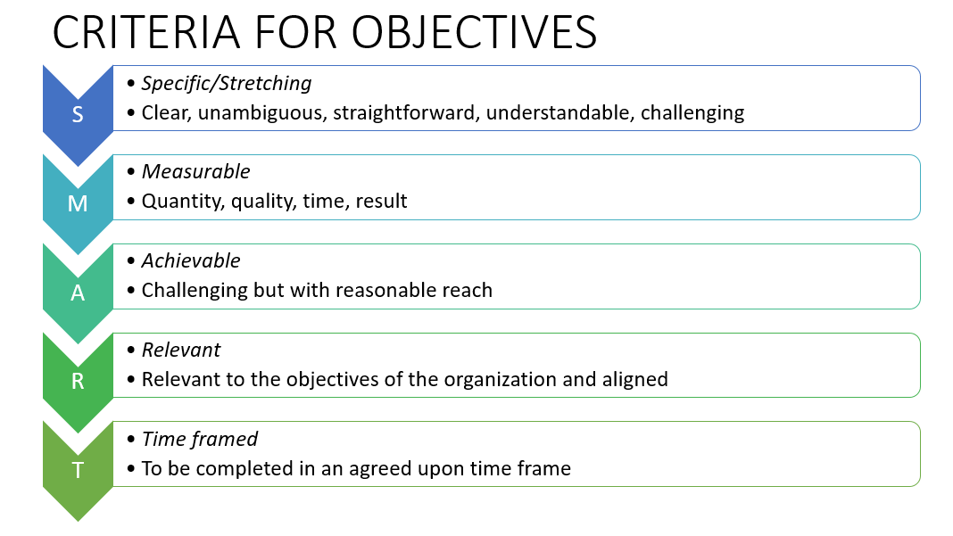
Source: Adapted from Armstrong & Taylor (2014)

Managing performance throught the year
Performance management should not feel like a forced task for managers, but something that is natural throughout the year. Appraisals are seen as disadvantageous as they focus and dwell on the past rather than what is at hand. Performance management can continue to improve on someone as yearly reviews will not focus on what is current and give certain goals for a whole year (Armstrong & Taylor, 2014).

Performance review
A performance review provides a focal point for the consideration of key performance and development issues. The performance review meeting is the means through which the five primary performance management elements of agreement, measurement, feedback, positive reinforcement and dialogue can be put to good use. It leads to the completion of the performance management cycle by informing performance agreements.
There are 12 golden rules for conducting performance review meetings:
- Be prepared. Managers should prepare by referring to a list of agreed objectives and their notes on performance throughout the year. They should form views about the reasons for success or failure and decide where to give praise, which performance problems should be mentioned and what steps might be undertaken to overcome them. Thought should also be given to any changes that have taken place or are contemplated in the individual’s role, and to work and personal objectives for the next period. Individuals should also prepare in order to identify achievements and problems, and to be ready to assess their own performance at the meeting. They should also note any points they wish to raise about their work and prospects.
- Work to a clear structure. The meeting should be planned to cover all the points identified during preparation. Sufficient time should be allowed for a full discussion – hurried meetings will be ineffective. An hour or two is usually necessary to get maximum value from the review.
- Create the right atmosphere. A successful meeting depends on creating an informal environment in which a full, frank but friendly exchange of views can take place. It is best to start with a fairly general discussion before getting into any detail.
- Provide good feedback. Individuals need to know how they are getting on. Feedback should be based on factual evidence. It refers to results, events, critical incidents and significant behaviours that have affected performance in specific ways. The feedback should be presented in a manner that enables individuals to recognize and accept its factual nature – it should be a description of what has happened, not a judgement. Positive feedback should be given on the things that the individual did well in addition to areas for improvement. People are more likely to work at improving their performance and developing their skills if they feel empowered by the process.
- Use time productively. The reviewer should test understanding, obtain information, and seek proposals and support. Time should be allowed for the individual to express his or her views fully and to respond to any comments made by the manager. The meeting should take the form of a dialogue between two interested and involved parties, both of whom are seeking a positive conclusion.
- Use praise. If possible, managers should begin with praise for some specific achievement, but this should be sincere and deserved. Praise helps people to relax – everyone needs encouragement and appreciation.
- Let individuals do most of the talking. This enables them to get things off their chest and helps them to feel that they are getting a fair hearing. Use open-ended questions (i.e. questions that invite the individual to think about what to reply rather than indicating the expected answer). This is to encourage people to expand.
- Invite self-assessment. This is to see how things look from the individual’s point of view and to provide a basis for discussion – many people underestimate themselves.
- Discuss performance not personality. Discussions on performance should be based on factual evidence, not opinion. Always refer to actual events or behaviour and to results compared with agreed performance measures. Individuals should be given plenty of scope to explain why something did or did not happen.
- Encourage analysis of performance. Don’t just hand out praise or blame. Analyse jointly and objectively why things went well or badly and what can be done to maintain a high standard or to avoid problems in the future.
- Don’t deliver unexpected criticisms. The discussion should only be concerned with events or behaviours that have been noted at the time they took place. Feedback on performance should be immediate; it should not wait until the end of the year. The purpose of the formal review is to reflect briefly on experiences during the review period and, on this basis, to look ahead.
- Agree measurable objectives and a plan of action. The aim should be to end the review meeting on a positive note (Ahmad & Alaskari, 2014).

Dealing with Underperformers (5 Steps)
1. Identify and agree the problem – provide feedback and make sure the employee agrees on the issue.
2. Establish the reasons for shortfall – this is not to provide blame. This is to look at the facts and discuss them with the employee.
3. Decide and agree on action required – actions may be taken by the manager, employee, or both. Arrangements for feedback can be made for the action.
4. Resource the action – managers can provide training, coaching, facilities, etc.
5. Monitor and provide feedback – this is to make sure the proper actions are being taken to correct any problems. If the actions are not working, feedback can be given and new plans can be put in action (Armstrong, 2015).

Performance management issues
The many-faceted nature of performance was commented on as follows by Cascio (2010, p. 303): ‘It is an exercise in observation and judgement, it is a feedback process, it is an organisational intervention. It is a measurement process as well as an intensely emotional process. Above all, it is an inexact, human process.’
As a human process, performance management can promise more than it achieves. However well designed a performance management system is, its effectiveness mainly depends on the commitment and skills of line managers (Armstrong & Taylor, 2014).

Performance management issues in SMEs
Lack of human resources. SMEs typically have limited human resources. Often all the staff are involved in the activities of managing daily work, and have no extra time for additional activities, such as implementing a PMS (Barnes et al., 1998; Hudson et al., 2000; Hvolby & Thorstenson, 2000; McAdam, 2000; Noci, 1995; Tenhunen et al., 2001).
Managerial capacity. Technical excellence in products and operational processes is often perceived as the only key critical factor in SMEs. A managerial culture is often lacking in these companies and therefore managerial tools and techniques are perceived as being of little benefit to the company. Very often, employees occupy different positions at the same time, the organisations are flat, and though the entrepreneur is in charge of both operational and managerial functions, he/she usually neglects the managerial activities (Marchini, 1995).
Limited capital resources. The impact of the resources needed to implement a PMS is proportionally more onerous in SMEs than in large companies (Barnes et al., 1998; Burns & Dewhurst, 1996; Ghobadian & Gallear, 1997; Hudson et al., 2000; Hvolby & Thorstenson, 2000; Neely & Mills, 1993; Noci, 1995). Moreover, the absence of affordable software platforms that focus on the specific needs of SMEs further obstructs the introduction of PMS in these companies (Bititci et al., 2002).
Reactive approach. SMEs are characterised by poor strategic planning and decision-making processes are typically not formalised. The lack of explicit strategies and methodologies to support the control process promotes both a short-term orientation and a reactive approach to managing the enterprise’s activities (Brouthers et al., 1998; Marchini, 1995).
Tacit knowledge and little attention given to the formalisation of processes. One of the main barriers to organisational development in SMEs is the lack of a managerial system and formalized management of the processes. Furthermore, since knowledge is mainly tacit and context-specific, the information required to implement and use a PMS is difficult to gather (Jennings & Beaver, 1997; Marchini, 1995; Martins & Salerno, 1999).
Misconception of performance measurement. Bourne (2001) underlines that a PMS can only be effectively implemented and used when the company perceives the benefits of the PMS. SMEs often do not understand the potential advantages of implementing a PMS; these systems are perceived as a cause of bureaucratization and an obstacle to the flexibility of SMEs (Hvolby &Thorstenson, 2000; Hussein et al., 1998; McAdam, 2000).

Performance assessment
An overall assessment is based on a general analysis of performance under the headings of the performance agreement (see Figure 5).

Figure 5. Performance assessment

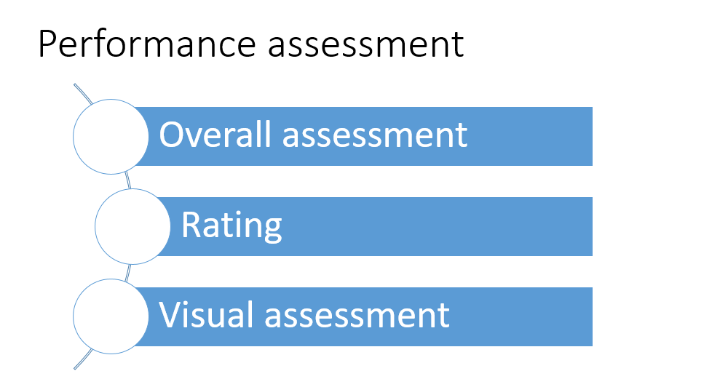
Source: Armstrong & Taylor (2014)

Overall assessment
The aim is to reach agreement about future action rather than to produce a summarized and potentially superficial judgement. An overall assessment is recorded in a narrative consisting of a written summary of views about the level of performance achieved (see Figure 6). This at least ensures that managers have to collect and record their thoughts.
Figure 6. Framework for overall assessment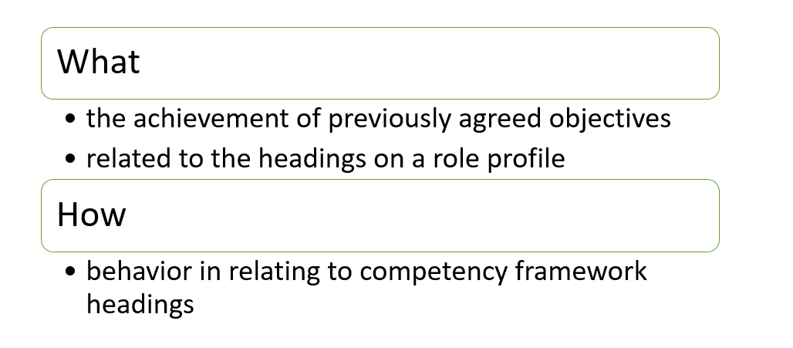
Source: Armstrong & Taylor (2014)
But different people will consider different aspects of performance and there will be no consistency in the criteria used for assessment, so it is necessary to have a framework for the analysis.
This could be provided on a ‘what’ and ‘how’ basis. The ‘what’ is the achievement of previously agreed objectives related to the headings on a role profile. The ‘how’ is behaviour in relating to competency framework headings. The results for each ‘what’ and ‘how’ heading could be recorded following a joint analysis during a review meeting.
Overall assessment limitations:
• We can recognize people at either extreme (top performers and inadequate performers) but cannot accurately distinguish performance differences in the bulk of people lying between those extremes.
• They can be bland, superficial and overgeneralized.

Rating
Rating summarizes on a scale the views of the evaluator on the level of performance achieved. A rating scale is supposed to assist in making judgements and it enables those judgements to be categorised to inform performance- or contribution-pay decisions, or simply to produce an instant summary for the record of how well or not so well someone is doing.
Rating scales can be defined alphabetically (a, b, c, etc), or numerically (1, 2, 3, etc). Initials (ex for excellent, etc) are sometimes used in an attempt to disguise the hierarchical nature of the scale. The alphabetical or numerical points scale may be described adjectivally, for example, a = excellent, b = good, c = satisfactory and d = unsatisfactory.
Rating limitations:
• They are largely subjective and it is difficult to achieve consistency between the ratings given by different managers;
• Because the notion of ‘performance’ is often unclear, subjectivity can increase;
• To label people as ‘average’ or ‘below average’, or whatever equivalent terms are used, is both demeaning and demotivating;
• Managers may inflate ratings to avoid confrontation with the individuals concerned.

Visual assessment
Visual assessment is an alternative to rating. This takes the form of an agreement between the manager and the individual on where the latter should be placed on a matrix or grid, as illustrated in Figure 7.
Figure 7. Assessment matrix
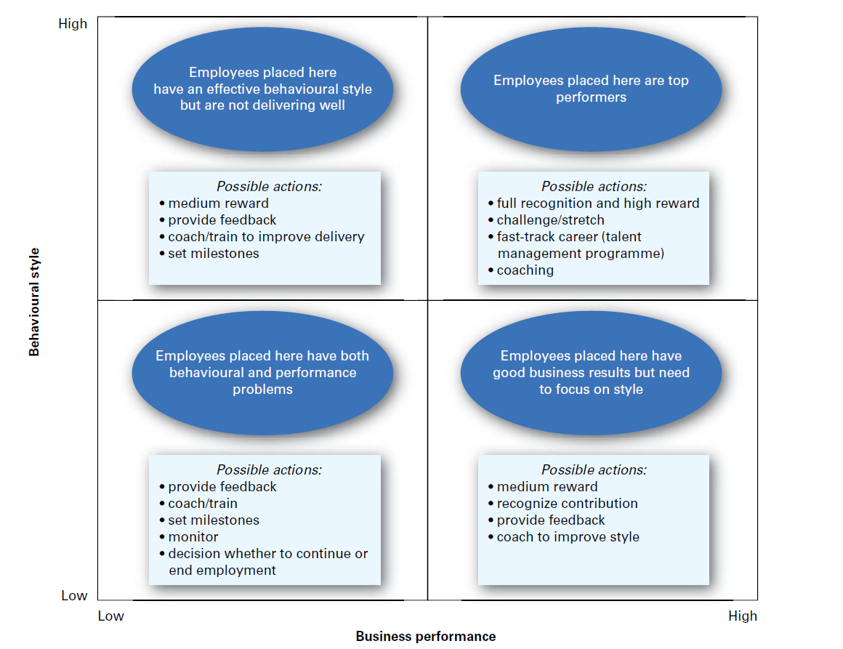
Source: Armstrong & Taylor (2014)

The vertical axis of the grid in this example assesses the behavioural style adopted by the individual in carrying out the role, i.e. inputs. The elements of behaviour to be assessed would be defined in a competency framework and this would be amplified in schedules of what would be regarded as acceptable or unacceptable behaviour for each area of competency. The horizontal axis measures the level of business performance, i.e. outputs or what the individual delivers. The assessment can place someone anywhere in one of the four quadrants according to behavioural style and delivery.

Performance management as a reward process
Performance management needs to be connected with the reward system to support employee motivation. As Figure 8 shows, performance management, if carried out correctly, gives employees support in their career paths.
Figure 8. Performance management as a reward system
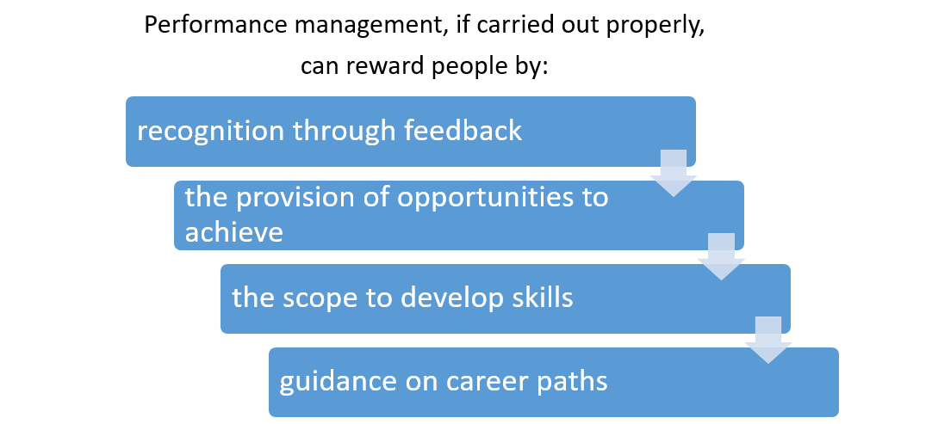
Source: Armstrong & Taylor (2014)

Also known as multisource feedback, 360-degree questionnaires are assessed and feedback is given by a number of people who may include their manager, subordinates, colleagues and customers. Assessments take the form of ratings against various performance dimensions. The term ‘360-degree feedback’ is sometimes used loosely to describe upward feedback where this is given by subordinates to their managers. This is the most common approach and is more properly described as 180-degree feedback. Feedback may be presented direct to individuals, or to their managers, or both (see Figure 8).

Performance measurement models for SMEs
Organisational performance measurement was developed specifically for SMEs. In this model, the most important indicator is stakeholder satisfaction (see Figure 9).

Figure 9. Organisational performance measurement
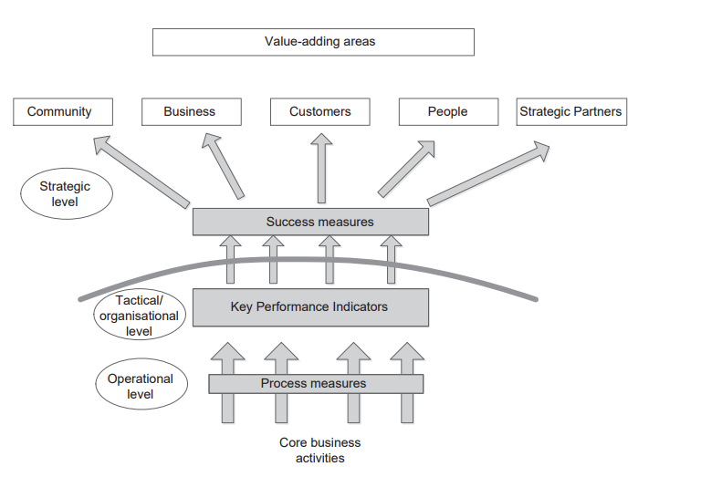
Source: Ahmad & Alaskari (2014)

The model starts at a strategic level to determine external measures, followed by a set of KPIs at a tactical level to enable the prediction and management of organisational performance. At operational level, measures are utilised for monitoring and control and improvement, however, the model is based on three principles: alignment, i.e., the selected performance measures support the alignment between people’s actions and company strategy; process thinking, i.e. the measurement system makes reference to the process of monitoring, control and improvement systems; practicability, i.e. at any level in the company, there is a consistent process for identifying measures that should be considered for ensuring the quality and suitability of data (see Figure 10).

Figure 10. Integrated performance measurement for small firms (IPMS)
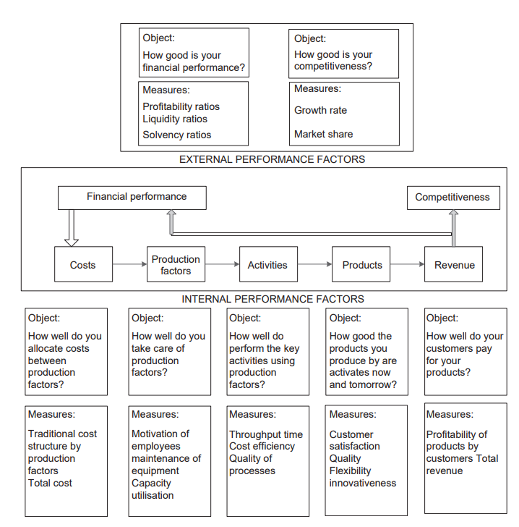
Source: Ahmad & Alaskari (2014)
IPMS is specifically designed for SMEs. The aim of this model is to develop a useful managerial tool for measuring and improving performance within the companies. It is based on seven main dimensions of measures categorised into two external dimensions (financial performance and competitiveness), and five internal dimensions (costs, production factors, activities, products and revenues) which are connected by a causal chain. The internal dimensions are used to monitor the whole production process and the external dimensions are used to monitor the organisation’s position in its competitive context. This framework is designed for the exclusive use of the director, implying that it is designed only for enterprises where the top management has complete control.

Performance management in SMEs (SHARPEN survey)
Performance management is an important part of HR practices, which helps to motivate and retain satisfied and engaged employees. According to results of the SHARPEN survey 2018, activities including performance evaluation are mainly conducted in SMEs by line managers and, in the case of micro and small enterprises, by the owner (see Table 4).

Table 4. Who evaluates employee performance? (%)
Country | Responsible person
Country | Owner | Line manager | HR specialist | Accountant | Admin. worker | External HR specialist / agency | Other | Activity is not performed
CZ | 36.71 | 56.96 | 10.13 | 1.27 | 1.27 | 1.27 | 6.33 | 5.06
Finland | 72.22 | 47.22 | 4.17 | 0.00 | 2.78 | 0.00 | 4.17 | 5.56
Germany | 33.73 | 71.08 | 20.48 | 0.00 | 2.41 | 0.00 | 4.82 | 2.41
Lithuania | 21.11 | 50.00 | 23.33 | 5.56 | 11.11 | 2.22 | 5.56 | 5.56
UK | 22.54 | 59.15 | 33.80 | 1.41 | 4.23 | 1.41 | 5.63 | 11.27

Source: Maršíková et al. (2019)
Note: respondents could choose more than one option
The performance evaluation (appraisal) process is often informal (around 50%), except for Finland where the results showed nearly 85% (but the result is again influenced by the respondents’ structure). See Table 5.
Table 5. Formal (systematic) employee performance evaluation process in SMEs in 5 European regions
Response | Number of responses
Response | CZ |  | Finland |  | Germany |  | Lithuania |  | UK
Response | % | abs. | % | abs. | % | abs. | % | abs. | % | abs.
Yes | 43.24 | 32 | 15.28 | 11 | 45.24 | 38 | 44.57 | 41 | 54.93 | 39
No | 56.76 | 42 | 84.72 | 61 | 54.76 | 46 | 55.43 | 51 | 45.07 | 32
Total | 100 | 74 | 100 | 72 | 100 | 84 | 100 | 92 | 100 | 71

Source: Maršíková et al. (2019)
Results of the SHARPEN survey provide interesting insight about performance management issues across five European regions and confirmed that these processes are often informal and facilitated by SME owners and line managers. Of course, it is not possible to generalise these findings but they confirm and support findings in the literature mentioned in this chapter.

You can find more information about the SHARPEN research in our research publication:
Maršíková, K., Rajander, T., Clauß, A.-M., Medžiūnienė, I., Meschitti, V., Štichhauerová, E, Davies, J., Dulkė, D., Komulainen, R., Macháčková, V., Richter, M., Schumann, C.-A., Moš, O., & Forkel, E. (2019). People management challenges for SMEs in five European regions: Spotlighting the (in)visible and the (in)formal and embedding SME HR issues firmly in the business and knowledge environment. Huddersfield, UK: University of Huddersfield.
ISBN: 978-1-86218-168-7
Link: https://sharpen.ef.tul.cz/upload/PublicationHRMinSMEs_research.pdf

Summary
Performance management is the continuous process of improving performance by setting goals that are aligned to the strategic goals of the organisation, planning performance to achieve the goals, reviewing progress, and developing the knowledge, skills and abilities of people. It allows individuals and teams to achieve better results within an agreed framework of planned goals, standards and competency requirements. Performance management is a key process which helps to get work done through communication about expectations and important goals. It is also a way for organisations to identify ineffective performers for development programmes.
The aim of performance management is to develop the capacity of people to meet and exceed expectations and to achieve their full potential to the benefit of themselves and the organisation. A further aim is to clarify how individuals are expected to contribute to the achievement of organisational goals by aligning individual objectives with strategic.
Performance management may improve organisational performance generally by creating a performance culture in which the achievement of high performance is a way of life.

You can find more practical information and advice in our publication:
Komulainen, R., Maršíková, K., Davies, J., Srėbaliūtė, I., Clauß, A.-M., Moš, O., Muschol, H., Rydvalová, P., Forkel, E., & Štichhauerová, E. (2019). A Good Practice Guide to Managing Human Resources in Regional SMEs. Huddersfield, UK: University of Huddersfield.
ISBN: 978-1-86218-167-0
Link: https://sharpen.ef.tul.cz/upload/HRM4SMEs_Handbook.pdf


Section review questions
1. What is performance management?
2. What are the primary elements of performance management?
3. What are the key processes in the performance management cycle?
4. What are key issues in performance management?
5. Explain how you would measure work performance.
6. What is 360-degree feedback?
7. Discuss the strengths and weaknesses of performance management systems in SMEs.

Video links
SHARPEN. Performance Management in SMEs. Link: https://youtu.be/nnVd3pDPxbY

Dictionary
Cafeteria plan | An employee benefit plan that allows employees to choose their own benefits (e.g., employees accumulate ”benefit points” which they can exchange for a variety of rewards such as vouchers, free days, money etc.)
External communication | The transmission of information between a business and another person or entity in the organisation's external environment.
Functional goals | These relate to the specific functions of an organisation (e.g. marketing, operations, HRM, finance) and which are designed to support the achievement of corporate objectives. A well-established business will divide its activities into several business functions.
Internal communication | The transmission of information between organisational members or parts of the organisation.
Reward management | The formulation and implementation of strategies and policies that aim to reward people fairly, equitably and consistently in accordance with their value to the organisation.
Self-efficacy | An individual's belief in their innate ability to achieve goals.

Case studies
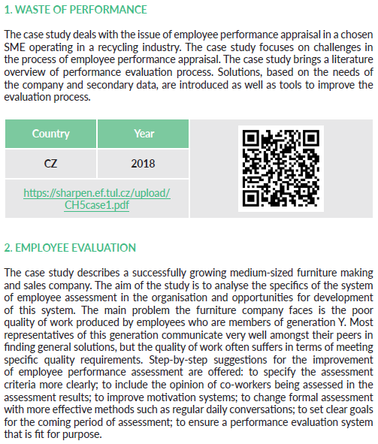
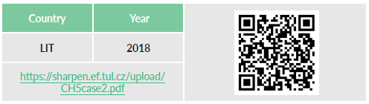
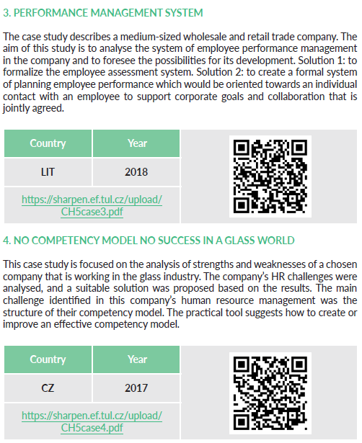


References
Ahmad, M. M. & Alaskari, O. (2014). Development of assessment methodology for improving performance in SMEs. International Journal of Productivity and Performance Management, 63(4), 477-498. doi: 10.1108/IJPPM-06-2013-0108.
Armstrong, M. & Taylor, S. (2014). Armstrong's handbook of human resource management practice (13th ed.). London, United Kingdom: Kogan Page.
Armstrong, M. (2015). Armstrong’s handbook of performance management. An evidence-based guide to delivering high performance (5th ed.). London, United Kingdom: Kogan Page.
Armstrong, M. & Baron, A. (2004). Managing Performance: Performance Management in action (Developing practice) (2nd ed.). London, United Kingdom: CIPD - Kogan Page.
Armstrong M. & Murlis H. (1998). Reward Management – A Handbook of Remuneration Strategy and Practice. (5th ed.). London: Kogan Page.
Ates, A., Garengo, P., Cocca, P. & Bititci, U. (2013). The development of SME managerial practice for effective performance management. Journal of Small Business and Enterprise Development, 20(1), 28-54. doi: 10.1108/14626001311298402.
Ates, A. & Bititci, U. (2011). Change process: a key enabler for building resilient SMEs. International Journal of Production Research. 49(18). 5601-18. doi: 10.1080/00207543.2011.563825
Bandura, A. (1986). Social foundations of thought and action: A social cognitive theory. Englewood Cliffs, NJ: Prentice-Hall.
Barnes, M., Dickinson, T., Coulton, L., Dransfield, S., Field, J., Fisher, N., Saunders, I. & Shaw, D. (1998). A new approach to performance measurement for small to medium enterprises. In Proceedings of the Performance Measurement – Theory and Practice Conference, Cambridge, 14–17 July.
Bititci, U. S., Turner, T., Nudurupati, S. S. & Creighton, S. (2002). Web enabled measurement systems – management implications. International Journal of Operations and Production Management, 22, 1273–1287. doi: 10.1108/01443570210450310
Blanchard, K. H. (1989). The One Minute Manager –Live! London: CareerTrack Publications.
Bourne, M. (2001). Implementation Issues, Hand Book of Performance Measurement. London: GEE.
Brouthers, K., Andriessen, F. & Nicolaes, I. (1998). Driving blind: strategic decision-making in small companies. Long Range Planning, 31, 130–138. doi: 10.1016/S0024-6301(97)00099-X
Burns, P. & Dewhurst, J. (1996). Small Business and Entrepreneurship. London: Macmillan.
Burnes, B. (2004). Managing Change: A Strategic Approach to Organisational Dynamics. (4th ed.). Prentice Hall, Harlow.
Cagliano, R., Blackmon, K. & Voss, C. (2001). Small firms under microscope: international differences in production/operations management practices and performance. Integrated Manufacturing Systems. 12, 469–482. doi: 10.1108/EUM0000000006229
Cascio, W. F. (2010.) Managing Human Resources: Productivity, quality of work life, profits. New York: McGraw-Hill Irwin.
Chamberlin, J. (2011). Who put the ‘ART’in SMART goals. Management Services, 55(3), 22–27.
Cook, R. A., Wolverton, & J. B. (1995). A scorecard for small business performance. Journal of Small Business Strategy, 6, 1–18. Retrieved from: https://libjournals.mtsu.edu/index.php/jsbs/article/view/315/293 (15.06.2018).
Egan, G. (1995). A clear path to peak performance. People Management. 1 (10). 34 – 37.
Garengo, P., Biazzo, S. & Bititci, U. S. (2005). Performance measurement systems in SMEs: A review for a research agenda. International Journal of Management Reviews, 7(1), 25–47. doi: 10.1111/j.1468-2370.2005.00105.x.
Garengo, P., & Biazzo, S., (2012). Unveiling strategy in SMEs through balanced scorecard implementation: A circular methodology. Total Quality Management & Business Excellence. 23(1), 79-102. doi: 0.1080/14783363.2011.637800
Ghobadian, A. & Gallear, D. (1997). TQM and organisation size. International Journal of Operations and Production Management, 17, 121–163. doi: 10.1108/01443579710158023
Gray, C. (2002). Entrepreneurship, resistance to change and growth in small firms. Journal of Small Business and Enterprise Development. 9(1). 61-72. doi: 10.1108/14626000210419491
Hamel, G. (2009). Moon shots for management. Harvard Business Review. 87(2). 91-8. Retrieved from: https://hbr.org/2009/02/moon-shots-for-management (20.02.2018).
Hudson, M. & Smith, D. (2000). Running before walking: the difficulties of developing strategic performance measurement systems in SMEs. In the Proceedings of the 7th International Annual EurOMA Conference, Ghent, 4–7 June.
Hudson, M., Smart, P. A., & Bourne, M. (2001). Theory and practice in SME performance measurement systems. International Journal of Operations and Production Management, 21, 1096– 1116. doi: 10.1108/EUM0000000005587
Hussein, M., Gunasekaran, A., & Laitinen, E.K. (1998). Management accounting system in Finish service firms. Technovation, 18, 57–67. doi: 10.1016/S0166-4972(97)00062-X
Hvolby, H-H. & Thorstenson, A. (2000). Performance measurement in small and medium-sized enterprises. In Proceeding of the International Conference on Stimulating Manufacturing Excellence in SMEs. Coventry, 17–19 April.
Jennings, P. & Beaver, G. (1997). The performance and competitive advantage of small firms: a management perspective. International Small Business Journal, 15, 34–58. doi: doi.org/10.1177/0266242697152004
Komulainen, R., Maršíková, K., Davies, J., Srėbaliūtė, I., Clauß, A.-M., Moš, O., Muschol, H., Rydvalová, P., Forkel, E., & Štichhauerová, E. (2019). A Good Practice Guide to Managing Human Resources in Regional SMEs. Huddersfield, UK: University of Huddersfield.
Latham, G., & Locke, R. (1979). Goal setting – a motivational technique that works. Organizational Dynamics. 8 (2), 68-80. doi: https://doi.org/10.1016/0090-2616(79)90032-9
Marchini, I. (1995). Il governo della piccola impresa, vol. 3 – La gestione delle funzioni, Genova: ASPI/ INS-EDIT.
Maršíková, K., Rajander, T., Clauß, A.-M., Medžiūnienė, I., Meschitti, V., Štichhauerová, E, Davies, J., Dulkė, D., Komulainen, R., Macháčková, V., Richter, M., Schumann, C.-A., Moš, O., & Forkel, E. (2019). People management challenges for SMEs in five European regions: Spotlighting the (in)visible and the (in)formal and embedding SME HR issues firmly in the business and knowledge environment. Huddersfield, UK: University of Huddersfield.
Martins, R. A. & Salerno, M. S. (1999). Use of new performance measurement system, some empirical findings. In Managing Operations Networks – VI International EurOMA Conference, Venice, Italy, 7–8 June.
McAdam, R. (2000). Quality models in an SME context. International Journal of Quality and Reliability Management, 17, 305–323. doi: 10.1108/02656710010306166
Neely, A.D. & Mills, J.F. (1993). Manufacturing in the UK – Report on a Survey of Performance Measurement and Strategy Issue in UK Manufacturing Companies. London: Manufacturing Engineering Group.
Noci, G. (1995). Accounting and non-accounting based measures of quality-based performances in small firms. International Journal of Operations and Production Management, 15, 78–106. doi: 10.1108/01443579510090435
Strebler, M., Robinson, D., & Bevan, S. (2001). Performance Review: Balancing objectives and content. IES Report 370, Brighton: Institute for Employment Studies
Tenhunen, J., Rantanen, H. & Ukko, J. (2001). SME-oriented Implementation of a Performance Measurement System. Lahti, Finland: Department of Industrial Engineering and Management, Lappeenranta University of Technology.
Townley, B. (1989). Selection and appraisal: reconstructing social relations? in (ed) J. Storey, New perspectives in Human Resource Management. London: Routledge.

The project has been funded by the Erasmus + KA2 Strategic Partnership programme. Project agreement number: 2016-1-CZ01-KA203-023916.

Legal notice:
The views expressed in this publication are the sole responsibility of the authors and do not necessarily reflect the views of the European Union, of the ERASMUS programme national agencies nor of the project partner universities. The Union, the national agencies and the universities are not liable for any use that may be made of the information contained therein.

