7. Employee Ownership

This section aims to:
- Stimulate understanding of the terms ‘ownership’ and ‘responsibility’.
- Explain possible ‘employee ownership’ structures.
- Introduce opportunities to modify employee ownership schemes.
- Discuss the specifics of employee ownership in SMEs.

Keywords

Employee ownership, employee participation, responsibility, structures of employee ownership, employee ownership schemes.


Required knowledge
Knowledge of basic HRM terms and control measures.


Time requirements
Total time recommended to study this chapter: two hours.

Contents
Introduction to employee ownership 3
Definition of employee ownership 3
Ownership and Responsibility 3
Aims of Employee Ownership 4
Forms of Employee Ownership 5
Structuring Employee Ownership Programmes 6
Immaterial Employee Participation 7
Material Employee Participation 8
Equity Participation 8
Profit participation 9
Implementing Employee Ownership 10
Selecting the Right Participation Model 11
Specifics of Employee Ownership in SMEs 12
Employee ownership in SMEs in numbers (the case of Germany) 13
Section review questions 15
Video Links 15
Dictionary 16
Case studies 17
References 19


Introduction to employee ownership
In the mid-1950s, employee participation was considered an important instrument for the fair distribution of income and wealth within social market economy (Nell-Breuning, 1955). In this context, employee participation is a general term for the participation of employees in the company’s capital (economic) success (material employee participation), as well as in its operational processes - provided that this exceeds legally prescribed information and participation rights (immaterial employee participation). Accordingly, “company partnership” is understood as a synonym for employee participation (FitzRoy & Kraft, 1987). Consequently, employee participation is a key step towards a co-operative and fair company (Mohn, 1996).
To assess an employee participation strategy as an instrument of regional management, we define ownership and responsibility. Wolfgang Ockenfels (1989) differentiates this position by pointing out that ownership – also of the company’s assets is significant for the company in different regards (Figure 1):
Figure 1: Significance of employee ownership
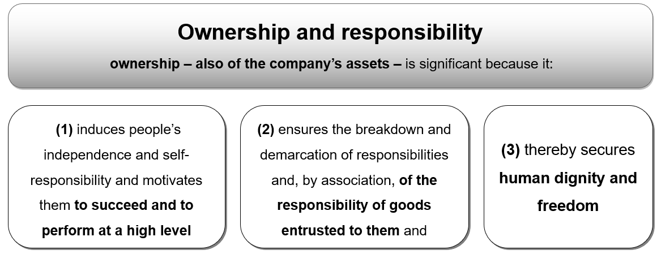
Source: Ockenfels (as cited in Komulainen, 2019)

Definition of employee ownership
First of all, employee participation is a general term for the participation of employees in the company’s capital resp. economic success (material employee participation), as well as in its operational processes − provided that this exceeds legally prescribed information and participation rights (immaterial employee participation).

Ownership and Responsibility

Since the mid-1950s, employee participation was considered as an important instrument for the fair distribution of income and wealth within a social market economy like Germany (Nell-Breuning, 1955). The term company partnership is understood as a synonym for employee participation which is viewed as important for transparency and fairness (FitzRoy & Kraft, 1987). Therefore, ownership and responsibility can be considered as a social necessity, especially in difficult times (see Figure 2).
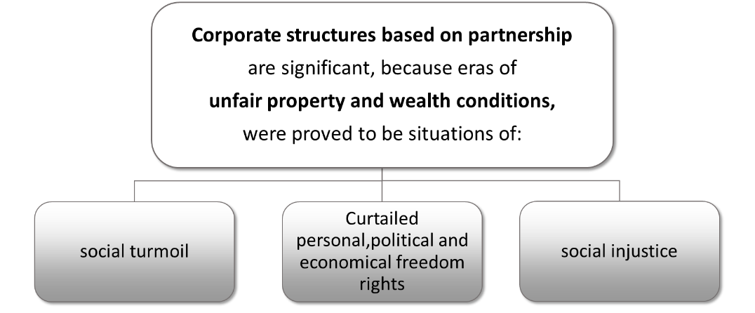
Figure 2: Partnership-based company as a social necessity
Source: Losinger (1994)

Aims of Employee Ownership
Ownership supports entrepreneurial action including social responsibility. This simultaneously forms an important basis for the arrangement of company succession and thus, for safeguarding the company.
A first current field of application is the so-called intrapreneurship, i.e. the striving for business success by entrepreneurial thinking and acting employees (Meyer, 2013). Regarding its content, the concept comprises different dimensions as illustrated in Figure 3 (Meyer, 2013).
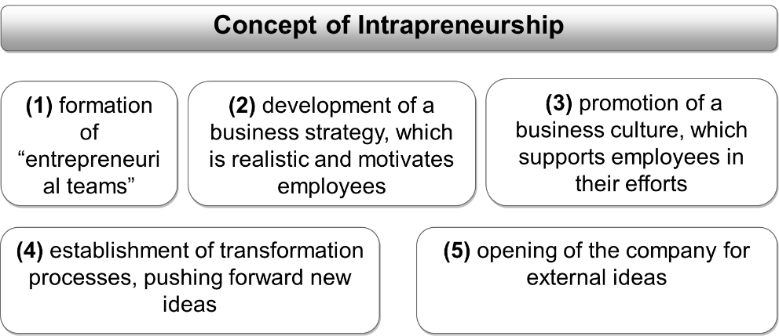
Figure 3: employee ownership and intrapreneurship
Source: Meyer (2013)
Another field of application is shortage of skilled labour. In the course of the demographic development and the associated increase of skills shortage, it is primarily necessary to recruit and retain qualified staff. Particularly, employee participation can be used as a problem-solving instrument in SMEs (AGP, 2011).
In 2013, according to the Institute for SME Research in Bonn (Institut für Mittelstandsforschung; IfM), it is expected that approximately 109,000 of 3.7m enterprises in Germany will be created by transfer and that these figures are anticipated to increase in future. Company succession is a multi-stage process starting with a draft of the transfer-conception and ending up with the complete transfer of the power of governance and control of a company from one person, or a group of persons, to another. Here, mixed forms of management-buy-outs and employee participation are conceivable too.

Forms of Employee Ownership
There exists a broad spectrum of different forms of employee participation programmes within an enterprise (Figure 4). It ranges from a co-operative as a partnership-based company per se, through the company acquired and managed by its own employees as a result of a management-buy-out, to the “classical” forms of a non-business oriented employee sub-participation.
Figure 4: Corporate structures based on partnership

Source: own elaboration
The co-operative as a first for of participation is more broadly interpreted than the employee participation, since the co-operative members cannot only be employees but also independent entrepreneurs – mostly small entrepreneurs like suppliers or customers. Nevertheless, the cooperative, even in the case of a just partial constitution with employees, is possibly the most intense form of employee participation (Helios et al., 2009).
Management-buy-out (MBO) is the acquisition of a company by the existing management. It is primarily practised by companies with limited liability (LLC/Ltd.; Gesellschaft mit beschränkter Haftung GmbH). Leading employees (heads of department, authorised officers, directors) acquire equity interests either immediately to its full extent or successively. The meaning of partnership, the MBO leads to a win-win situation between previous owners and acquiring employees offering advantages to both sides (Figure 5 and 6) (Kreuzhof, 1989).
Figure 5: Advantages for previous owners of MBOs
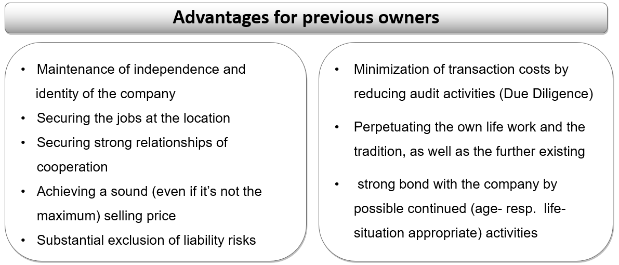
Source: Kreuhof (1989)
Figure 6: Advantages for acquirers
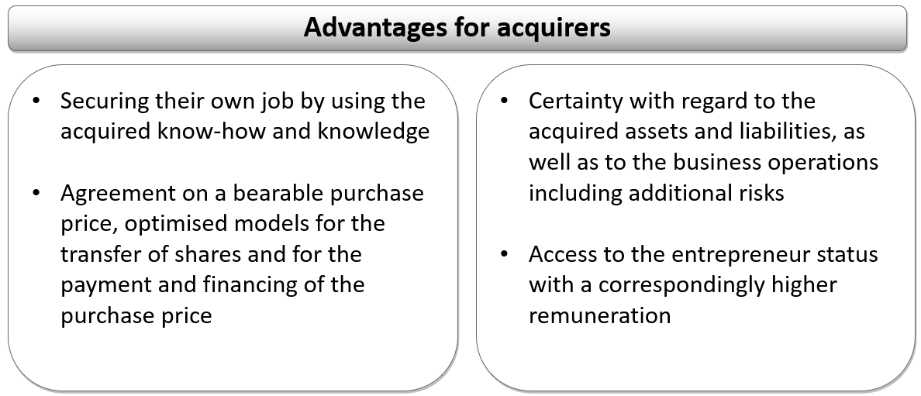
Source: Kreuhof (1989)

Structuring Employee Ownership Programmes

A more relevant method for involving as many employees as possible in profit participation is represented in different – rather non-entrepreneurial oriented - models of the material and the immaterial employee participation (Figure 7).
Figure 7: Spectrum of employee ownership forms

Source: own elaboration

Immaterial Employee Participation
As in nearly all areas of life (such as politics, education, family), the professional sphere – and thus not at least the employment position – within the economy tends to be characterised by its increasing maturity. As a result, management is generally well-advised to pursue more interest-oriented co-ordination (win-win-strategies) than authoritarian leadership in personnel work. Such an interest co-ordination with more rights (such as co-determination rights, information rights), but also obligations (e.g. activities in improvement systems) already represents a first element of the partnership within the company and may be also considered as a form of employee participation, just as the intangible employee participation (Figure 8).
Figure 8: Immaterial Employee Participation
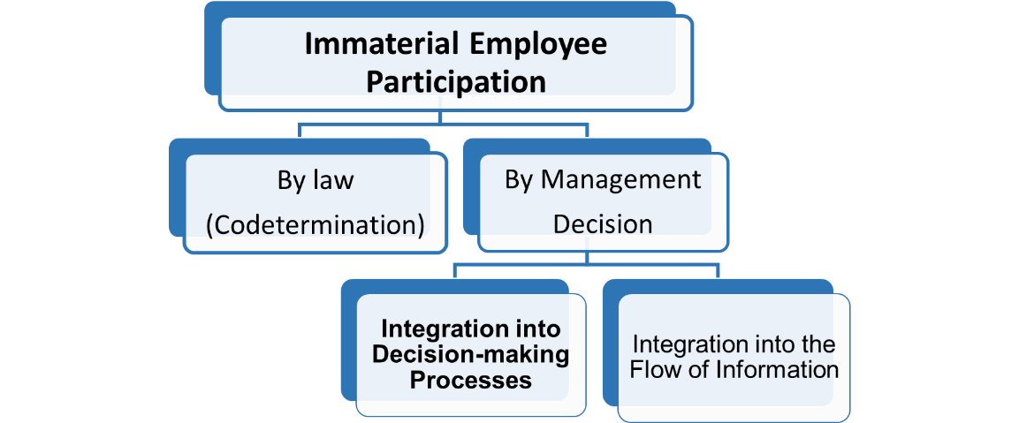
Source: own elaboration

Inclusion of employees in decision-making process can be achieved by the following methods:
- Voluntary works council
- Employee suggestion system
- Employee attitude survey
- Semi-autonomous working groups
Communications can be achieved by the following methods:
- Strategy consulting
- Planning sessions
- Target costing
- Risk-management-systems

Material Employee Participation
With the help of material participation models (Figure 9), employees can not only be appropriately remunerated for their activities and - if relevant - for their higher risk acceptance. Simultaneously, they can be given more responsibility with the consequence that income differentials derived from work on the one hand and from capital on the other hand – indeed depending on the specific model to a different extent - will be reduced and at the same time will lead to a fairer distribution of wealth. Distinction should be made between equity participation and profit participation.
Figure 9: Material Employee Participation
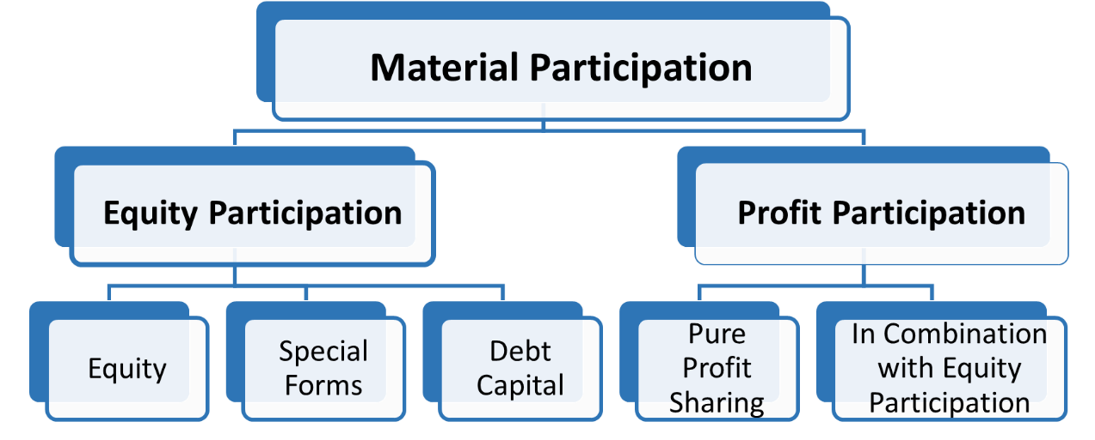
Source: own elaboration

Equity Participation
Equity participation will either be affected as sub-participation or as an acquisition of limited/fewer voting rights – each with the aim to participate in the company’s short- and long-term success. Principal manifestations are employees’ share, sub-participation in GmbH-shares (shares in an LLC), silent partnership, employee loans and agreement on profit participation capital. The difference between direct and indirect participation is shown in Figure 10. The different forms of ownership in direct equity participation are shown in Figure 11.
Figure 10: Direct vs. indirect equity participation
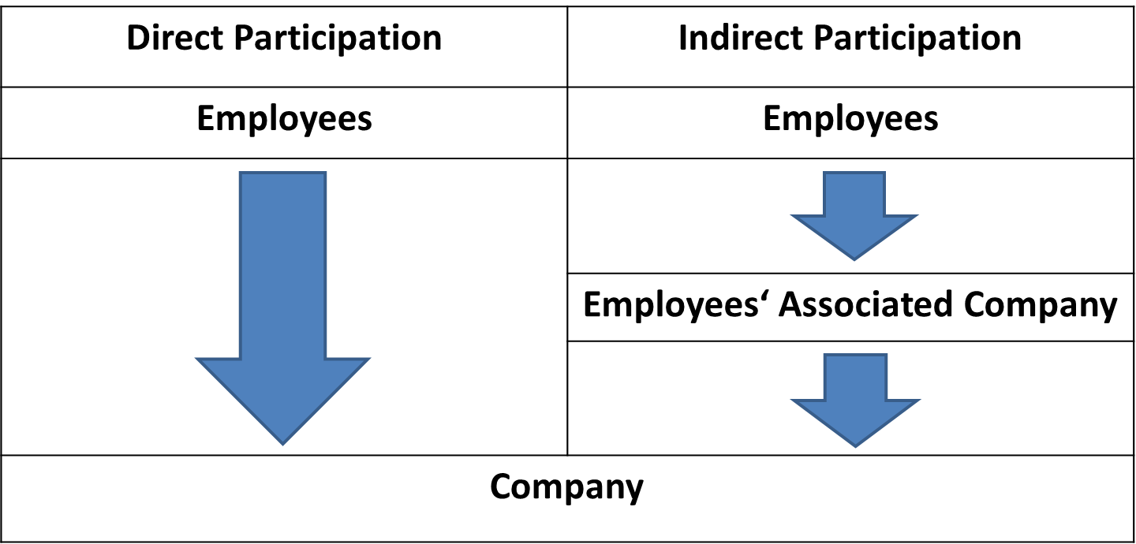
Source: own elaboration
Figure 11: Direct Equity Participation
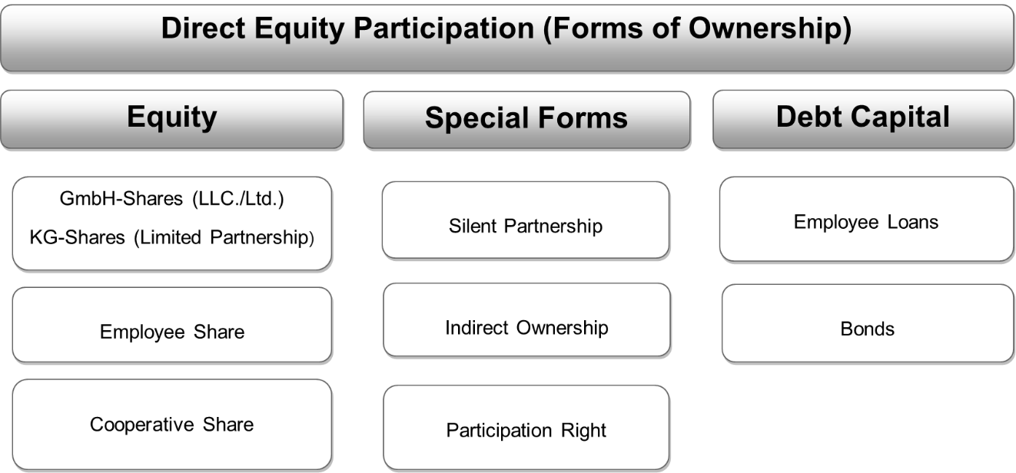
Source: own elaboration

Profit participation
Profit Participations represents additional remunerations dependant on the organisation’s success, i.e., the employee’s contribution to the company’s performance (Figure 12). Within the scope of the so-called gratification, the classical form of profit participation, a specific quota of the company’s profit, i.e., performance of a profit-centre, is remunerated in addition to the normal salary. Apart from the profit-related remuneration there exists another feasible (additional) performance-related remuneration (achievement of individual performance goals/plans), which has to be regularly agreed on the condition that the company will be generating profits in the future.
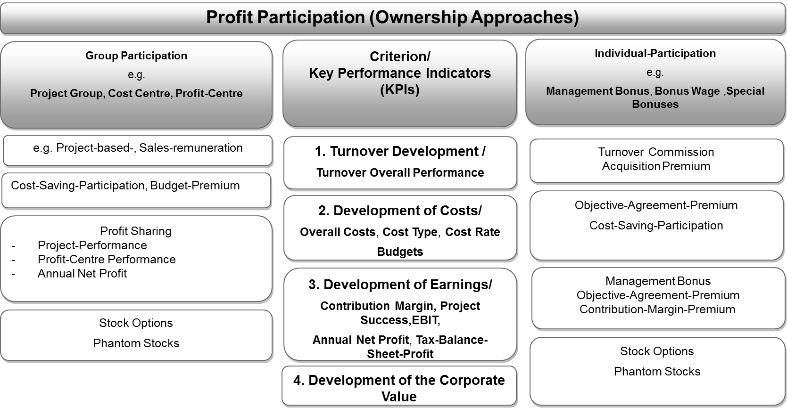
Figure 12: Profit Participation (Ownership Approaches)
Source: own elaboration

Implementing Employee Ownership
Employee participation programmes have to be ethical (especially regarding the going concern principle) and economically reasonable. For this purpose, conceptual reflections have to be made within three different areas (see Table 1):
- Economic concept: Is the business model of the partnership company profitable and thus reasonable?
- Financial concept: Is the company formation resp. the share purchase financing solid and secure?
- Company concept: Optimal legal form (regarding fiscal and commercial law issues)?
- Does the company agreement enable or guarantee short- and long-term decisions?
- Does the desired participation (possibly sub-participation) correspond to the company’s premises, especially to the company agreement?
Table 1: From Input to Output
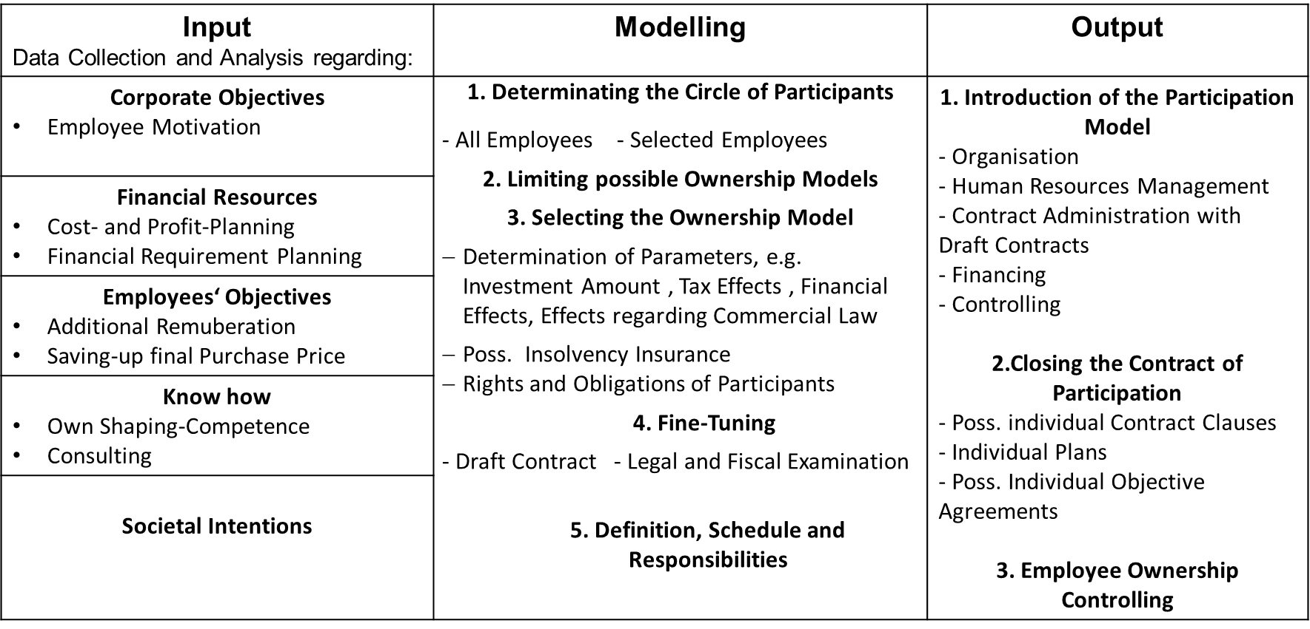
Source: own elaboration

Selecting the Right Participation Model
The first step in selecting the right participation model is to ask oneself a set of questions on company objectives (Table 2).
Table 2: Questionnaire on Objective Determination
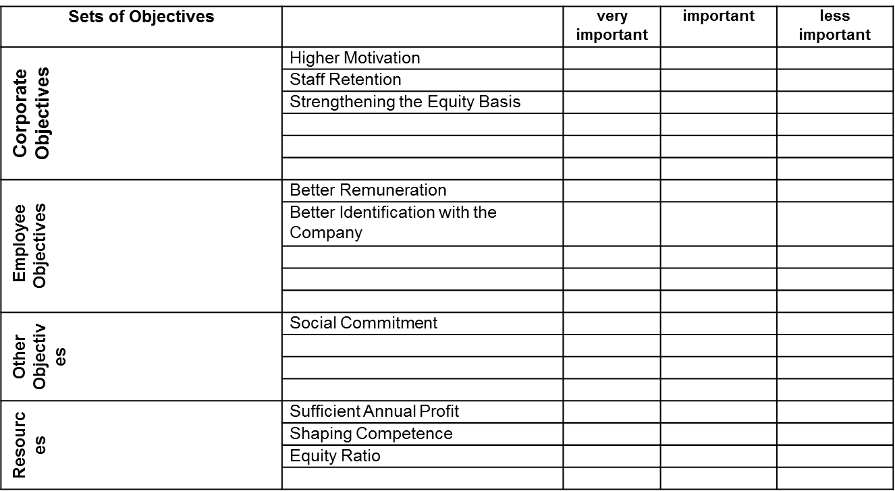
Source: own elaboration
The second step is to involve the participated employees into the company’s information processes (Controlling) in order to inform about the achieved business and - possibly - personal performance goals (Table 3).
Table 3: Objective Determination
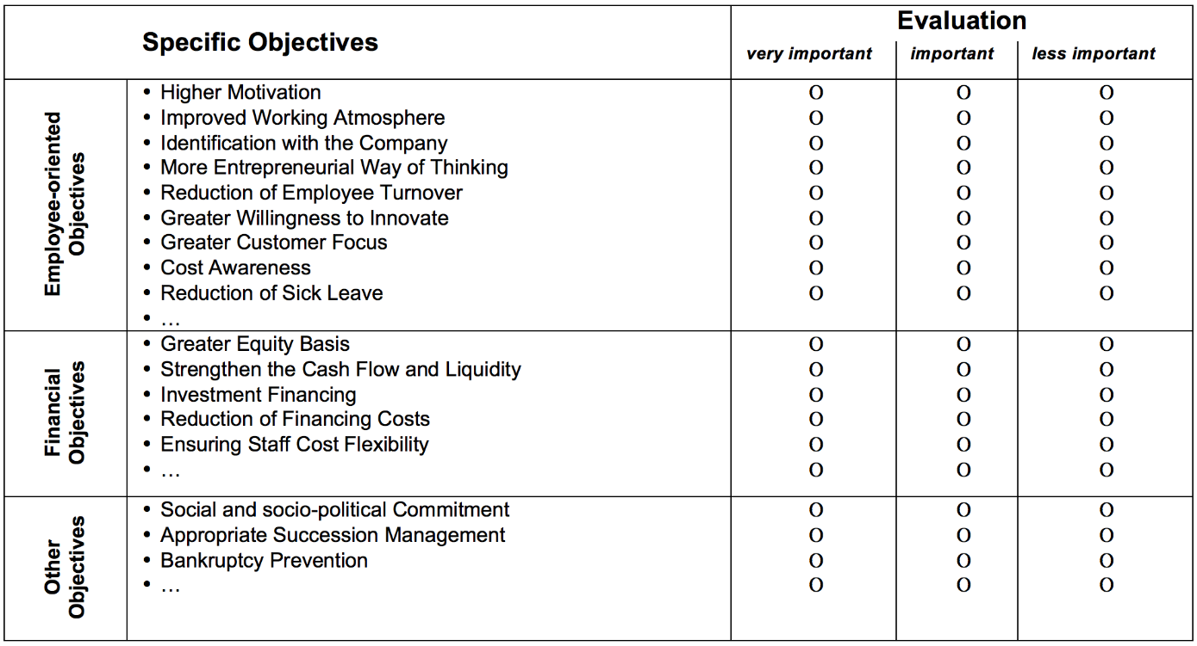
Source: own elaboration

Specifics of Employee Ownership in SMEs

Employee participation involves employees in the company’s capital (economic) success and in its operational processes. It can be considered as a key step towards a cooperative and fair company.
SMEs can use employee ownership for branding purposes in order to appeal to potential employees. Also, immaterial employee participation can boost employee motivation
Employee ownership benefits a comprehensive potential to entrepreneurial action including social responsibility. It is also an important basis for the arrangement of company succession. Safeguarding company for future generations of owners and employees is especially relevant for SMEs struggling to recruit new employees.

Employee ownership in SMEs in numbers (the case of Germany)

According to the Gallup Engagement Index Germany 2011 (see Figure 16), only 14% of employees in German companies feel high emotional engagement towards their company, compared to 23% who feel none. Most of the employees surveyed (63%) feel low emotional engagement.
Figure 13: Employee engagement in Germany

Source: Gallup Engagement Index Germany (2011)
Figure 17 shows that 29% of small German enterprises have profit participation in place. In comparison, 26% of medium-sized enterprises and 35% of large enterprises have implemented profit participation. In total, 9% of all German enterprises practise profit participation. This illustrates that small enterprises do not necessarily offer profit participation less often.
Figure 14: Companies with profit participation (by size)

Source: IAB Betriebspanel 2009 (2011)
In German companies, profit participation is not the only option to engage employees. As explained in this chapter, equity participation is also possible. Figure 18 shows a similar relation of company size to the availability of equity participation as Figure 17 for profit participation. Approximately 4% of small enterprises have implemented equity participation. Compared to the total percentage of 1% this is higher than for profit participation.
Figure 15: Companies with equity participation (by size)

Source: IAB Betriebspanel 2009 (2011)

Summary
- Employee ownership is a key step towards a co-operative and fair company.
- Immaterial and material employee participation can be beneficial for the company (employee motivation)
- Employee ownership benefits a comprehensive potential to entrepreneurial action including social responsibility.
- Employee ownership is an important basis for the arrangement of company succession and safeguarding for future times.

You can find more practical information and advice in our publication:

Komulainen, R., Maršíková, K., Davies, J., Srėbaliūtė, I., Clauß, A.-M., Moš, O., Muschol, H., Rydvalová, P., Forkel, E., & Štichhauerová, E. (2019). A Good Practice Guide to Managing Human Resources in Regional SMEs. Huddersfield, UK: University of Huddersfield.
ISBN: 978-1-86218-167-0
Link: https://sharpen.ef.tul.cz/upload/HRM4SMEs_Handbook.pdf

You can find more information about the SHARPEN research in our research publication:
Maršíková, K., Rajander, T., Clauß, A.-M., Medžiūnienė, I., Meschitti, V., Štichhauerová, E, Davies, J., Dulkė, D., Komulainen, R., Macháčková, V., Richter, M., Schumann, C.-A., Moš, O., & Forkel, E. (2019). People management challenges for SMEs in five European regions: Spotlighting the (in)visible and the (in)formal and embedding SME HR issues firmly in the business and knowledge environment. Huddersfield, UK: University of Huddersfield.
ISBN: 978-1-86218-168-7
Link: https://sharpen.ef.tul.cz/upload/PublicationHRMinSMEs_research.pdf

Section review questions

- Why are ownership and responsibility significant for companies?
- Which forms of employee ownership exist?
- What forms of immaterial employee participation do you know?
- What forms of material employee participation do you know?
- Name the main steps in modelling employee ownership measures.
- What objectives should be considered when selecting the right employee participation model?
- What are specifics of employee ownership in SMEs?

Video Links
SHARPEN. Material participation.
https://www.youtube.com/watch?v=9791BwpvTXU
SHARPEN. Introduction to employee ownership. Link: https://www.youtube.com/watch?v=UeT7jkoe3po
SHARPEN. Intangible participation tool. Link: https://www.youtube.com/watch?v=8rPPFJfA6TA

Dictionary
Co-operative | A partnership-based enterprise.  The enterprise is owned, controlled, and operated by a group of users for their own benefit. Each member contributes equity capital, and shares in the control of the firm on the basis of a one-member one-vote principle (and not in proportion to his or her equity contribution) (Business Dictionary, 2019).
Employee participation and ownership | Programmes aimed at increased participation of employees in operational and entrepreneurial decisions
Intrapreneurship | Employees strive for business success by entrepreneurial thinking within the organisation.
Management buy-out | A type of acquisition where a group led by people in the current management of a company buy out the majority of shares from existing shareholders and take control of the enterprise.
Ownership model | A model of employee participation/ownership (e.g. co-operative as a partnership-based company, management-buy-out, non-entrepreneurial models of employee participation).
Strategic alignment | The process of bringing the actions of an organisation's business divisions and staff members into line with the organisation's planned objectives.
Succession management | A process for identifying and developing new leaders who can replace leaders when they are promoted, leave, retire or die.

Case studies
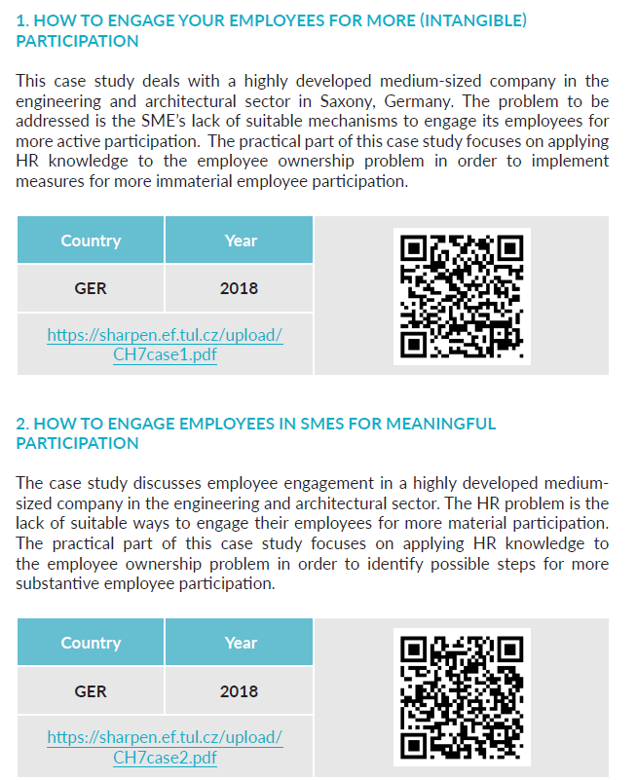

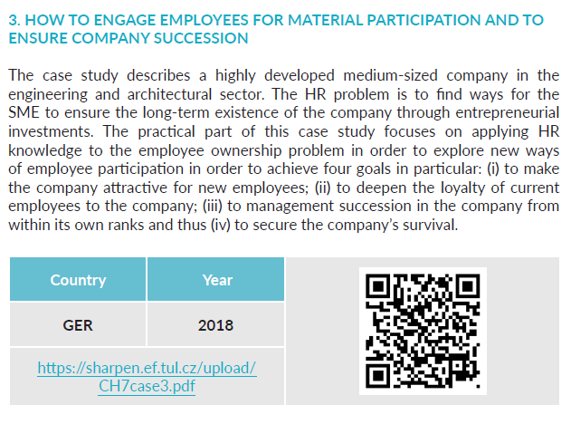

The project has been funded by the Erasmus + KA2 Strategic Partnership programme. Project agreement number: 2016-1-CZ01-KA203-023916.

Legal notice:
The views expressed in this publication are the sole responsibility of the authors and do not necessarily reflect the views of the European Union, of the ERASMUS programme national agencies nor of the project partner universities. The Union, the national agencies and the universities are not liable for any use that may be made of the information contained therein.


References
AGP (2011). Mitarbeiterbeteiligung. Führungskonzept für den Mittelstand. Kassel AGP.
Betriebsverfassungsgesetz § 5 Abs. 1 Betriebsverfassungsgesetz (BetrVG).
FitzRoy, F., Kraft, K. (1987). Mitarbeiterbeteiligung und Mitbestimmung im Unternehmen. Berlin, New York: de Guyter Verlag.
Gallup (2011). Engagement Index Deutschland 2011.
Helios, M., Strieder, T. (2009). Beck’sches Handbuch der Genossenschaft. München, Beck Verlag.
IAB (2011). Betriebspanel 2009. IAB-Kurzbericht Ausgabe Nr. 17 2011.
Komulainen, R., Maršíková, K., Davies, J., Srėbaliūtė, I., Clauß, A.-M., Moš, O., Muschol, H., Rydvalová, P., Forkel, E., & Štichhauerová, E. (2019). A Good Practice Guide to Managing Human Resources in Regional SMEs. Huddersfield, UK: University of Huddersfield.
Kreuzhof, R. (1989). Innovation und Qualifikation. Betriebliche Ansatzpunkte regionaler Struktur- und Arbeitsmarktpolitik in Oberfranken. in: Mittelstand und Betriebswirtschaft. Beiträge aus Wissenschaft und Praxis. Band 5.
Leitner, T. (2011). Grundlagen für das Gesellschaftliche Unternehmen, Graz.
Maršíková, K., Rajander, T., Clauβ, A.-M., Medžiūnienė, I., Meschitti, V., Štichhauerová, E, Davies, J., Dulkė, D., Komulainen, R., Macháčková, V., Richter, M., Muschol, H., Moš, O., & Forkel, E. (2019). People management challenges for SMEs in five European regions: Spotlighting the (in)visible and the (in)formal and embedding SME HR issues firmly in the business and knowledge environment, UK: University of Huddersfield
Meyer, J.-A. (2013). Berliner Forschungsbeiträge zu kleinen und mittleren Unternehmen. Ausgewählte Beiträge. Köln: EUL Verlag.
Mohn, R.. (1996). Erfolg durch Partnerschaft. Berlin. Siedler Verlag.
Muschol, H. (2009). Verfahren und Praxis der Unternehmensbewertung. in: Kompendium des Rechnungswesens Band 2. Plauen, M&S-Verla.
Nell-Breuning, O. (1955). Eigentumsbildung in Arbeitnehmerhand. 2. um eine Thesenfolge vermehrte Auflage. Paderborn: Bonifacius Verlag.
Ockenfels, W. (1989). Kleine Katholische Soziallehre. Eine Einführung nicht nur für Manager. Trier: Paulinus Verlag.
Ostrom, E. (1999). Die Verfassung der Allmende – jenseits von Staat und Markt, Mohr Siebeck, Tübingen.

